

**DENTAL CLINIC MANAGEMENT AND SCHEDULING**

Final Release Document

– Da Nang, November 2025 –

**Table of Contents**

1. Record of Changes 6
2. Release Package & User Guides 7
   1. Deliverable Package 7
   2. Installation Guides 7
      1. User Guide (For End-Users) 7
      2. Installation Instruction 7
         1. Minimum Hardware Requirements 7
         2. Software Requirements 7
   3. User Manual 8
      1. User Manual Guide 8
         1. Sign In for All User Roles 8
         2. Sign Up for Patient 9
      2. Forget Password Patient 10
      3. Complete Information Personal Patient 13
      4. Booking an appointment 16
      5. Clinic appointment payment 19
      6. Postpone an appointment 20
      7. View service (for patient) 24
      8. Create account users (for admin) 25
      9. Ban employees account (for admin) 27
      10. View user account details (for admin) 29
      11. View medical history (for admin) 30
      12. View service details (for admin) 31
      13. Update Service (for admin) 32
      14. Deactivate Service (for admin) 33
      15. Deactivate Service (for admin) 34
      16. Create discount (for admin) 35
      17. Edit discount 36
      18. Deactivate discount 36
      19. Create doctor services (for admin) 37
      20. Edit doctor services 38
      21. Deactivate doctor services 39
      22. Delete doctor services 40
      23. View employees information 41
      24. View location information 42
      25. View Statistic revenue 42
      26. View schedule doctor 43
      27. Create doctor schedule 44
      28. View Staff schedule 46
      29. CRUD staff schedule 47
      30. View Schedule for staff (For staff) 50
      31. Create appointment offline (For staff) 51
      32. View revenue (for staff) 53
      33. CRUD payment 53
      34. View appointment (For doctor) 55
      35. CRUD medical record 56
      36. View History medical record 58
      37. View doctor schedule (for doctor) 59
      38. View and update profile (for doctor) 59

**Table of Tables**

Table 1: Deliverable Package 7

**Table of Figures**

Figure 1. Login Screen 9

Figure 2. Step 1 in Sign Up 10

Figure 3. Step 4 in Sign Up 10

Figure 4. Step 1 in Forget password Patient 11

Figure 5. Step 4 in Forget password Patient 11

Figure 6. Step 5 in Forget password Patient 12

Figure 7. Step 6 in Forget password Patient 12

Figure 8. Step 3 in Complete Information Personal 13

Figure 9. Step 4 in Complete Information Personal 14

Figure 10. Step 4 in Complete Information Personal 14

Figure 11. Step 5 in Complete Information Personal 15

Figure 12. Step 6 in Complete Information Personal 15

Figure 13. Step 8 in Complete Information Personal 16

Figure 14. Step 2 in Booking an appointment 17

Figure 15. Step 3 in Booking an appointment 17

Figure 16. Step 4 in Booking an appointment 18

Figure 17. Step 4 in Booking an appointment 18

Figure 18. Step 5 in Booking an appointment 18

Figure 19. Step 6 & 7 in Booking an appointment 19

Figure 20. Step 1 in Clinic appointment payment 20

Figure 21. Step 2 choose “Danh sách yêu cầu” service 20

Figure 22. Step 2 in Postpone an appointment 21

Figure 23. Step 3 in Postpone an appointment 21

Figure 24. Step 4 in Postpone an appointment 22

Figure 25. Step 5 in Postpone an appointment 22

Figure 26. Step 6 in Postpone an appointment 23

Figure 27. Step 6 in Postpone an appointment 23

Figure 28. Step 7 in Postpone an appointment 24

Figure 29. Step 1 in View service 25

Figure 30. Step 2 in View service 25

Figure 31. Step 3 in View service 25

Figure 32. Step 1 in Create account user 26

Figure 33. Step 2 in Create account user 26

Figure 34. Step 2 in Create account user 27

Figure 35. Step 3 in Create account user 27

Figure 36. Step 1 in the Ban employees account 28

Figure 37. Step 1 in the Ban employees account 28

Figure 38. Step 2 in the Ban employees account 29

Figure 39. Step 1 in View user account details 30

Figure 40. Step 1 in View medical history 31

Figure 41. Step 1 in View service detail 31

Figure 42. Step 1 in View service detail 32

Figure 43. Step 2 in Update service 32

Figure 44. Step 2 in Update service 33

Figure 45. Step 2 in Update service 33

Figure 46. Step 2 in Deactivate service 33

Figure 47. Step 2 in Deactivate service 34

Figure 48. Step 2 in Create service 34

Figure 49. Step 2 in Create service 35

Figure 50. Step 1 in Create discount 35

Figure 51. Step 2 in Create discount 36

Figure 52. Step 2 in Edit discount 36

Figure 53. Step 2 in Deactivate discount 37

Figure 54. Step 2 in Deactivate discount 37

Figure 55. Step 1 in Create doctor services 38

Figure 56. Step 3 in Create doctor services 38

Figure 57. Step 2 in Edit doctor services 39

Figure 58. Step 2 in Deactivate doctor services 39

Figure 59. Step 2 in Deactivate doctor services 40

Figure 60. Step 2 in Deactivate doctor services 40

Figure 61. Step 2 in View employees information 41

Figure 62. Step 2 in View employees information 41

Figure 63. Step 2 in View employees information 42

Figure 64. Step 1 in View location information 42

Figure 65. Step 1 View statistic revenue 43

Figure 66. Step 3 View Doctor schedule 44

Figure 67. Step 3 View Doctor schedule 44

Figure 68. Step 2 in Create doctor schedule 44

Figure 68. Step 3 in Create doctor schedule 45

Figure 69. Step 4 in Create doctor schedule 45

Figure 70. Step 4 in Create doctor schedule 46

Figure 71. Step 3 in View staff schedule full-time 46

Figure 72. Steps 3 in View staff schedule part-time 47

Figure 73. Steps 1 in CRUD staff schedule 48

Figure 74. Steps 2 in CRUD staff schedule 48

Figure 75. Steps 3 in CRUD staff schedule 49

Figure 76. Steps 3 in CRUD staff schedule 49

Figure 77. Steps 5 & 6 & 7 in CRUD staff schedule 49

Figure 78. Steps 8 in CRUD staff schedule 50

Figure 78. Steps 9 in CRUD staff schedule 50

Figure 79. Steps 2 in view staff schedule 51

Figure 80. Steps 1 in create appointment offline 51

Figure 81. Steps 3 in create appointment offline 52

Figure 82. Steps 4 in create appointment offline 52

Figure 83. Steps 5 in create appointment offline 53

Figure 84. Step 1 in View revenue 53

Figure 85. Step 1 in CRUD payment 54

Figure 86. Step 2, 3 in CRUD payment 55

Figure 87. Step 1 in View appointment 56

Figure 88. Step 2 in CRUD medical record 56

Figure 89. Step 3 in CRUD medical record 57

Figure 90. Step 4 in CRUD medical record 57

Figure 91. Step 5 in CRUD medical record 58

Figure 91. Step 1 in View History medical record 59

Figure 92. Step 1 in View doctor schedule 59

Figure 93. Step 2 in View and update profile 60

# Record of Changes

|  |  |  |  |
| --- | --- | --- | --- |
| **Date** | **A* M, D** | **In charge** | **Change Description** |
| 14/09/2025 | A | Dental Team | Add create account |
| 21/09/2025 | M | Dental Team | Update create account |
| 22/09/2025 | A | Dental Team | Add create account |
| 23/09/2025 | A | Dental Team | Add bookAppointment |
| 24/09/2025 | A | Dental Team | Add middlewares staff |
| 22/09/2025 | A | Dental Team | Add create profile patient |
| 25/09/2025 | M | Dental Team | Update bookAppointment |
| 24/09/2025 | M | Dental Team | Update middlewares staff |
| 26/09/2025 | A | Dental Team | Add create profile doctor |
| 30/09/2025 | A | Dental Team | Add create schedule doctor |
| 2/10/2025 | A | Dental Team | Add locations |
| 03/10/2025 | A | Dental Team | Add create schedule staff |
| 5/10/2025 | M | Dental Team | Update create schedule doctor |
| 8/10/2025 | M | Dental Team | Update create schedule staff |
| 9/10/2025 | A | Dental Team | Add create prescription |
| 12/10/2025 | A | Dental Team | Add create medicines |
| 15/10/2025 | A | Dental Team | Add create medical record |
| 19/10/2025 | M | Dental Team | Update medical record |
| 21/10/2025 | A | Dental Team | Add create equipment |
| 22/10/2025 | A | Dental Team | Add create equipment issue |
| 25/10/2025 | A | Dental Team | Add service |
| 26/10/2025 | A | Dental Team | Add service doctor |
| 27/10/2025 | M | Dental Team | Add contact |
| 29/10/2025 | M | Dental Team | Update contact |
| 31/10/2025 | M | Dental Team | Update bookAppointment |

*A - Added M - Modified D - Deleted

# Release Package & User Guides

## Deliverable Package

|  |  |  |
| --- | --- | --- |
| **No.** | **Deliverable Item** | **Description** |
| 1 | Project Schedule/Tracking | Report3_Project Tracking |
| 2 | Project Backlog | Report2_Project Management Plan |
| 3 | Source Codes | Dental-clinic Back-End |
| Dental-clinic Front-End Manager |
| Dental-clinic Front-End Admin |
| Dental-clinic Front-End Doctor |
| Dental-clinic Front-End Patient |
| Dental-clinic Front-End Staff |
| 4 | Final Report Document | Report7_Final Project Report |
| 5 | Test Cases Document | Report2_Test Documentation |

***Table 1: Deliverable Package***

## Installation Guides

### User Guide (For End-Users)

**System Requirements (Client):**

* **Hardware:** A device (computer, tablet, or smartphone) with an internet connection.
* **Software (Browsers):** The application works best on modern browsers such as **Google Chrome, Microsoft Edge, Firefox, and Safari** (latest versions).

**Access URLs:**

* **Login Page:** http//localhost:3000/dental-clinic
* **Registration Page:** http//localhost:3000/dental-clinic

### Installation Instruction

#### Minimum Hardware Requirements

* + - * + CPU: 1 Core
        + RAM: 4GB
        + Storage (Free space): 10GB

#### Software Requirements

|  |  |  |  |
| --- | --- | --- | --- |
| No. | Name | Version | Description |
| 1. | Visual Studio Code | Latest | Code editor |
| 2. | Git | Latest | Version control |
| 3. | Node.js | Latest | JavaScript runtime environment (to run |

|  |  |  |  |
| --- | --- | --- | --- |
|  |  |  | Back-End & Front-End) |
| 4. | MongoDB | Latest | Database to store application data |
| 5. | Web browser | Chrome, Edge (last ver) | Used for running and testing (development) |
| 6. | Postman | Latest | Tool for testing APIs (Back-End) |
| 7. | Draw.io | Latest | For viewing design diagrams |

## User Manual

### User Manual Guide

#### Sign In for All User Roles

This guide explains the functionalities available on the Login screen of the dental clinic web and provides step-by-step instructions for users to perform actions like logging in, resetting passwords, or navigating to registration.

* **Functionality:**
  1. Submits the entered email and password to authenticate the user.
  2. If login is successful, the system automatically determines the user's role (e.g., Patient, Doctor, Admin, staff, manager).
  3. The system **redirects the user to the appropriate landing screen** based on their determined role.
  4. Displays an error message if credentials are invalid or the account is deactivated.
* **Steps:**
  1. Ensure you have entered a valid email and password.
  2. Tap the blue "Sign in" button.
  3. Wait for confirmation or error messages. If login fails, check your credentials and try again.

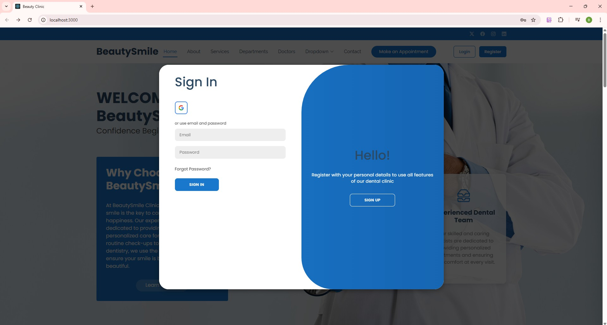

***Figure 1. Login Screen***

#### Sign Up for Patient

The account registration function allows new patients to create an account to book an appointment service. The process involves entering essential information such as a valid phone number, email address, and a secure password. Users are required to confirm their password to ensure accuracy. Once all inputs are validated, the system guides the user to the next step, typically email verification.

Step 1: Go to the website and navigate to the registration screen.

Step 2: Enter your first name, last name, email address, and confirm password.

Step 3: Click the send code button to confirm that is your email. The code will be sent to the email you have entered.

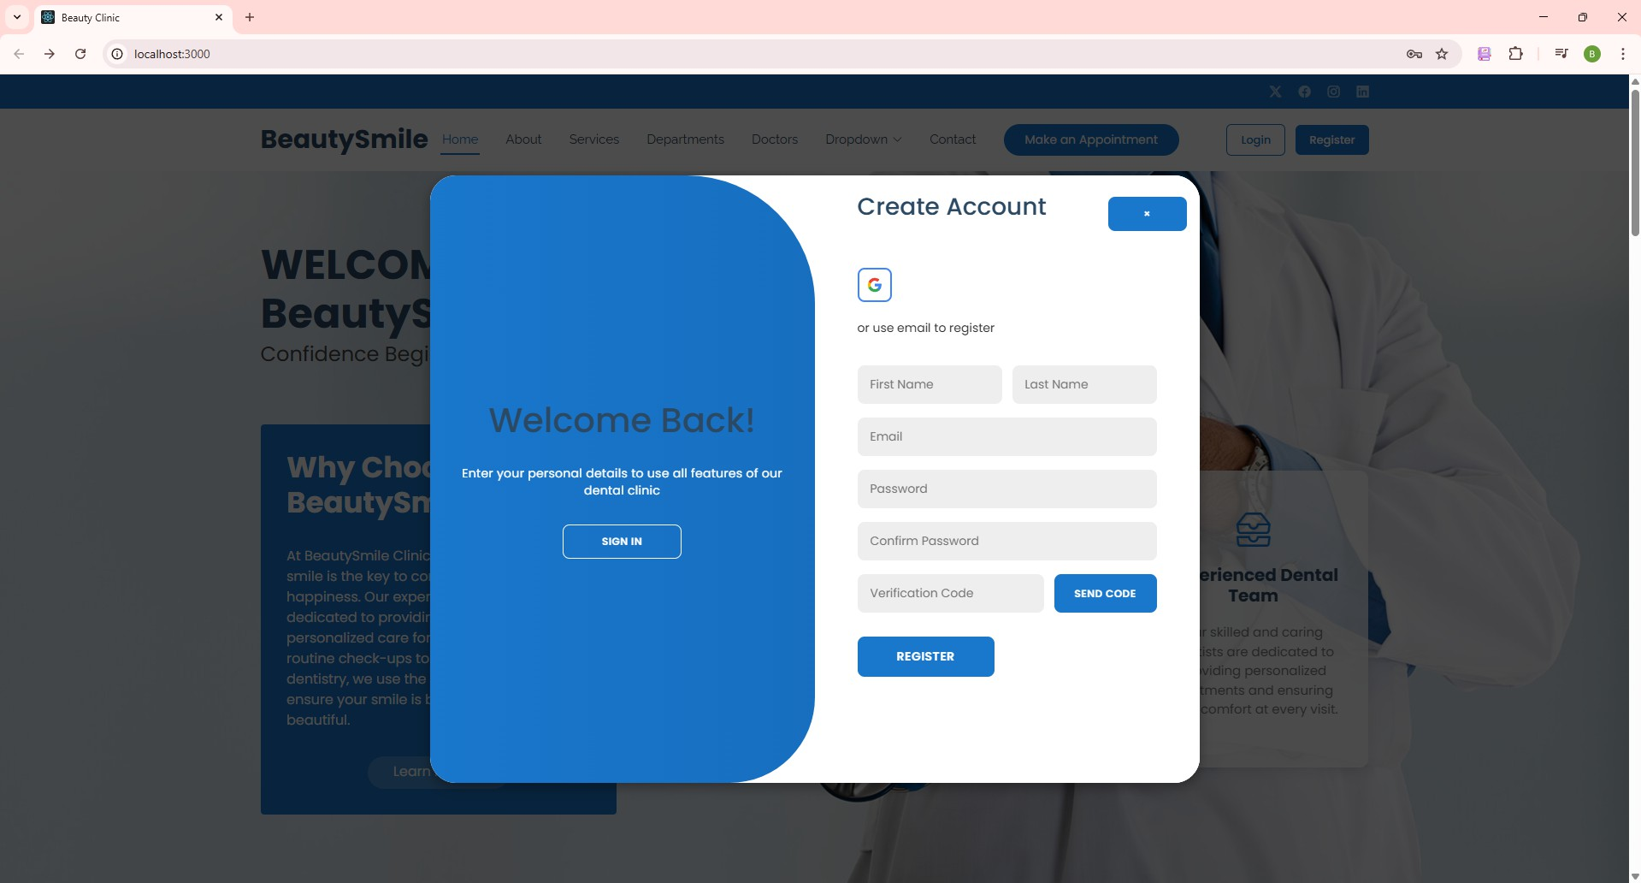

***Figure 2. Step 1 in Sign Up***

Step 4: The system will send an OTP to your registered email.

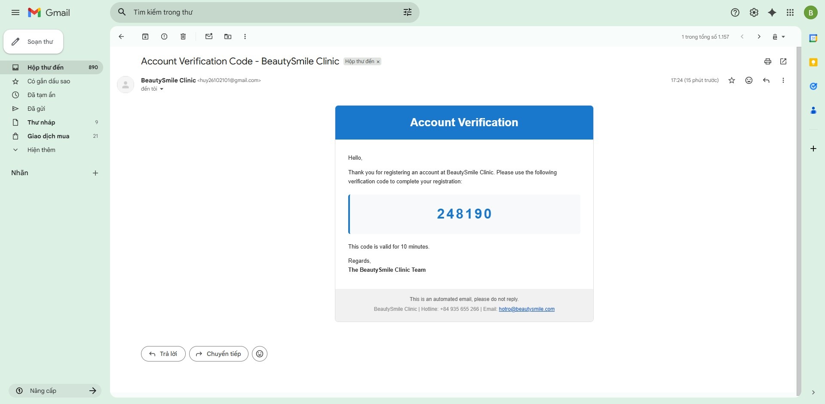

***Figure 3. Step 4 in Sign Up***

Step 5: Copy code you have in email and paste in text-box send code. Step 6: Click “Register” to complete your registration.

#### Forget Password Patient

The password change function allows users to change their password when they forget the password. This process includes the user remembering their email.

Step 1: Go to the website and navigate to the login screen. Step 2: Click “Forget password”



***Figure 4. Step 1 in Forget password Patient***

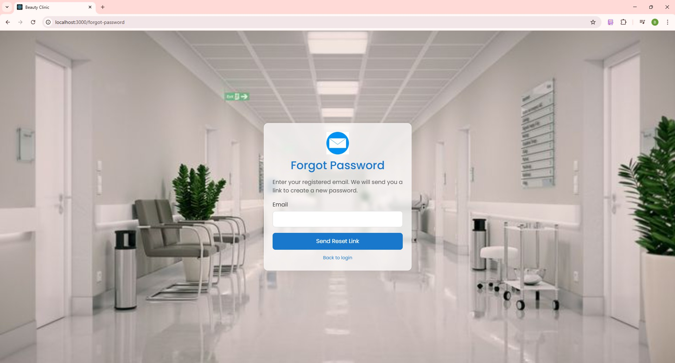Step 3: Enter your email to change the password. Step 4: Click “Send reset link”

***Figure 5. Step 4 in Forget password Patient***

Step 5: The system will send a link to change password, click “Reset Password”

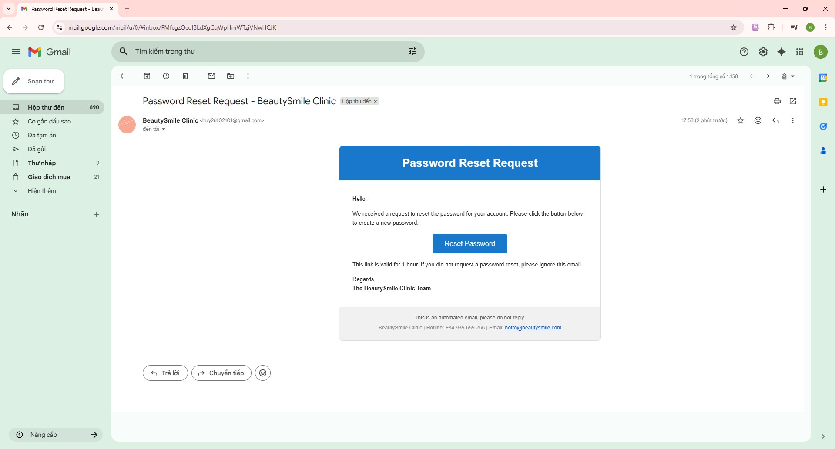

***Figure 6. Step 5 in Forget password Patient***

Step 6: Enter new password and confirm password

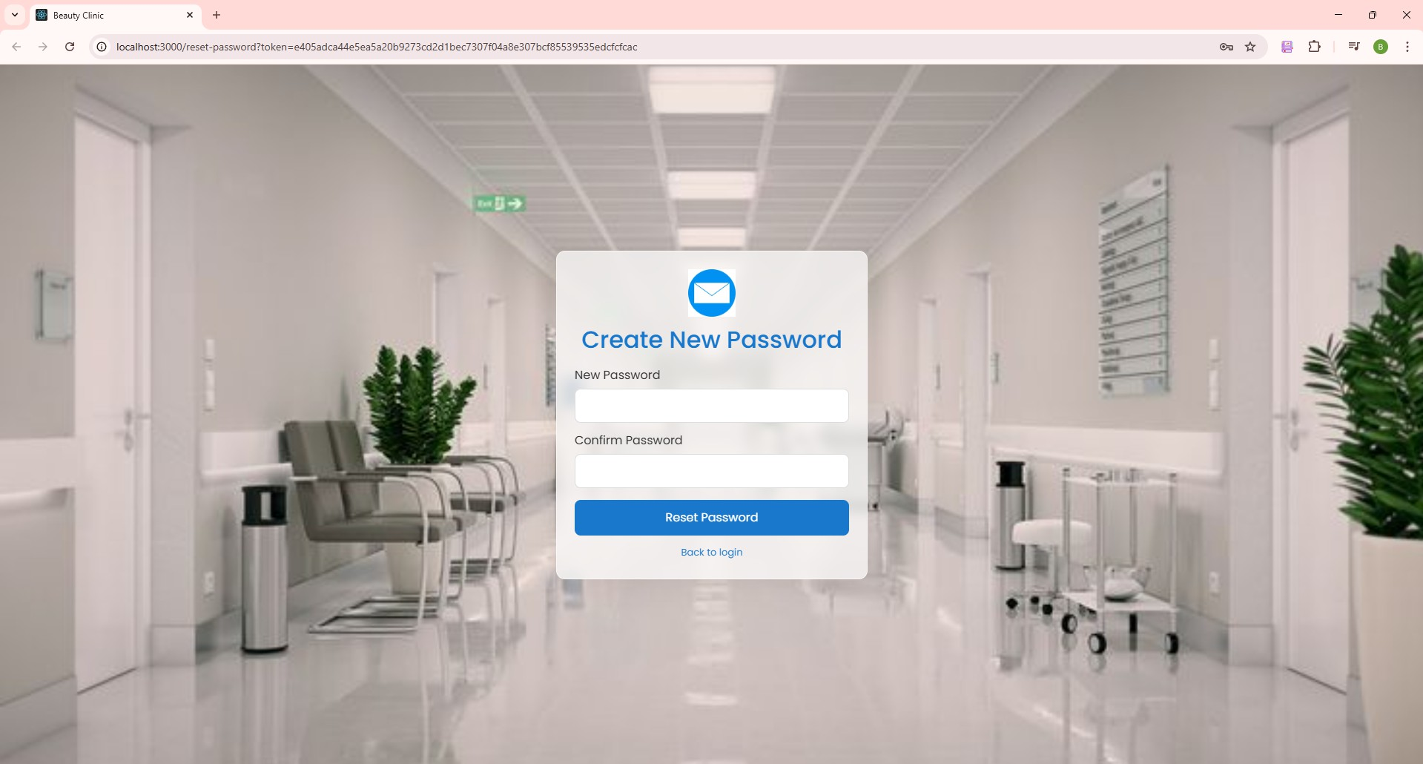

***Figure 7. Step 6 in Forget password Patient***

Step 7: Click “Reset Password” to proceed with changing the password.

#### Complete Information Personal Patient

The password change function allows users to change their password when they want to update a new password. This process includes the account must be logged into the application. After logging into the system, users can change the password on the personal information screen.

Step 1: Go to the website and navigate to the login screen. Step 2: Log in with the registered email and password

Step 3: Click the orange “Complete profile” button to input information personal



***Figure 8. Step 3 in Complete Information Personal***

Step 4: Enter your information.

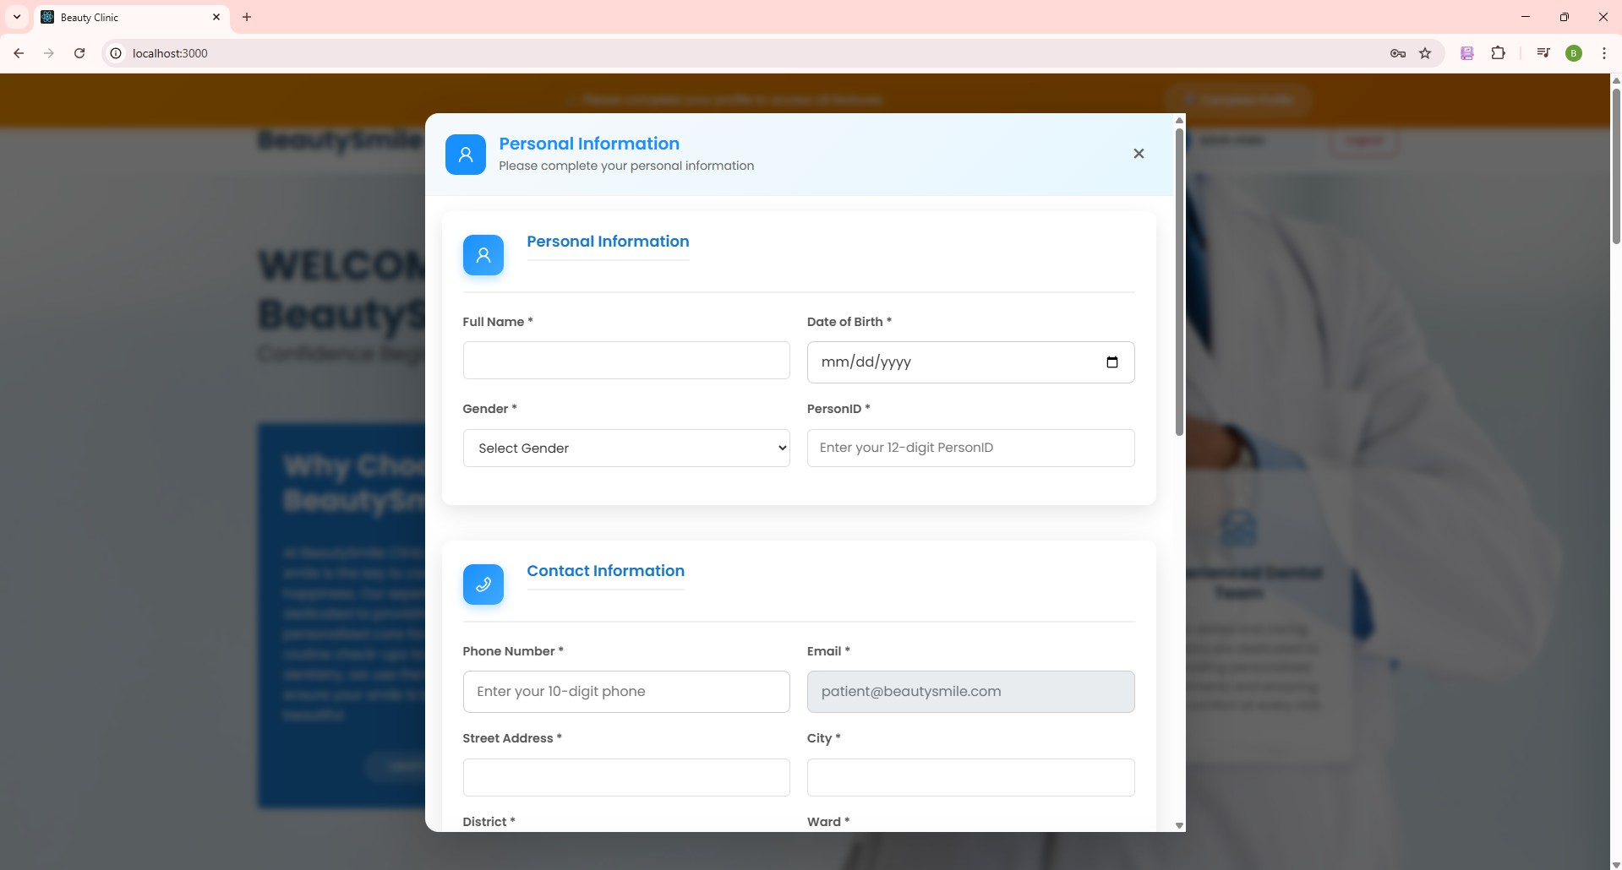

***Figure 9. Step 4 in Complete Information Personal***

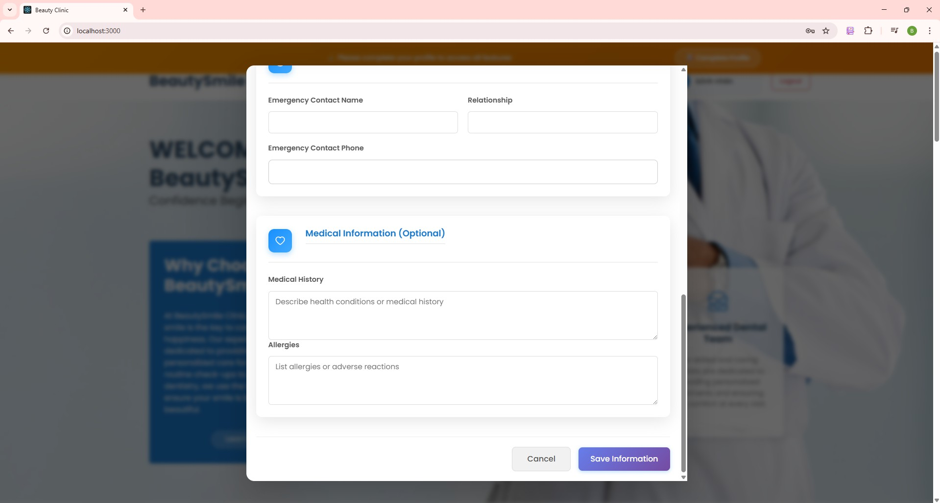

***Figure 10. Step 4 in Complete Information Personal***

Step 4: Click “Save Information” to proceed with complete personal information Step 5: Enter your avatar to see your information complete.

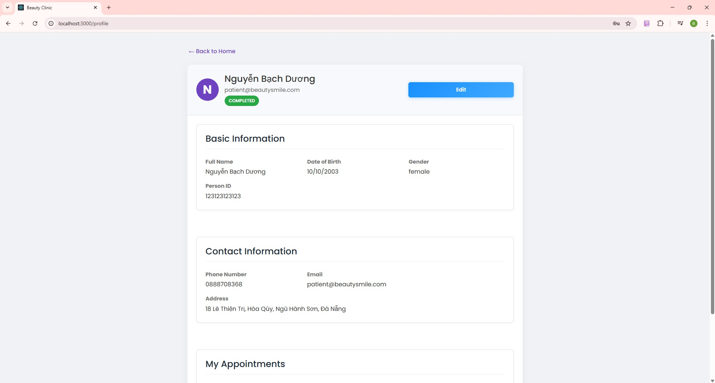

***Figure 11. Step 5 in Complete Information Personal***

Step 6: Click the blue “Edit” button if you want to edit your information. Step 7: Input the information you want to update or change.

Step 8: Click “Save information” proceed with update or change personal information

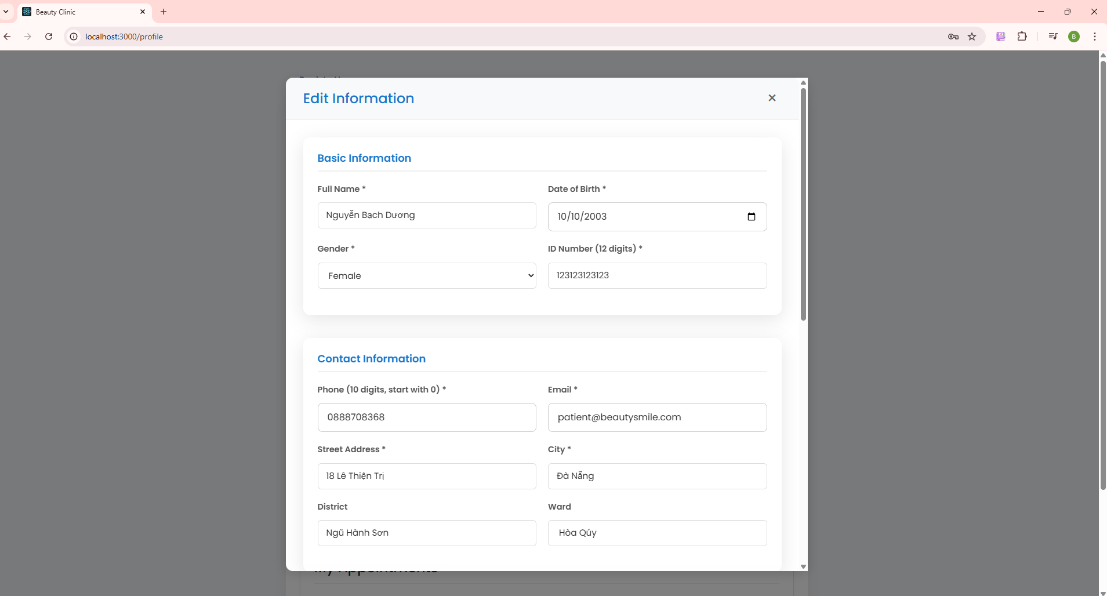

***Figure 12. Step 6 in Complete Information Personal***

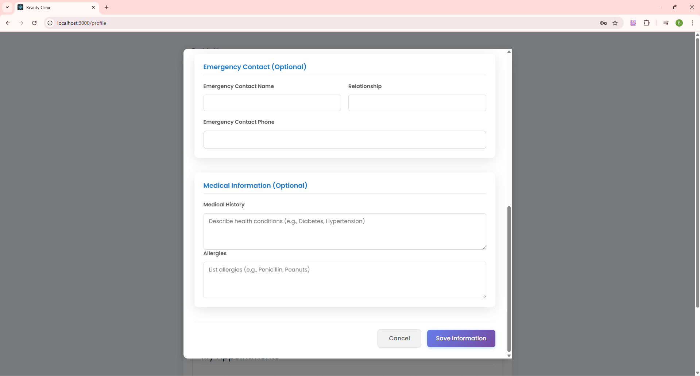

***Figure 13. Step 8 in Complete Information Personal***

#### Booking an appointment

The appointment booking feature allows the user to select the location, doctor, and time for the patient to come in for a medical examination. This feature provides flexibility with different service options like “Book a doctor”.

Steps to Book a doctor:

* + - 1. After completing your personal profile, click the blue “Make an Appointment” button.
      2. From the home screen, tap on the **"Select Location"** dropdown.

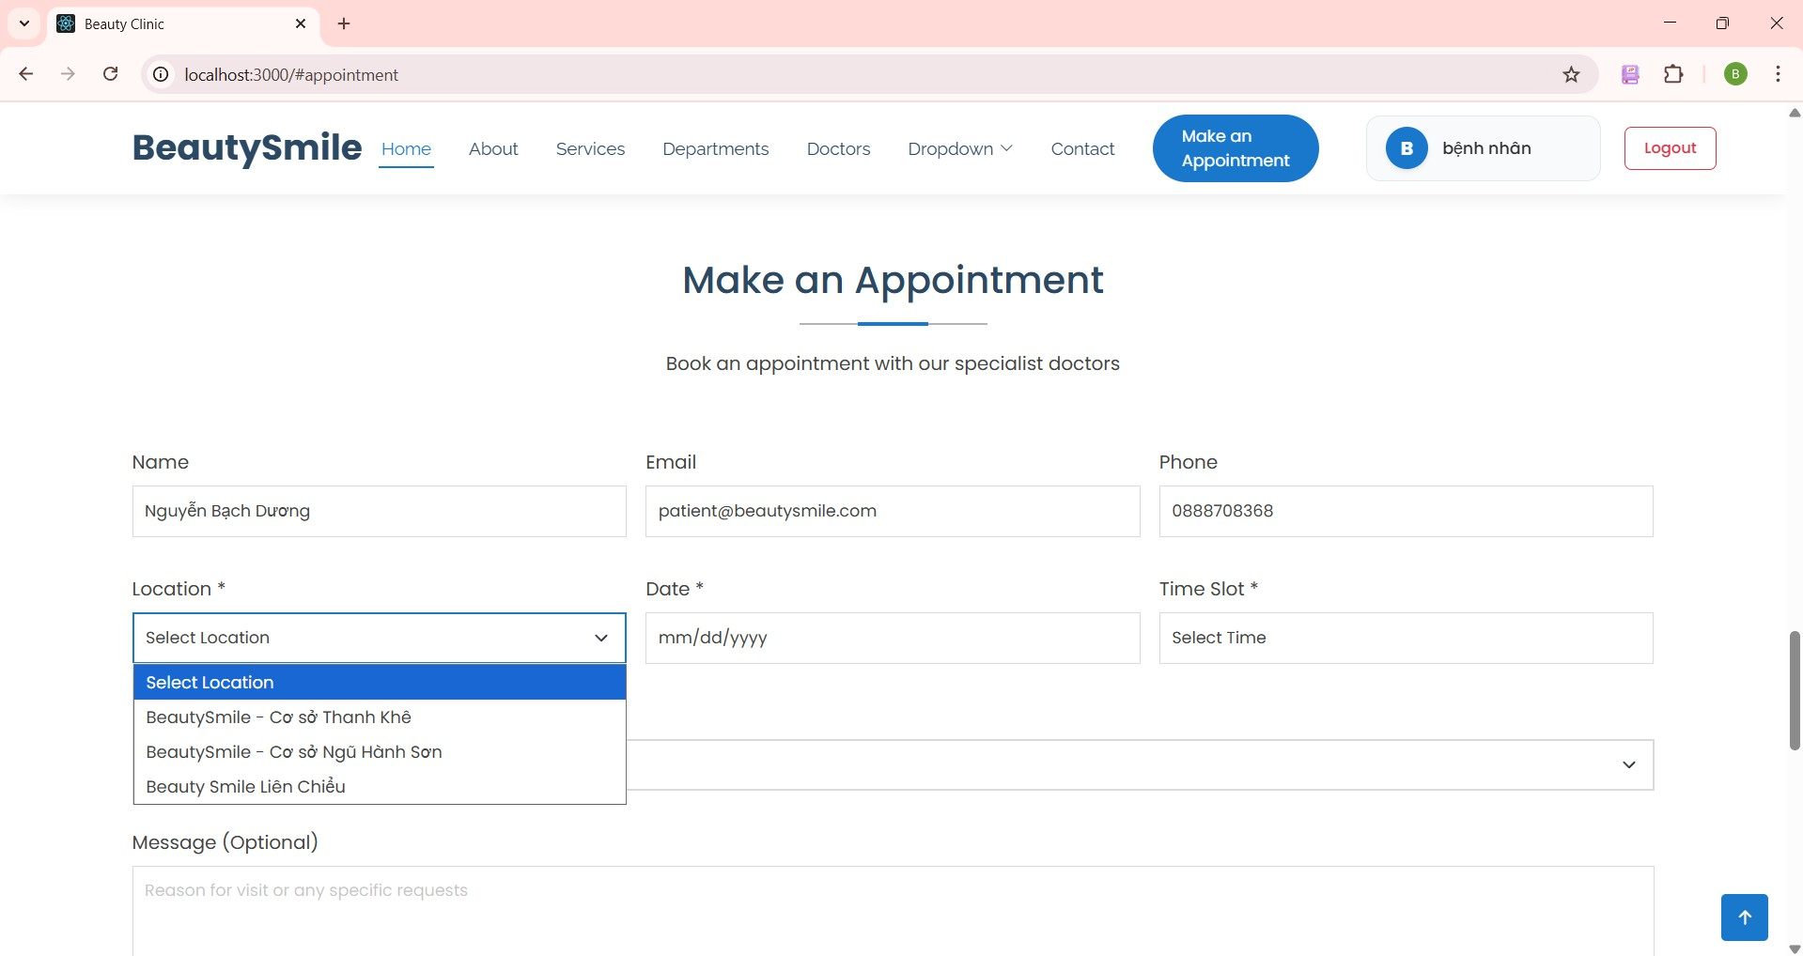

***Figure 14. Step 2 in Booking an appointment***

* + - 1. Tap on the “mm/dd/yyyy” calendar to select date, month you want to book an appointment

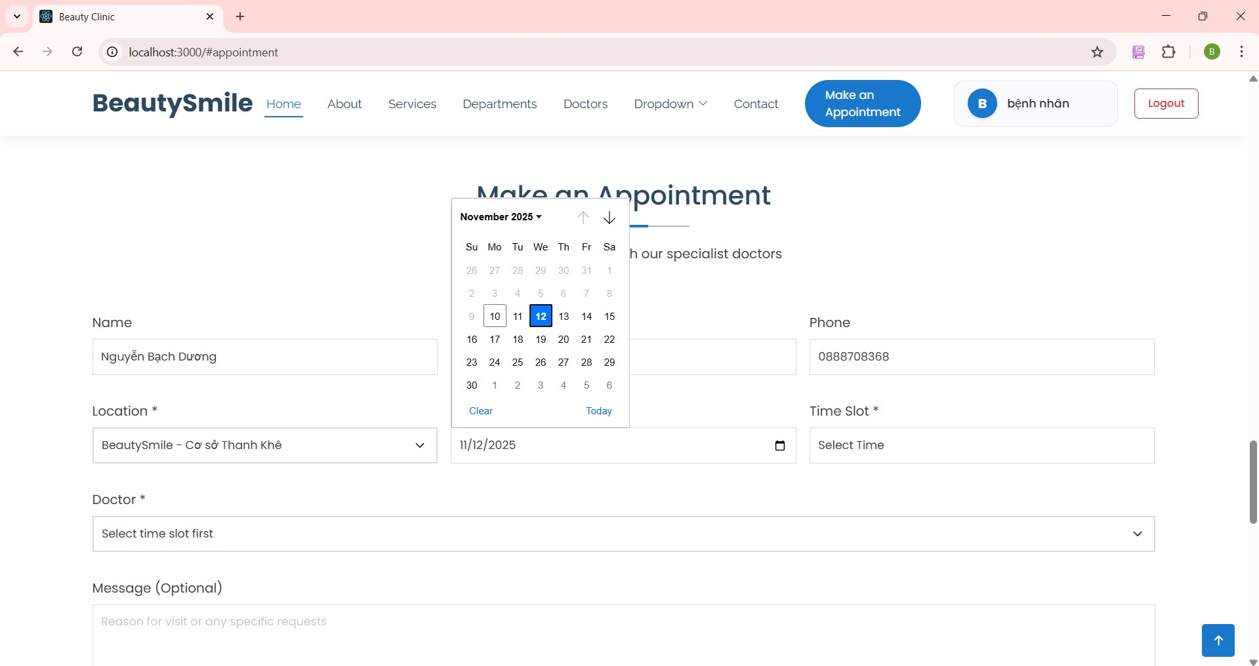

***Figure 15. Step 3 in Booking an appointment***

* + - 1. Tap on the “Time Slot” dropdown to choose time.
         * Case 1: If the location has no free slot, the slot will not be displayed for the patient to book.
         * Case 2: If the location has a free schedule, the schedule will be displayed for the patient to book

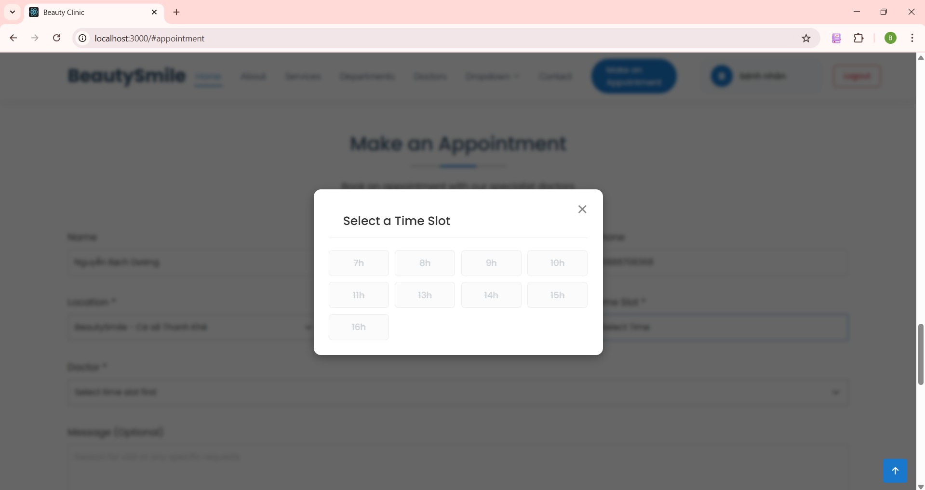

***Figure 16. Step 4 in Booking an appointment***

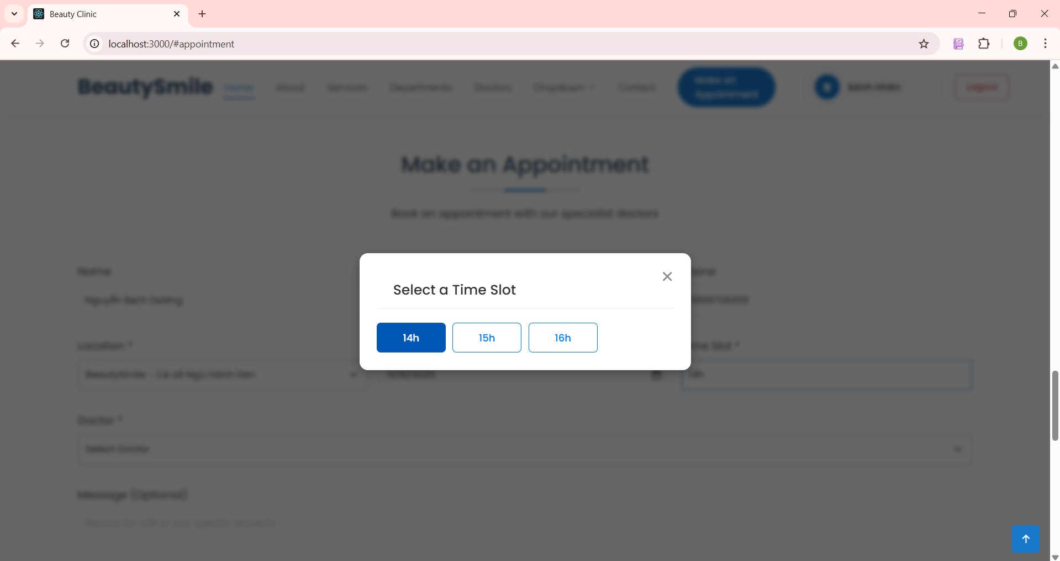

***Figure 17. Step 4 in Booking an appointment***

* + - 1. Tap on the “Select Doctor” dropdown to choose a doctor.

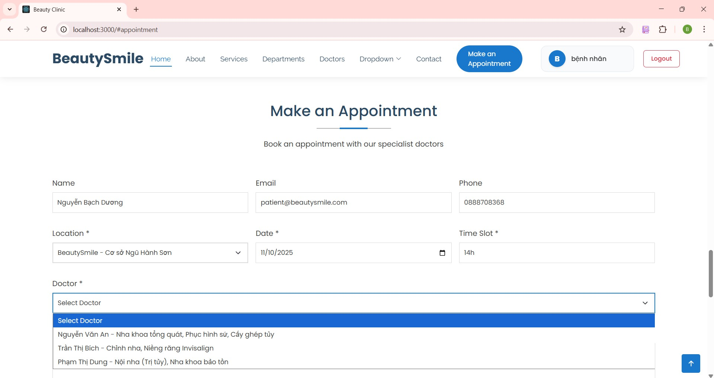

***Figure 18. Step 5 in Booking an appointment***

* + - 1. Add any message for the doctor in the provided field.
      2. Tap on the “Proceed to payment” button to complete the booking appointment.

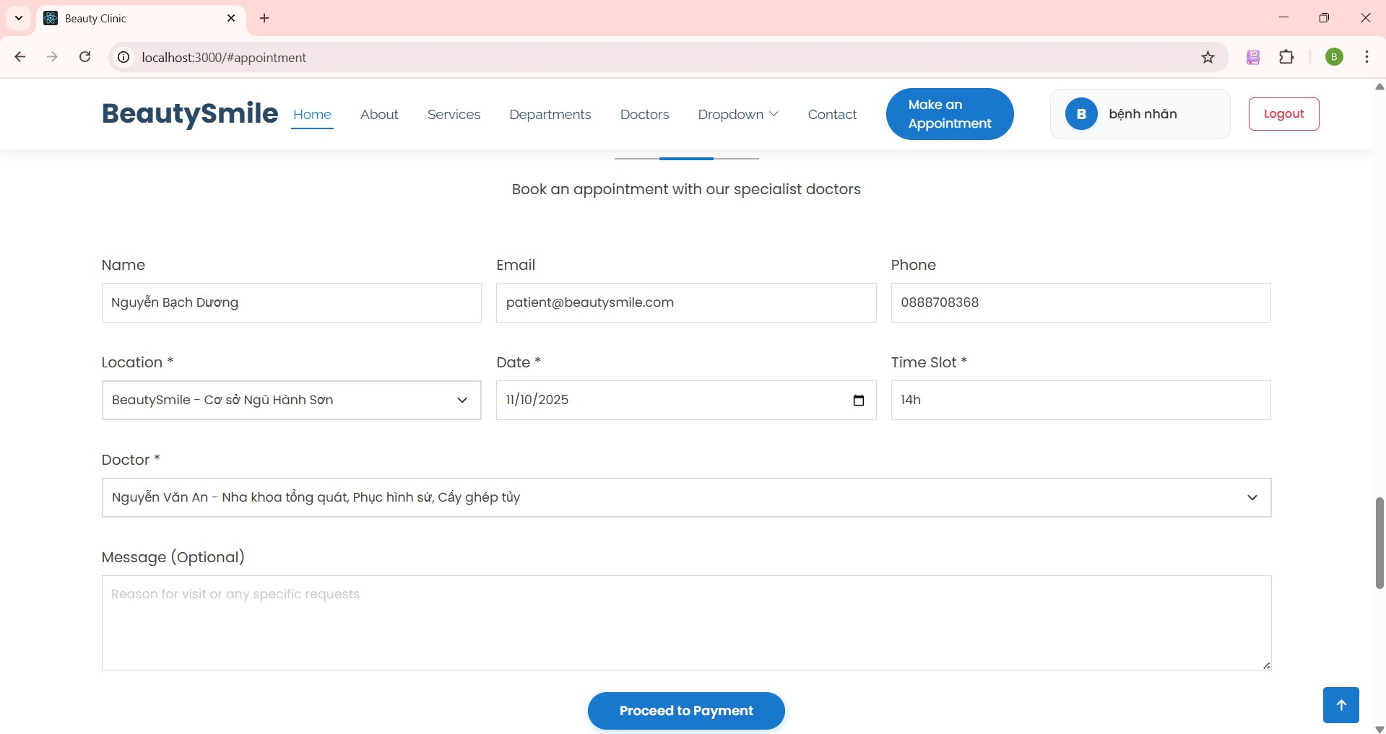

***Figure 19. Step 6 & 7 in Booking an appointment***

#### Clinic appointment payment

After booking an appointment and clicking the blue “Proceed to payment”, you must pay a deposit to book an appointment with the clinic.

Steps to pay a deposit:

* + - 1. Input your card information.

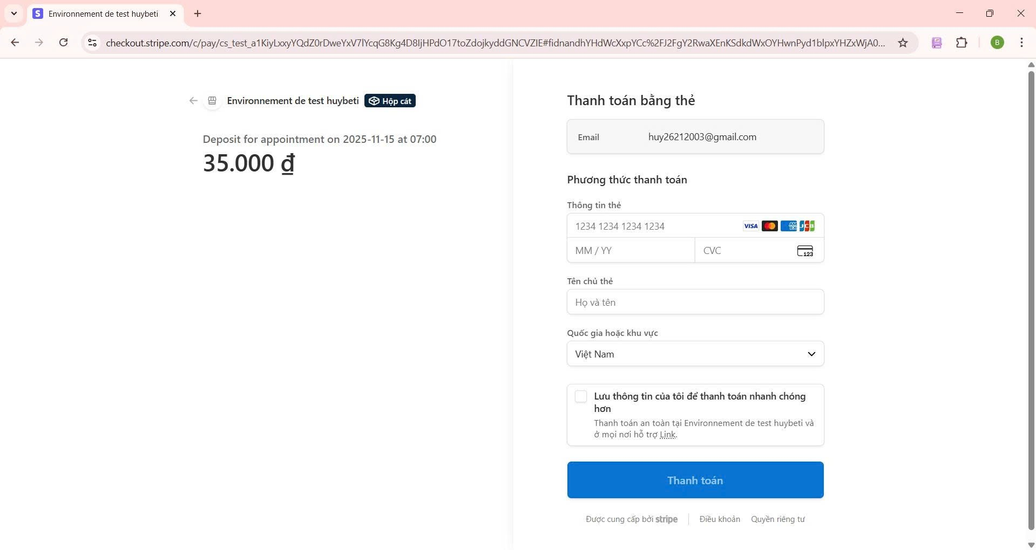

***Figure 20. Step 1 in Clinic appointment payment***

* + - 1. Click the blue button “Thanh toán” for payment success.

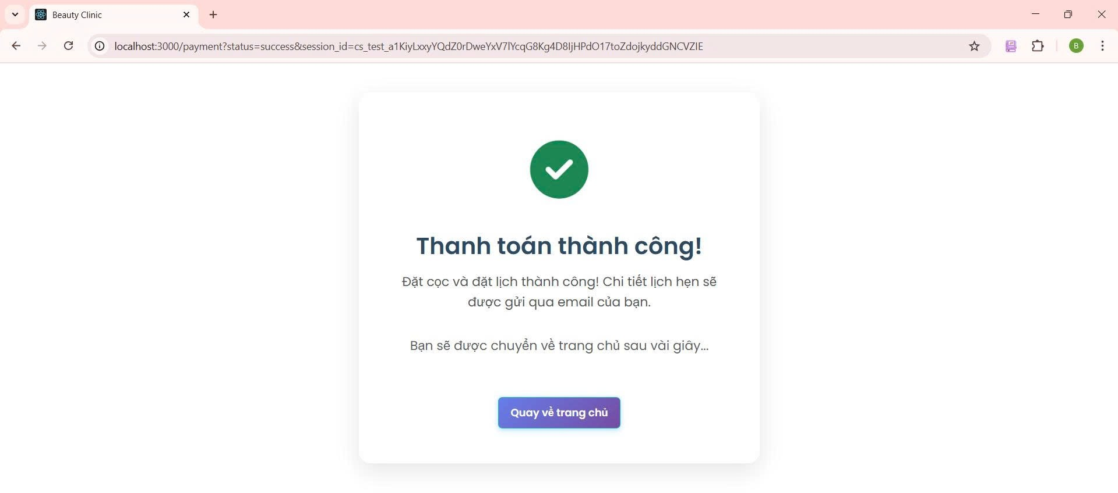

***Figure 21. Step 2 choose “******Danh sách yêu cầu” service***

#### Postpone an appointment

The appointment change function allows users to change appointments by location, day, slot, doctor. Steps to postpone an appointment:

* + - 1. From the Profile screen, tap on the **"Reschedule"** button.
      2. Click “Confirm reschedule”

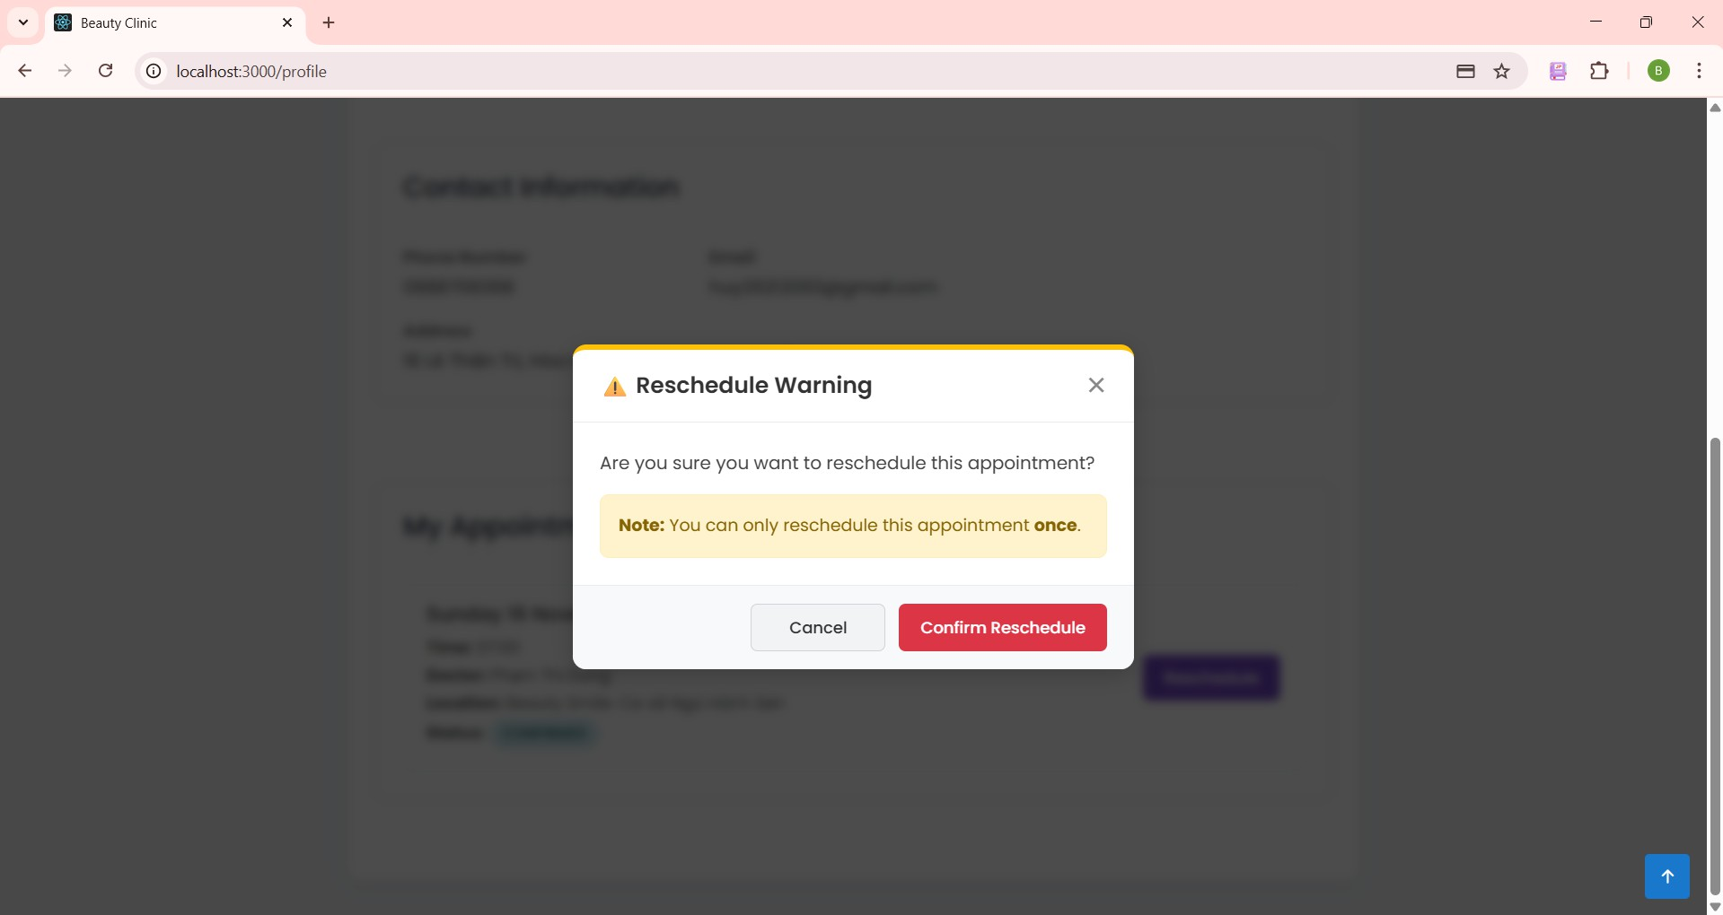

***Figure 22. Step 2 in Postpone an appointment***

* + - 1. Choose the location you want to change.

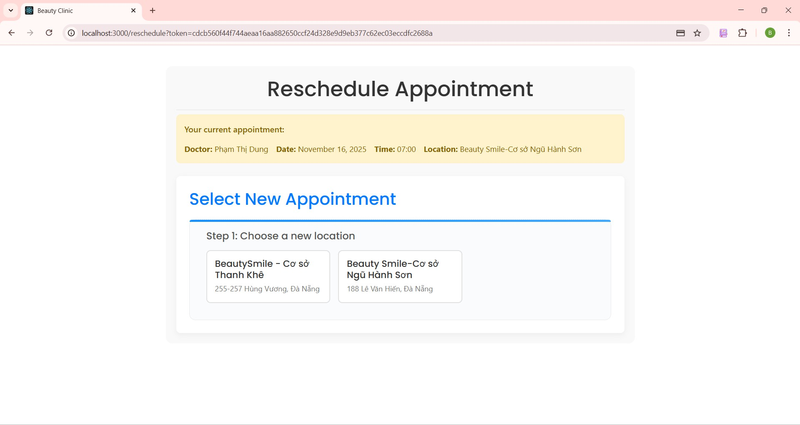

***Figure 23. Step 3 in Postpone an appointment***

* + - 1. Choose the date you want to change.

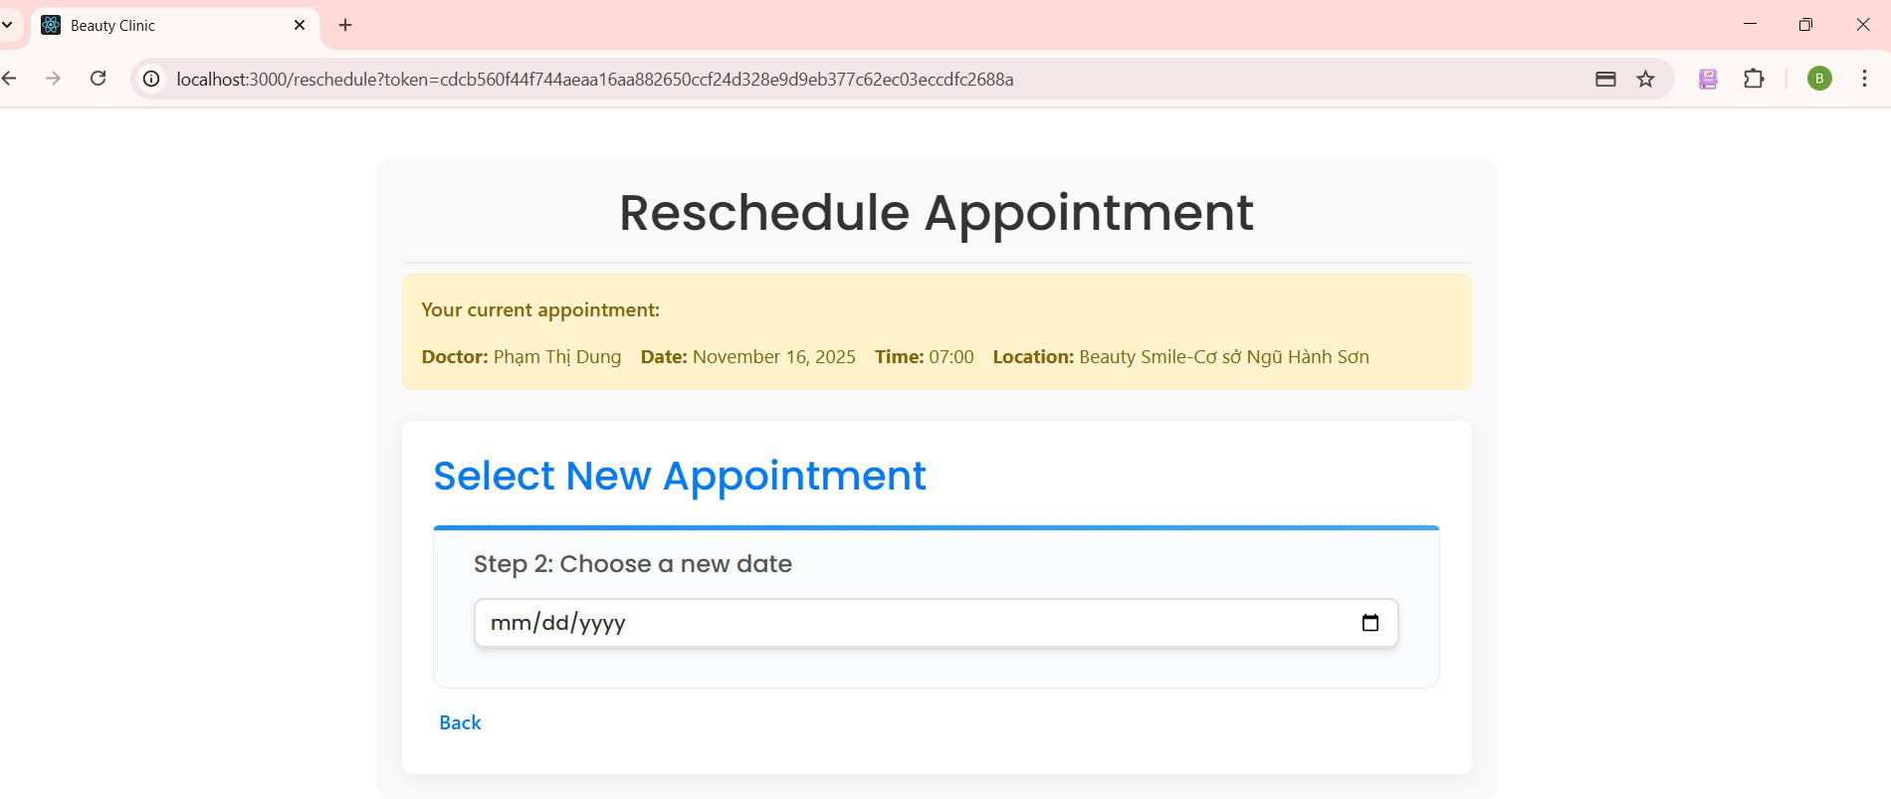

***Figure 24. Step 4 in Po******stpone an appointment***

* + - 1. Choose a new time you want to change.

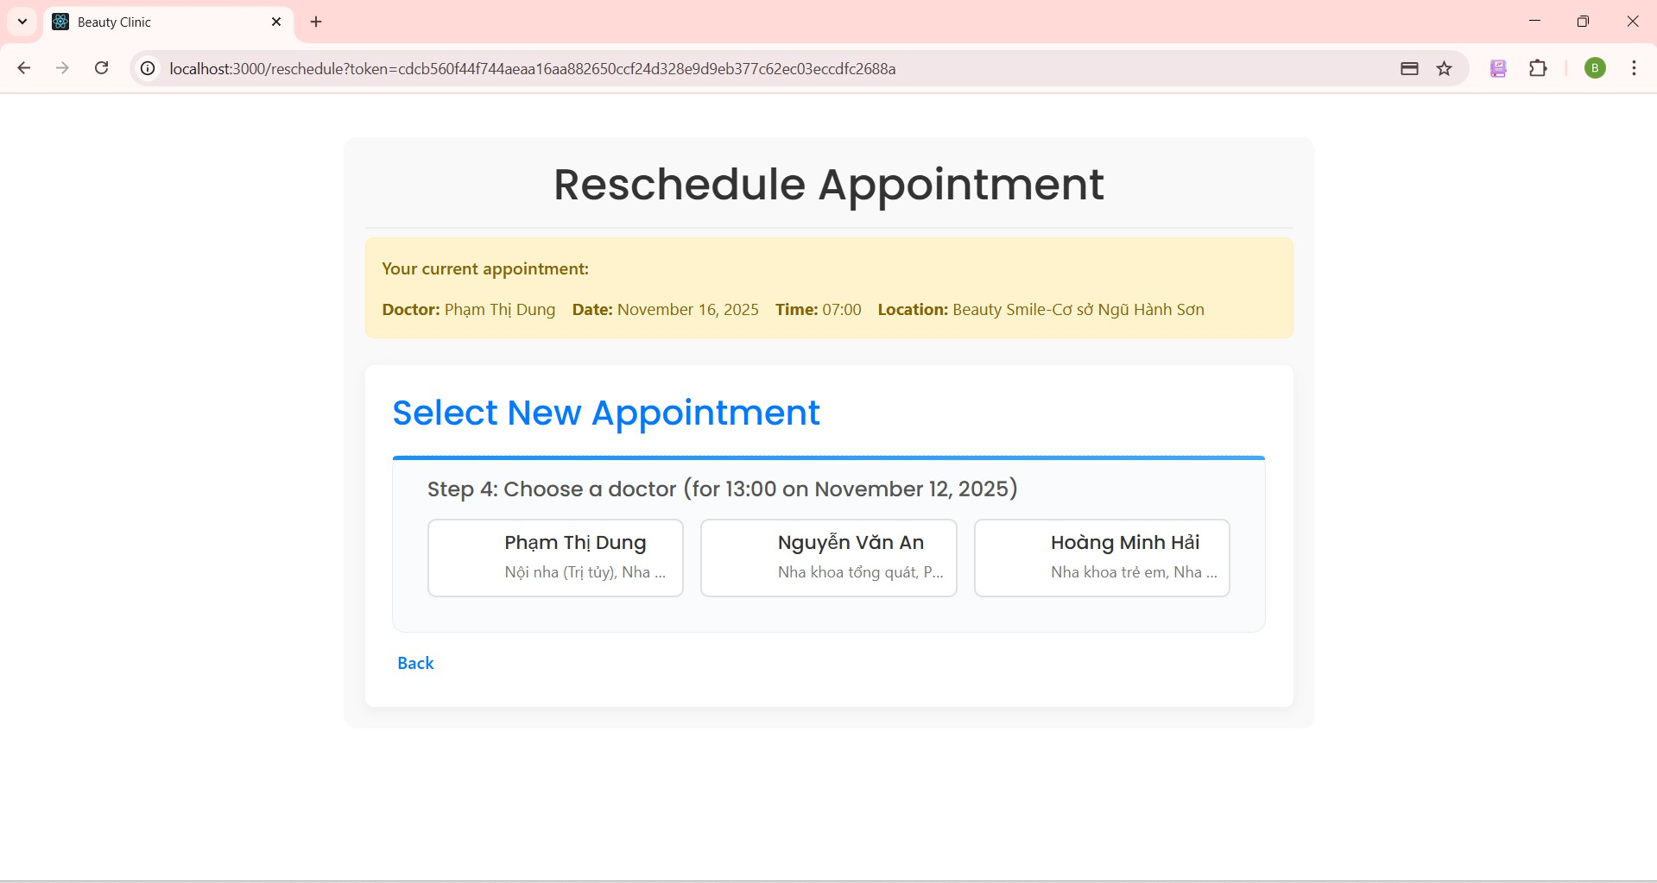

***Figure 25. Step 5 in Postpone an appointment***

* + - 1. Choose a doctor you want to change and click the blue “Confirm Selection” button to make reschedule successful.

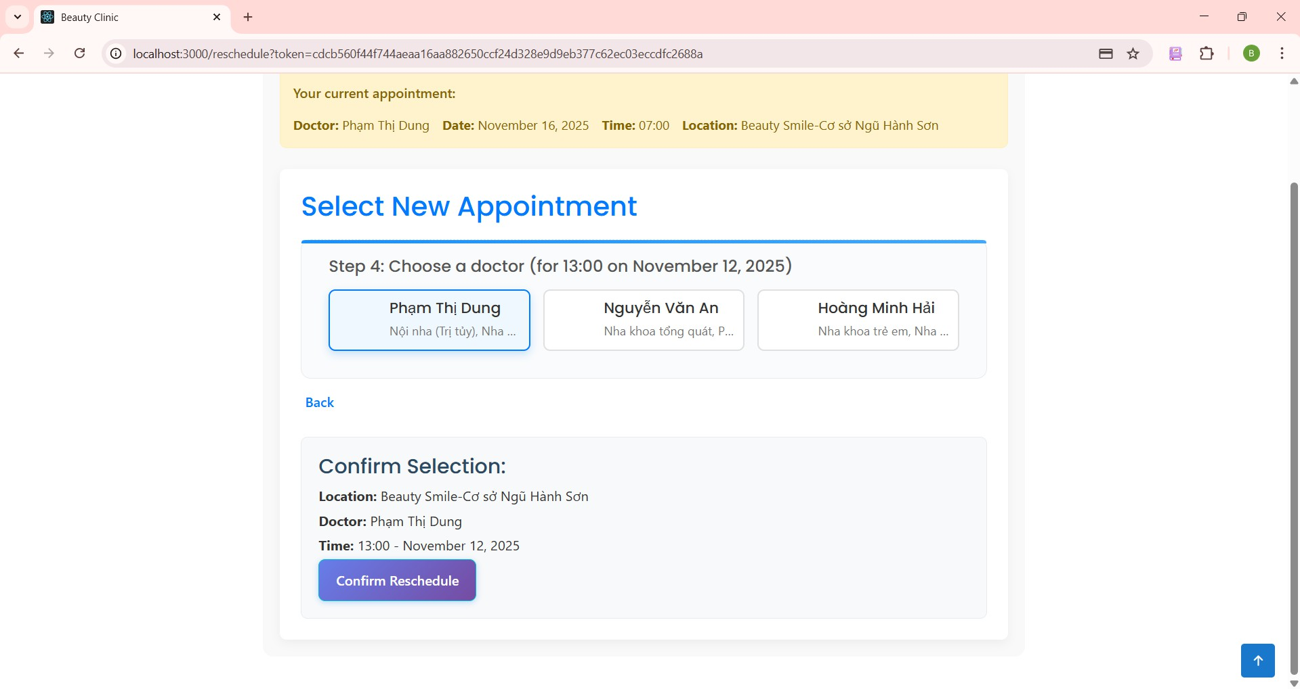

***Figure 26. Step 6 in Postpone an appointment***

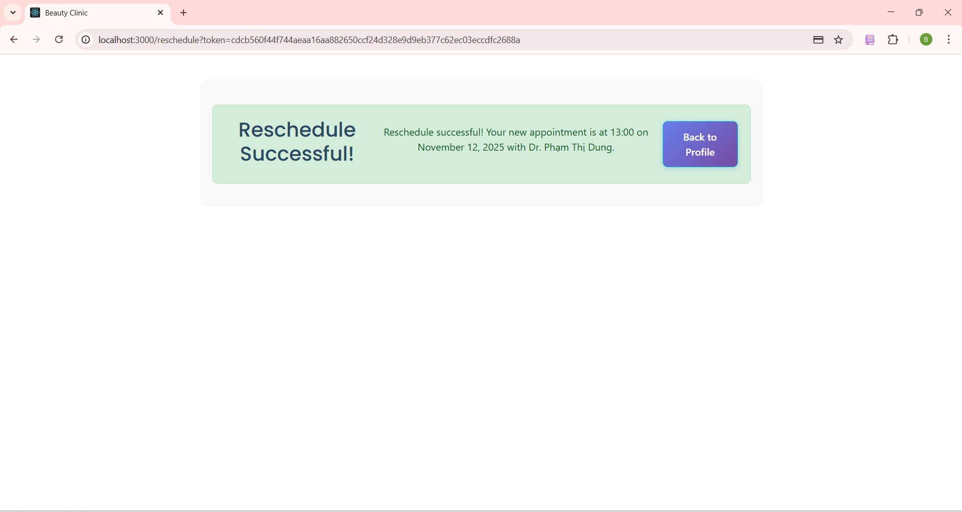

***Figure 27. Step 6 in Postpone an appointment***

* + - 1. Click the blue “Back to profile” to go to the profile screen.

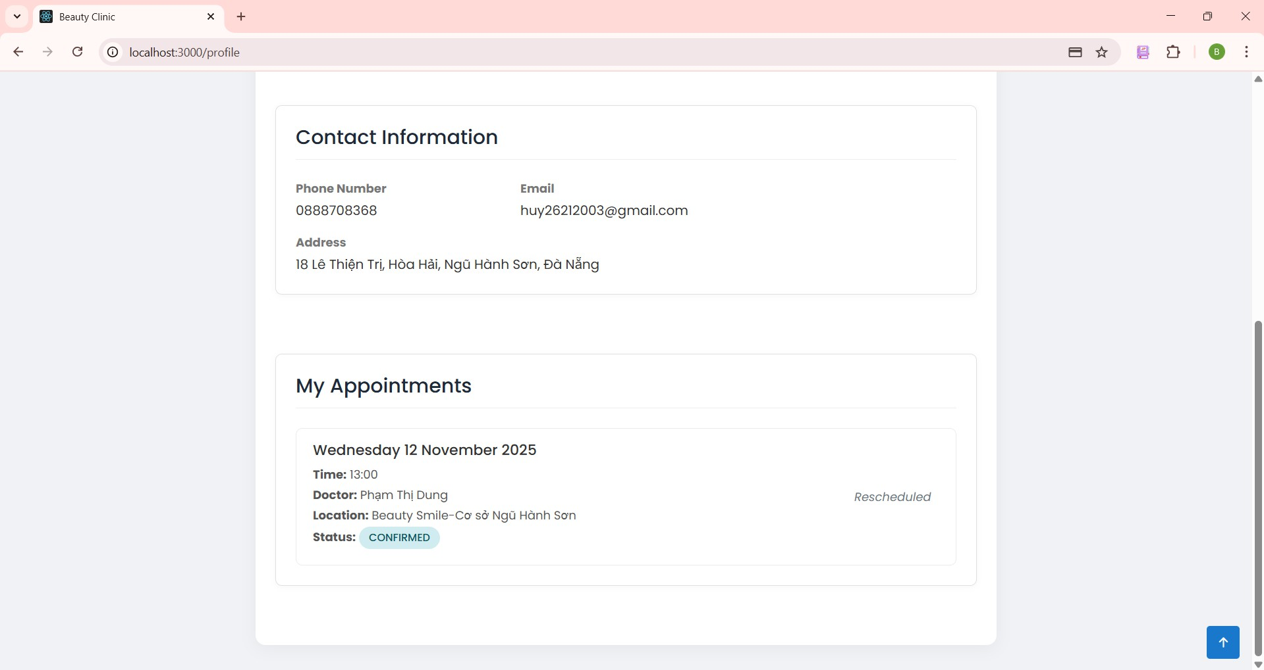

***Figure 28. Step 7 in Postpone an appointment***

#### View service (for patient)

The view service information function allows patients to get all the detailed information of service. Steps to get service information and get all the detailed information of service:

* + - 1. From the Home screen, tap on the **"Service"** navbar.

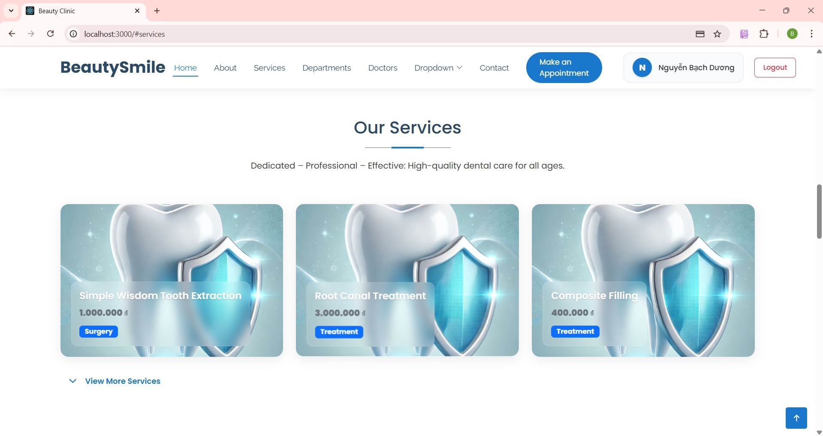

***Figure 29. Step 1 in View service***

* + - 1. From the Service Selection screen, tap on the service you want to see detail.

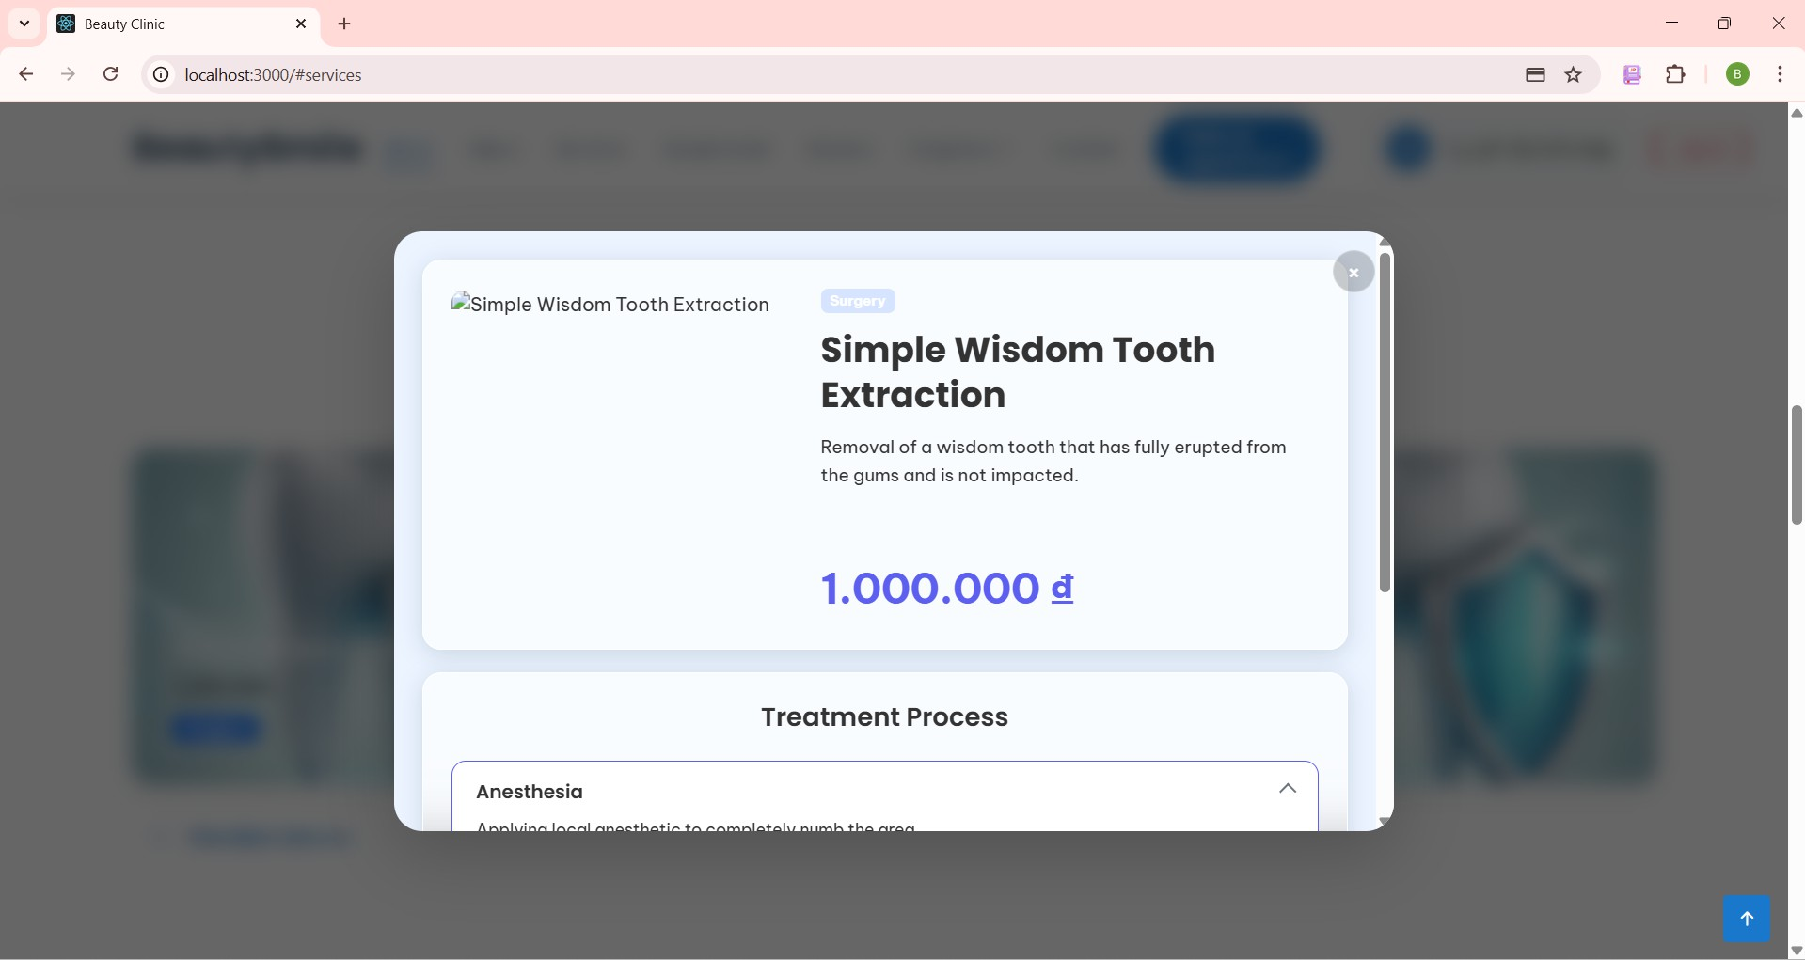

***Figure 30. Step 2 in View service***

* + - 1. From the service detail screen, click “Treatment process” dropdown to see detailed steps.

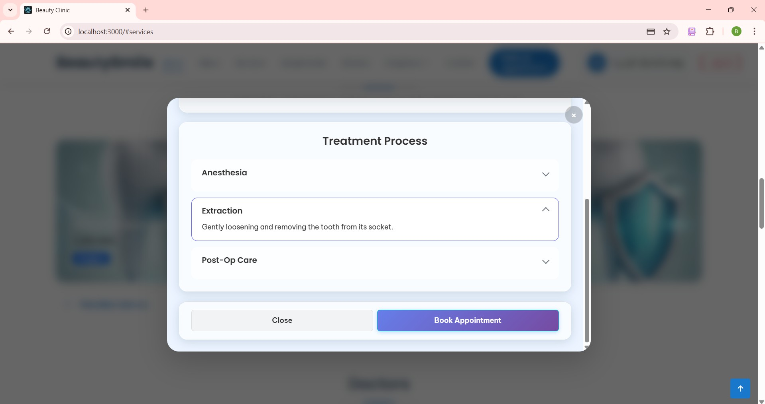

***Figure 31. Step 3 in View service***

#### Create account users (for admin)

The create account users function allows admin to create accounts according to roles such as doctors, staff, and managers.

Steps to create account:

* + - 1. Login with role admin. In the Home screen, click the “User” button in the navbar.

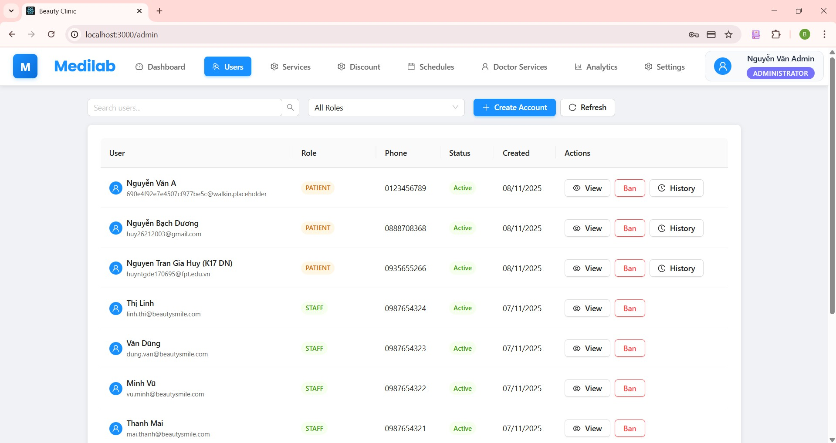

***Figure 32. Step 1 in Create account user***

* + - 1. Click the blue “Create Account” to create account employees. Input employees information, click the “Create account” to success.

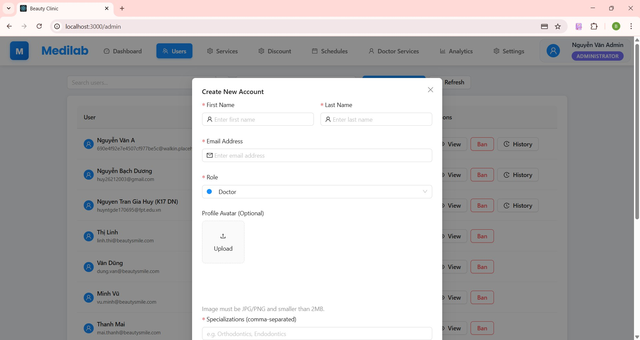

***Figure 33. Step 2 in Create account user***

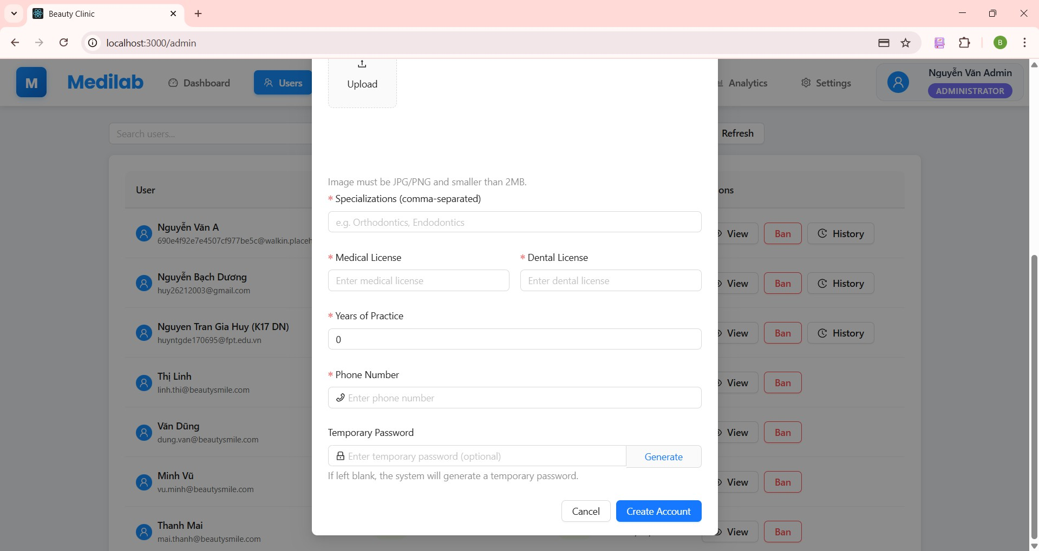

***Figure 34. Step 2 in Create account user***

* + - 1. After creating account success, a result successfully shows on the screen.

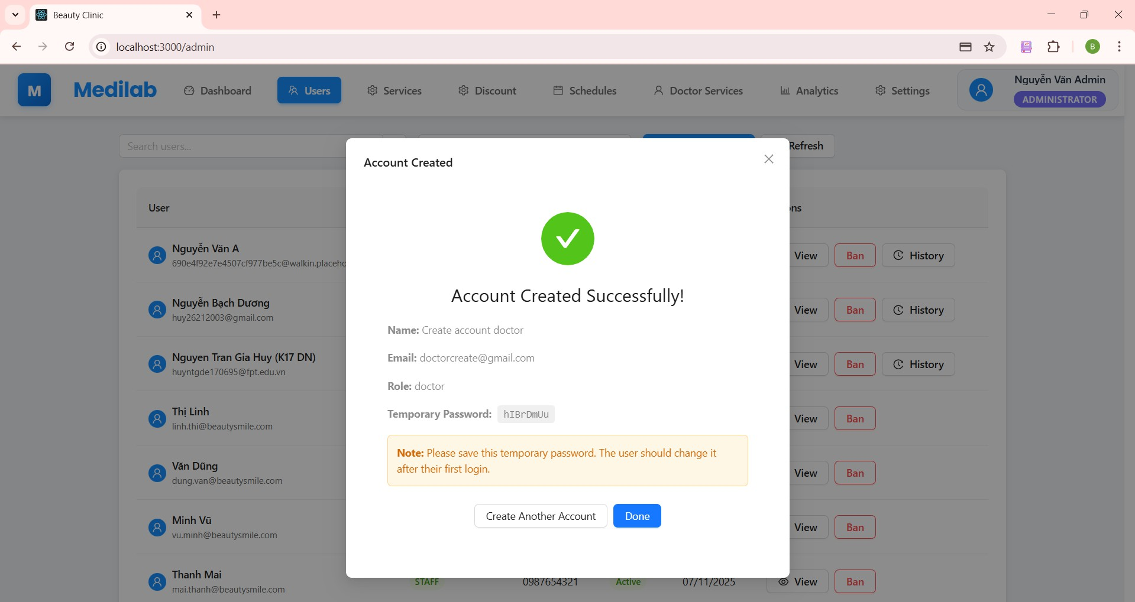

***Figure 35. Step 3 in Create account user***

#### Ban employees account (for admin)

The ban employees function allows the admin to ban the account. Steps to ban an account:

* + - 1. From the User screen, admin clicks the “Ban” button to ban an account in roles of doctors, staff, managers, and patients.

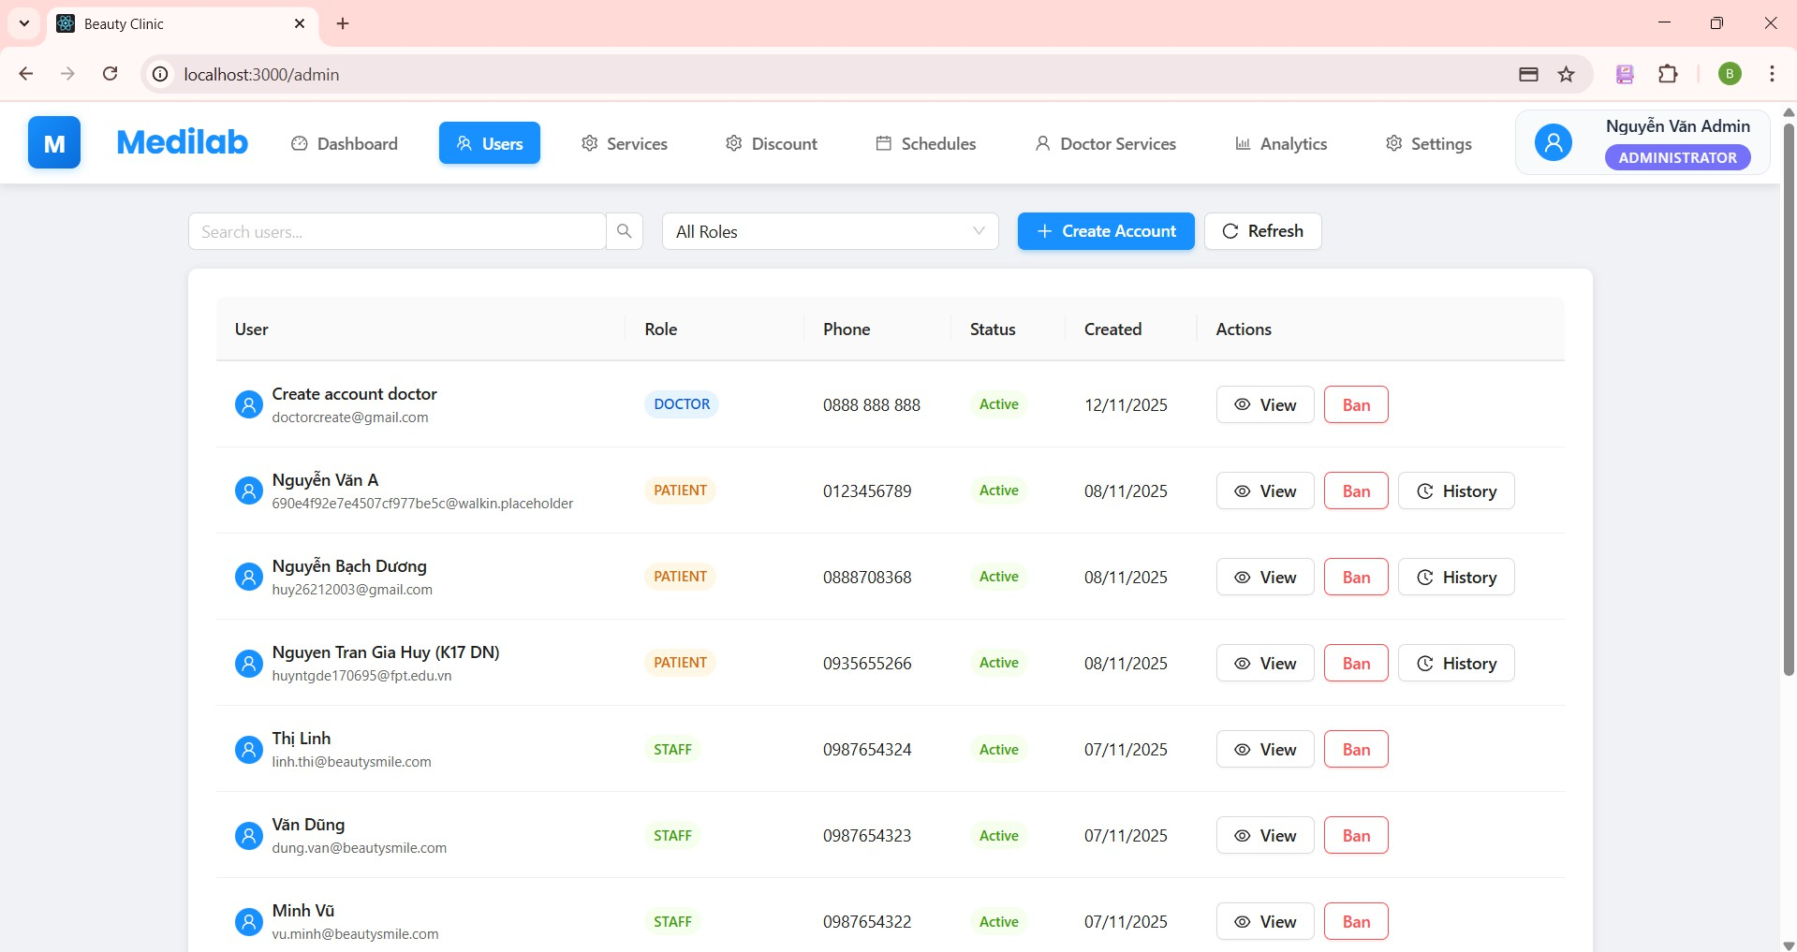

***Figure 36. Step 1 in the Ban employees account.***

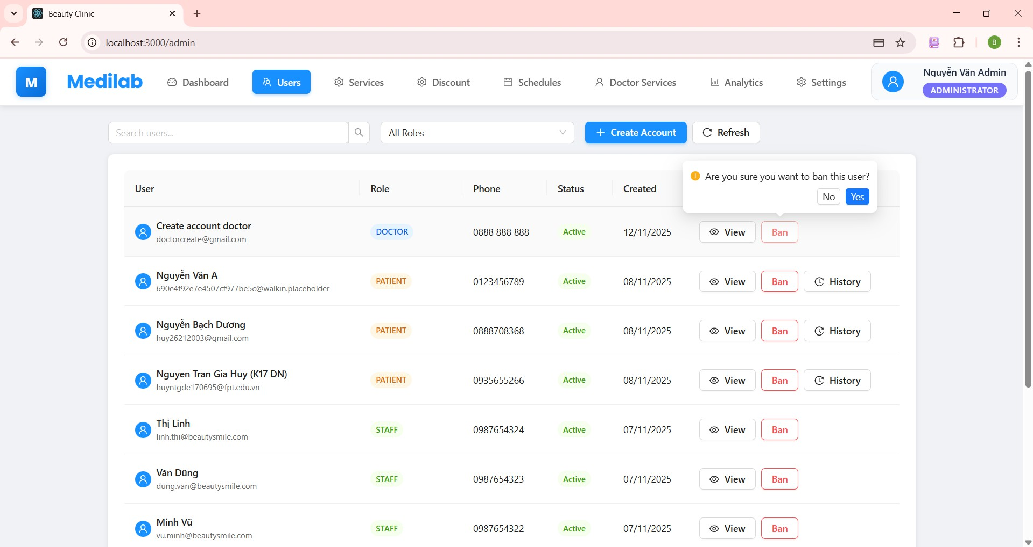

***Figure 37. Step 1 in the Ban employees account.***

Step 2: Click “No” if the admin doesn’t want to ban. Click “Yes” If the admin wants, the status “Active” changes to “Inactive”.

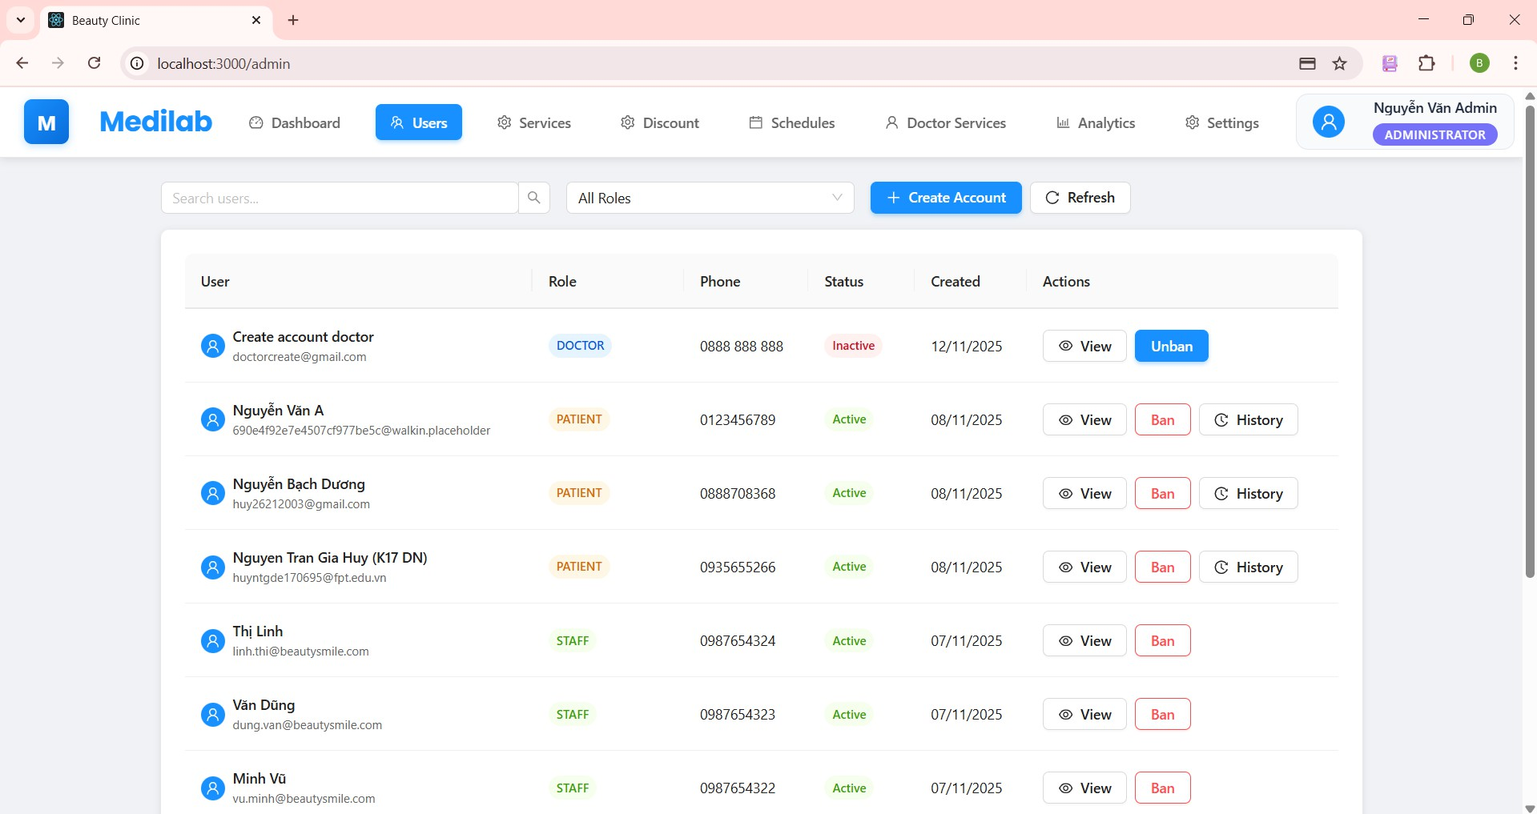

***Figure 38. Step 2 in the Ban employees account.***

#### View user account details (for admin)

The view user account details function allows admin to view detailed information of user accounts. Steps to view user account details:

Step 1: From the User screen, admin clicks the “View” button to get all account details in roles of doctors, staff, managers, and patients.

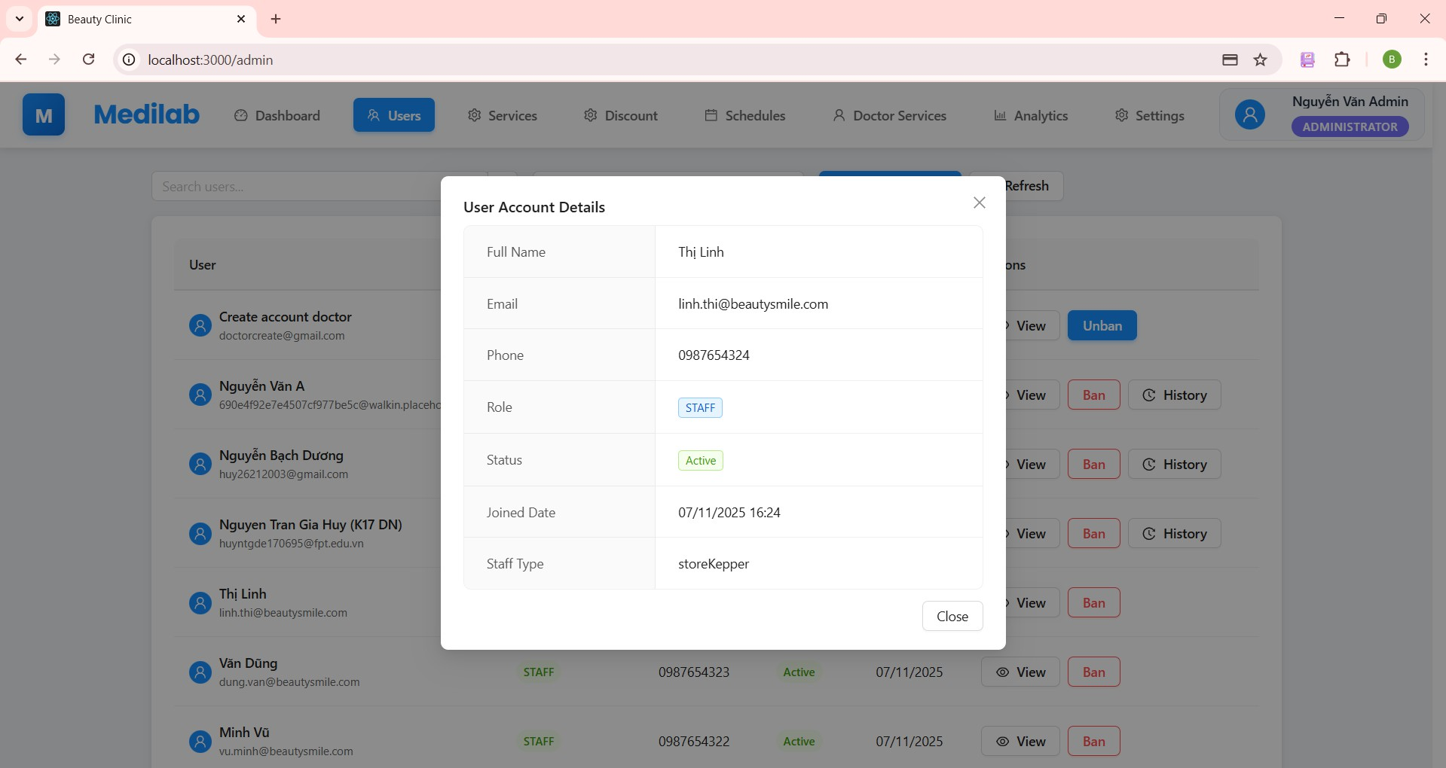

***Figure 39. Step 1 in View user account details***

#### View medical history (for admin)

The View Medical History function allows administrators to view a patient's medical history. Steps to View Medical History:

* + - 1. From the User screen, tap on the **"History"** icon.

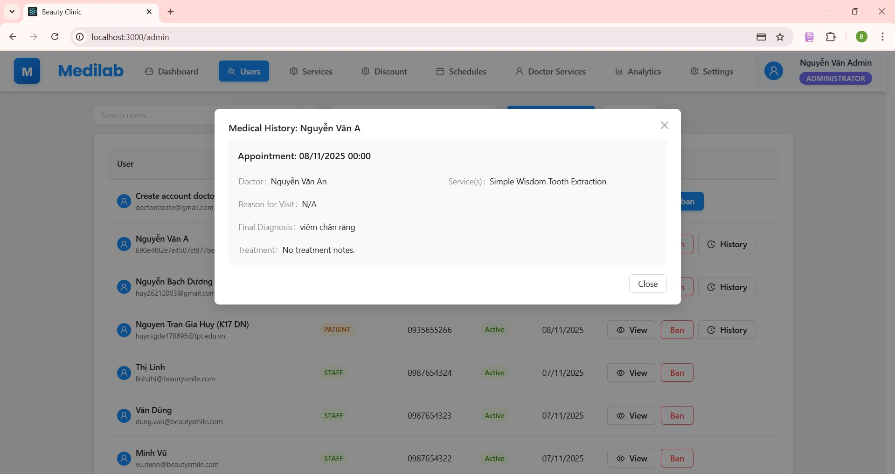

***Figure 40. Step 1 in View medical history***

#### View service details (for admin)

* + - 1. From the Home screen, tap on the **"Services"** navbar.

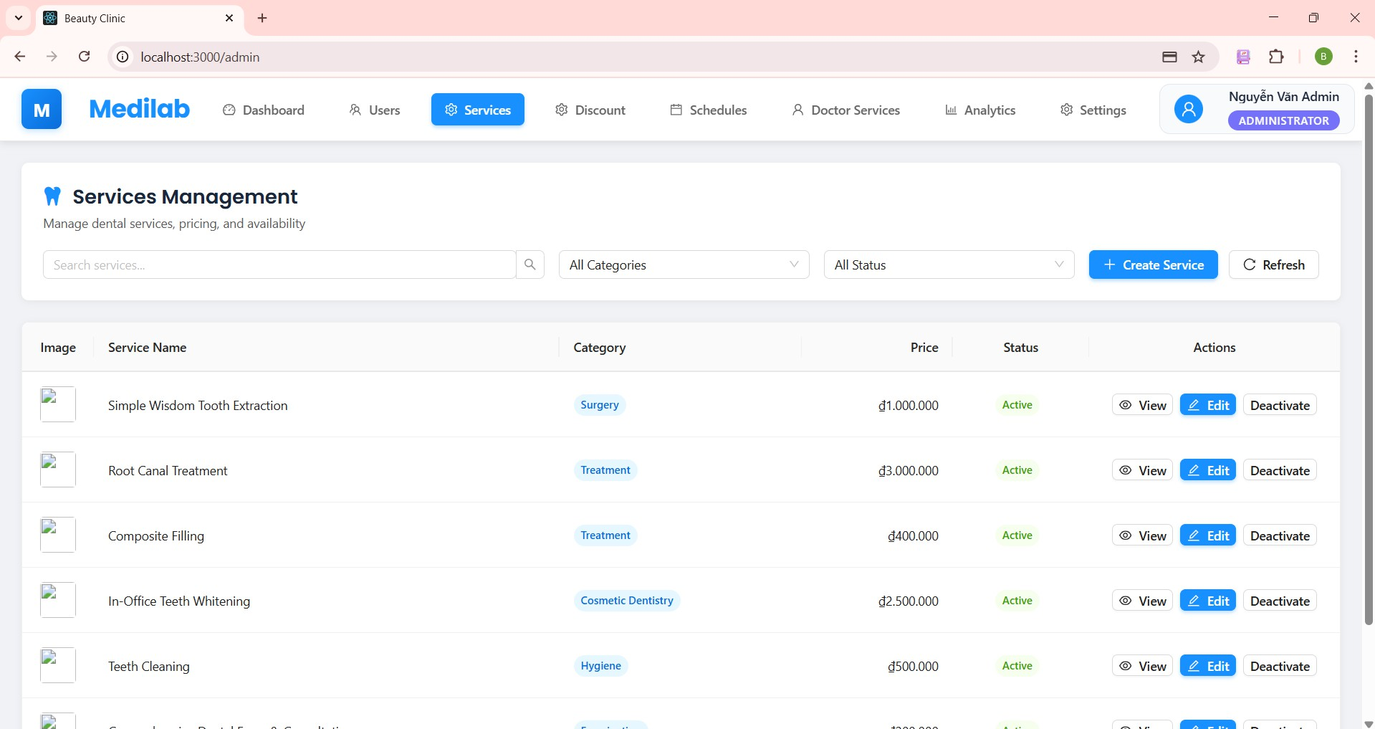

***Figure 41. Step 1 in View service detail.***

* + - 1. From the Service screen, tap on the **"View"** icon.

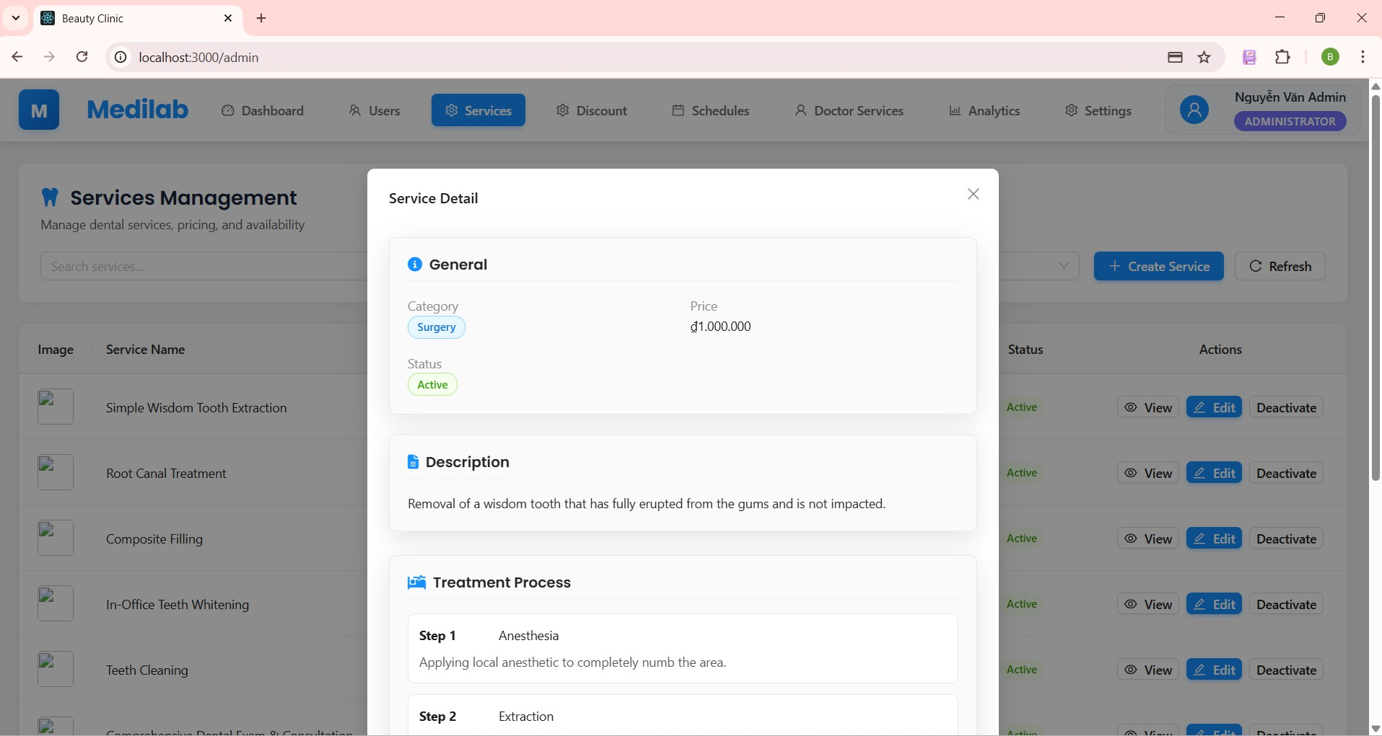

***Figure 42. Step 1 in View service detail.***

#### Update Service (for admin)

* + - 1. From the Service screen, tap on the **"Edit"** icon.
      2. Input information admin wants to update service.
      3. Click “Update service” to update success.

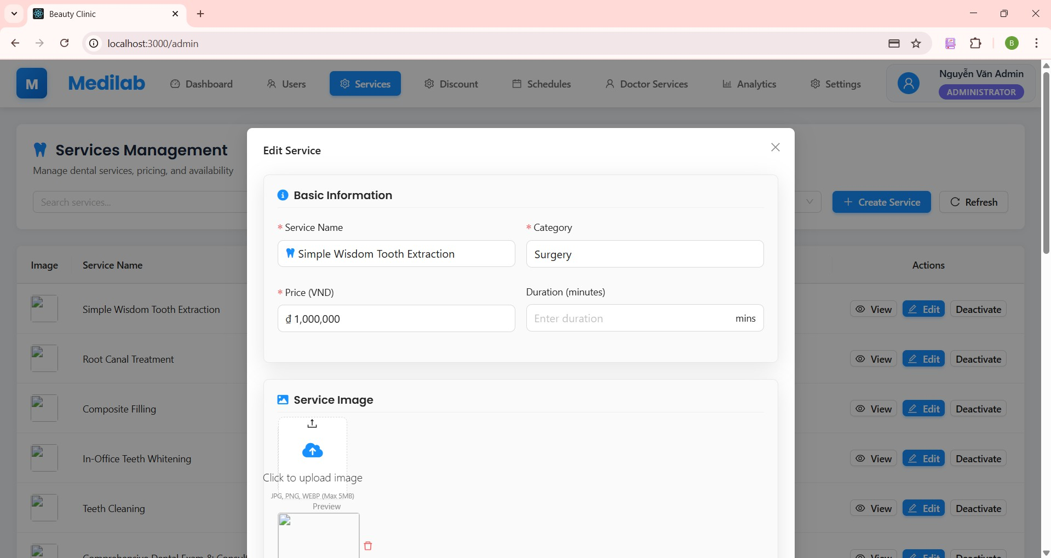

***Figure 43. Step 2 in Update service.***

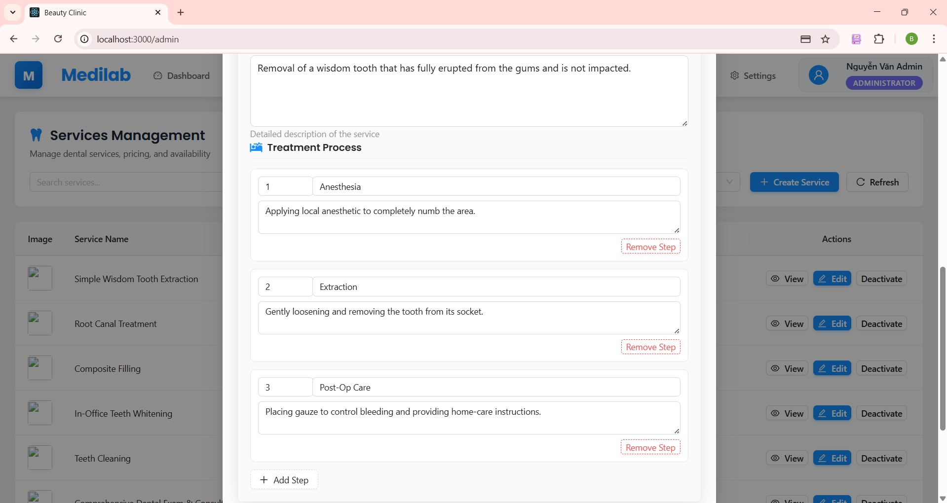

***Figure 44. Step 2 in Update service.***

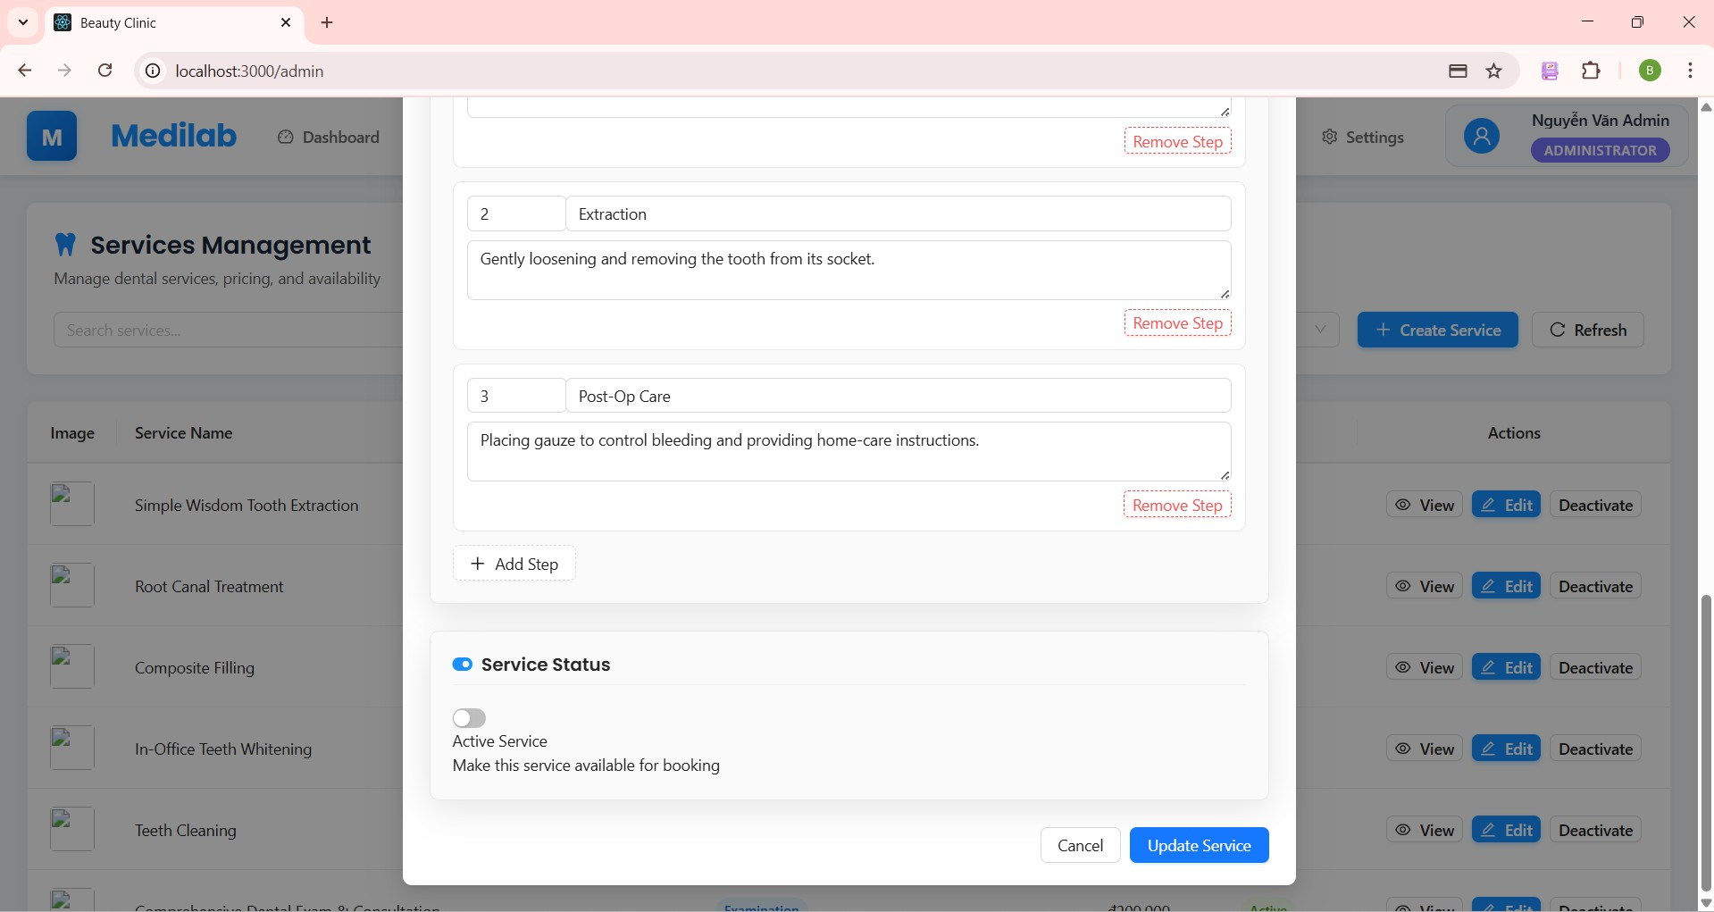

***Figure 45. Step 2 in Update service.***

#### Deactivate Service (for admin)

* + - 1. From the Service screen, tap on the **"Deactivate"** icon.
      2. If the admin wants to deactivate, choose yes and the status will change to “Inactive” else choose no.

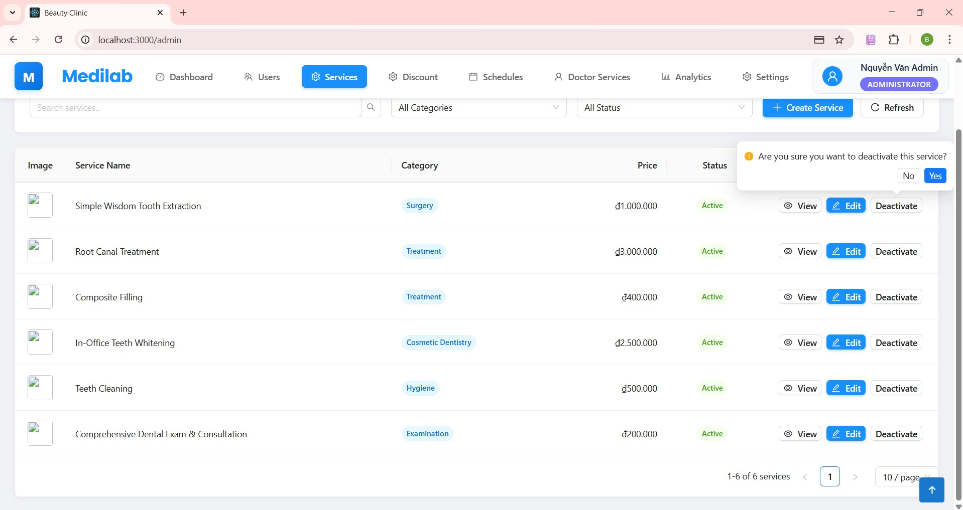

***Figure 46. Step 2 in Deactivate service.***

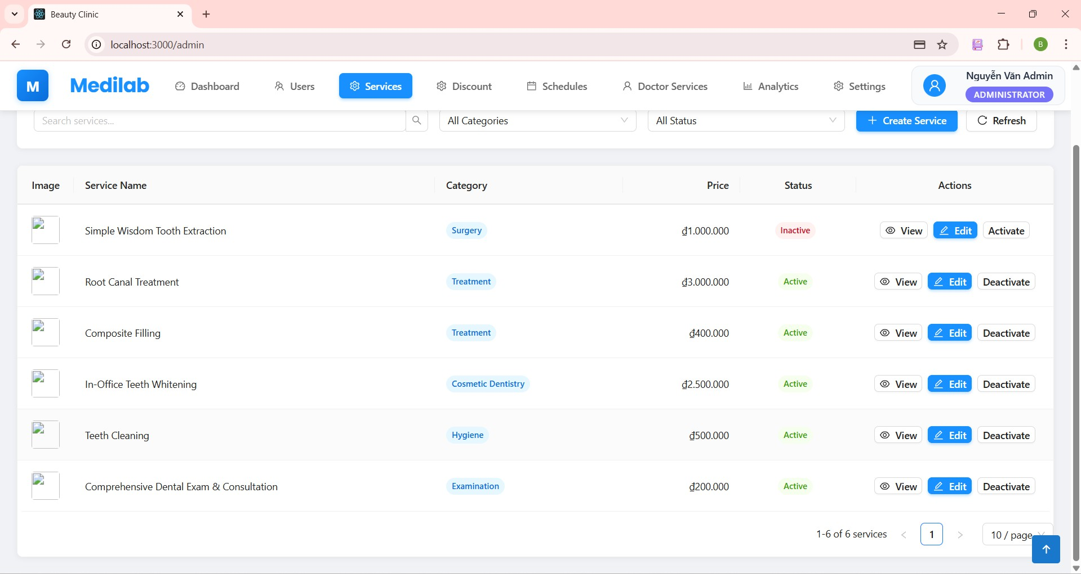

***Figure 47. Step 2 in Deactivate service.***

#### Deactivate Service (for admin)

* + - 1. From the Service screen, tap on the **"Create services"** button.
      2. Input service’s information.
      3. Click “Create service” to succeed.

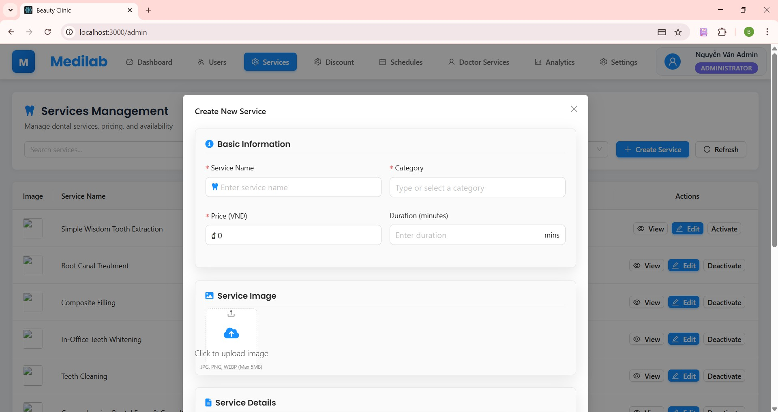

***Figure 48. Step 2 in Create service.***

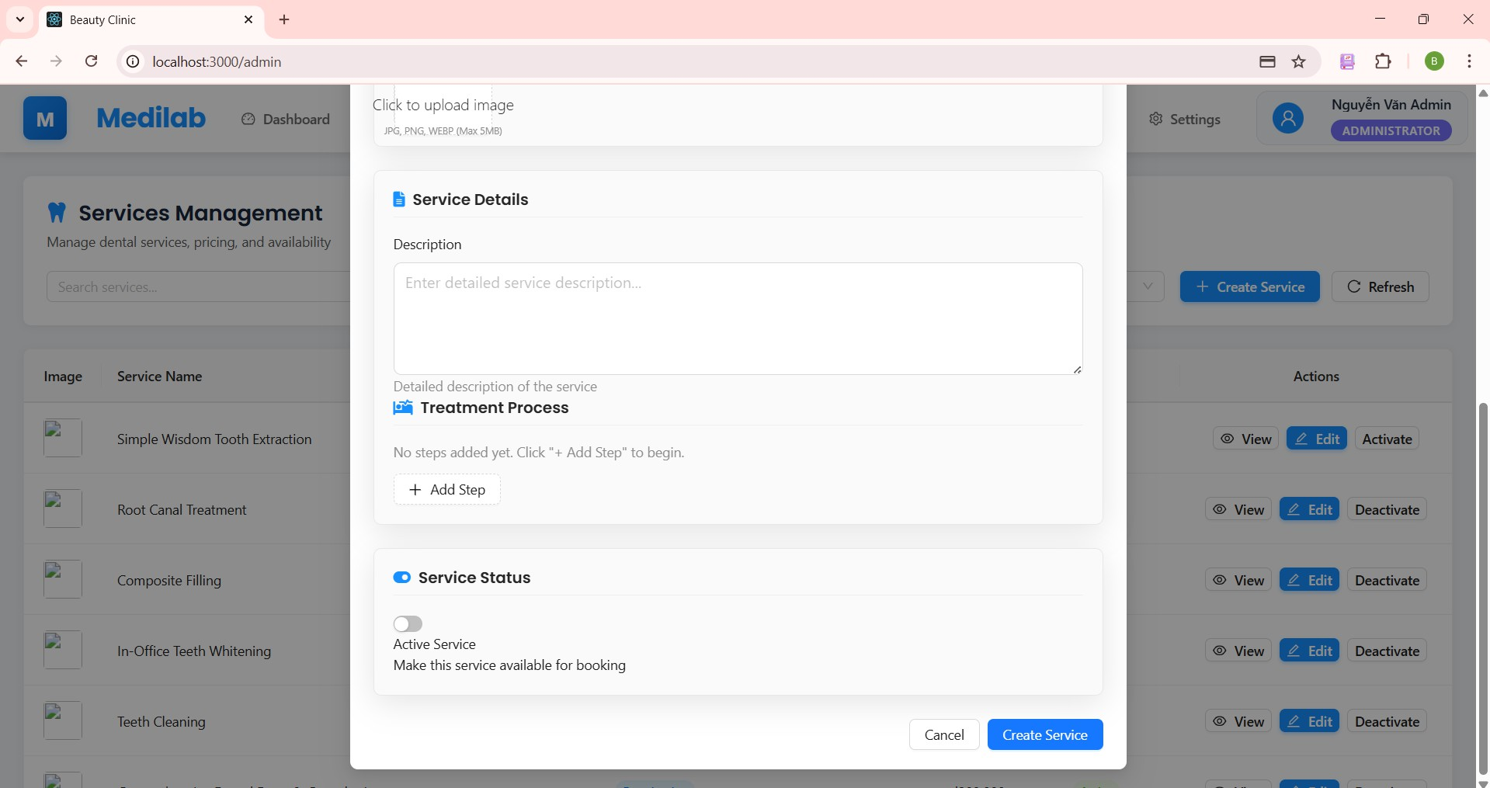

***Figure 49. Step 2 in Create service.***

#### Create discount (for admin)

* + - 1. From the Home screen, tap on the **"Discount"** navbar.
      2. From the Discount screen, tap on the **"Create"** button.
      3. Input discount information. Click “create” to succeed.

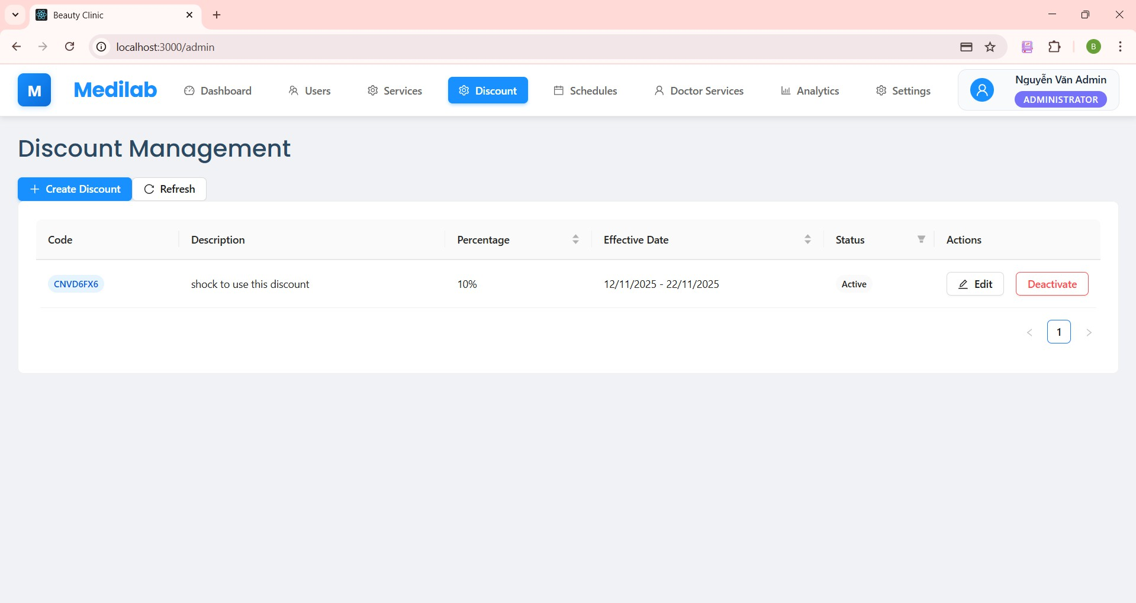

***Figure 50. Step 1 in Create discount.***

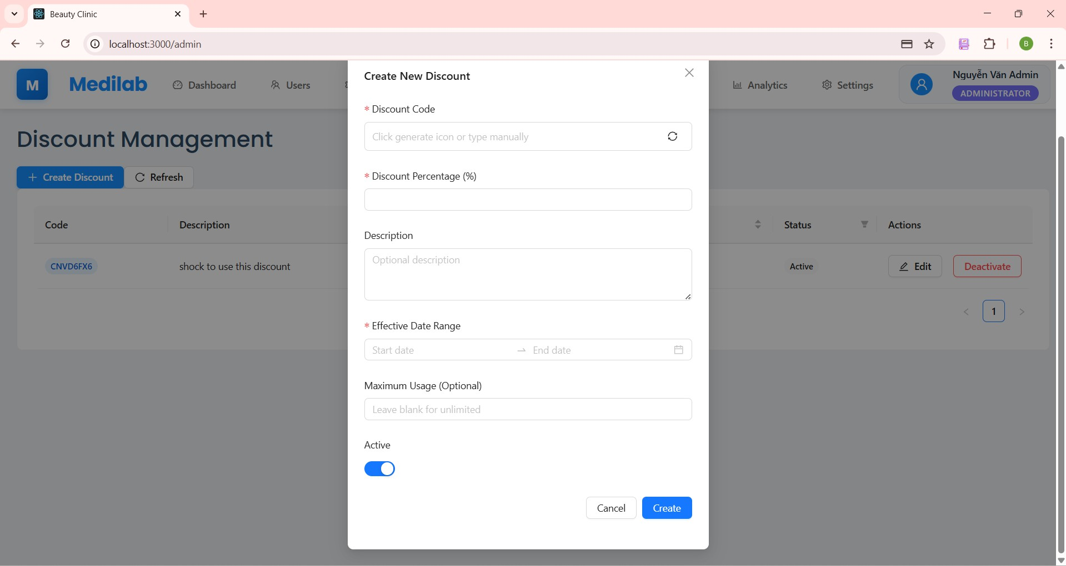

***Figure 51. Step 2 in Create discount.***

#### Edit discount

* + - 1. From the Discount screen, tap on the **"Edit"** icon.
      2. Input discount information admin wants to update. Click “Update” to succeed.

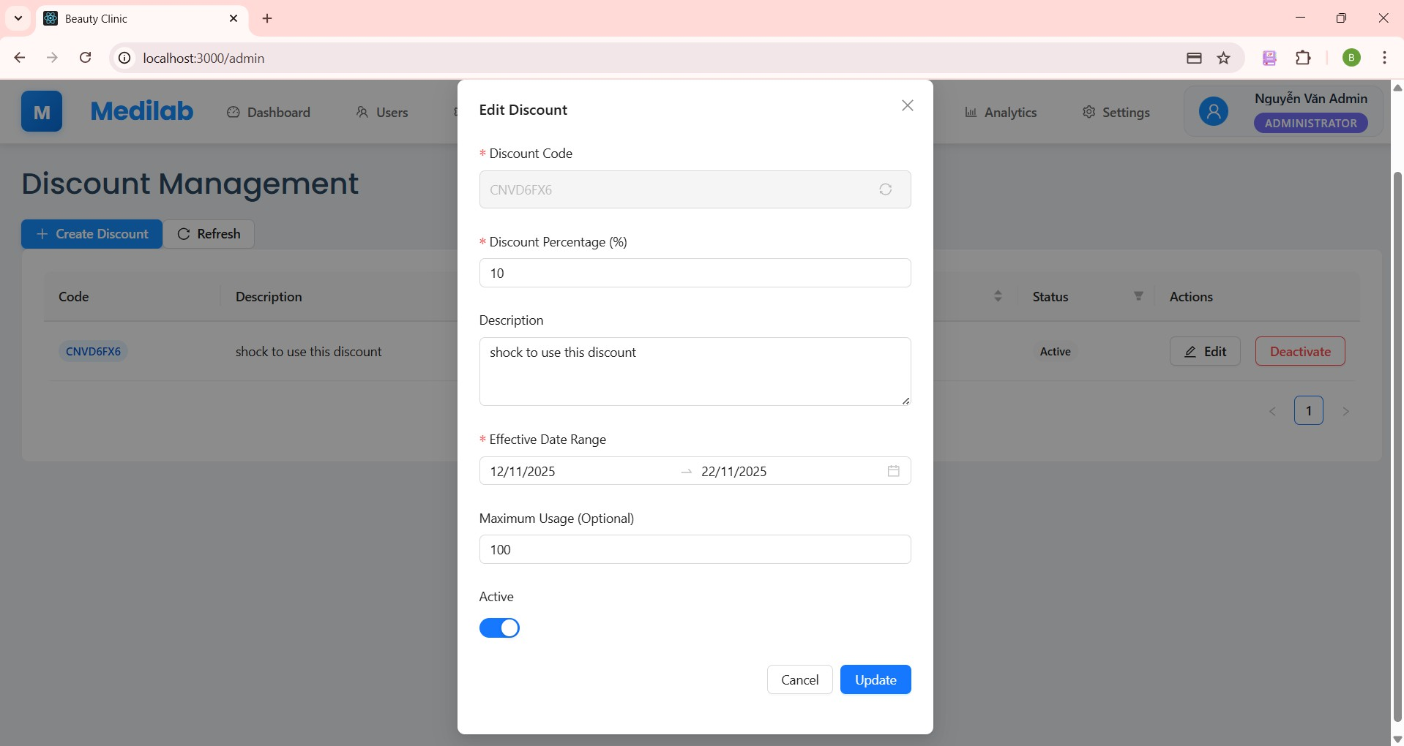

***Figure 52. Step 2 in Edit discount***

#### Deactivate discount

* + - 1. From the Discount screen, tap on the **"Deactivate"** icon.
      2. If the admin wants to deactivate, choose yes and the status will change to “Inactive” else choose no.

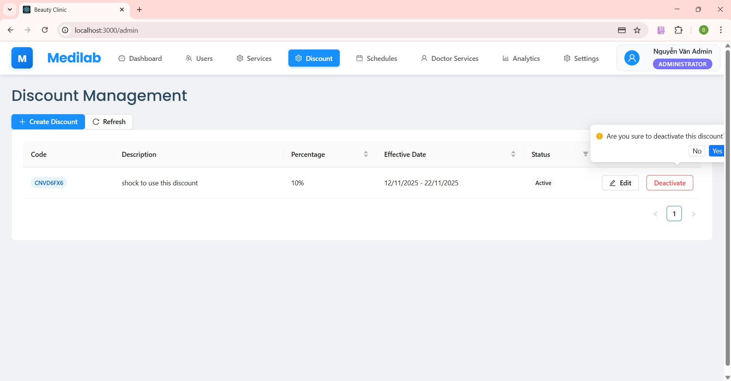

***Figure 53. Step 2 in Deactivate discount***

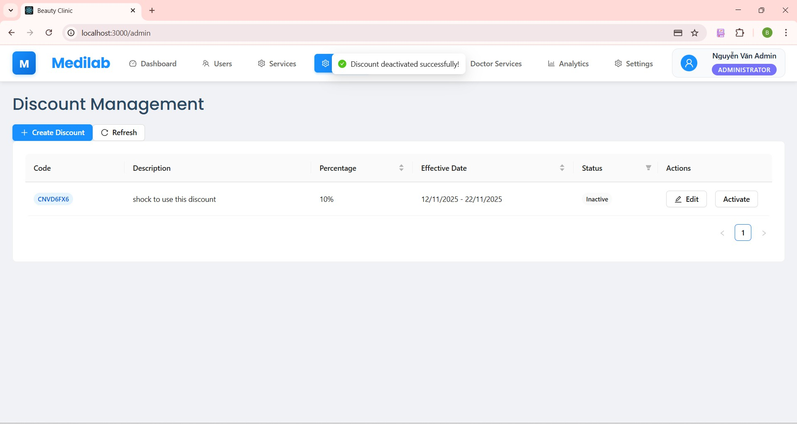

***Figure 54. Step 2 in Deactivate discount***

#### Create doctor services (for admin)

* + - 1. From the Home screen, tap on the **"Doctor services"** navbar.
      2. From the Doctor services screen, tap on the **"Create Service"** button .
      3. Input doctor services information, click “Create service” to succeed.

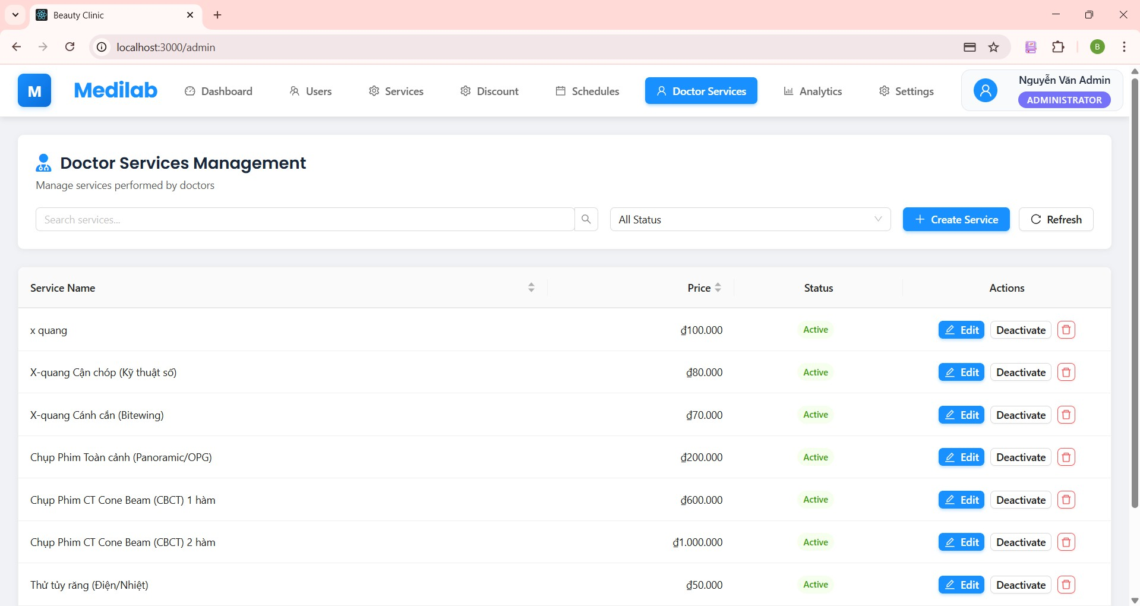

***Figure 55. Step 1 in Create doctor services***

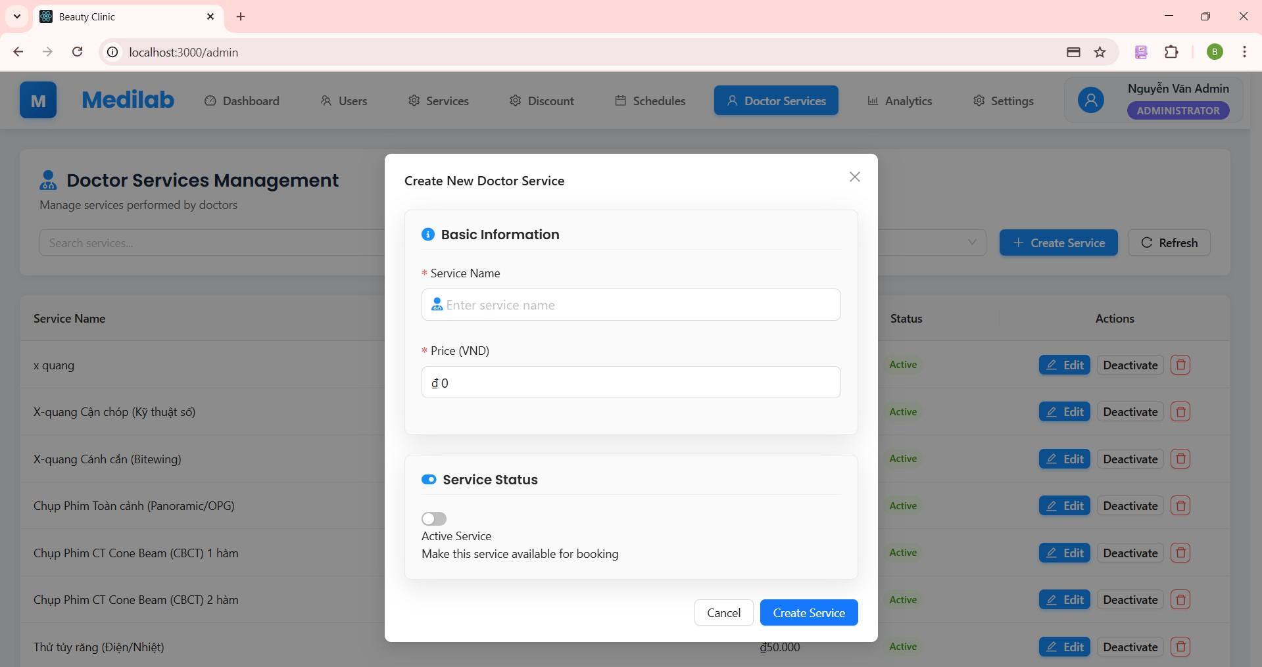

***Figure 56. Step 3 in Create doctor services***

#### Edit doctor services

* + - 1. From the Doctor services screen, tap on the **"Edit"** icon
      2. Input doctor services you want to update. Click “Update Service” to succeed.

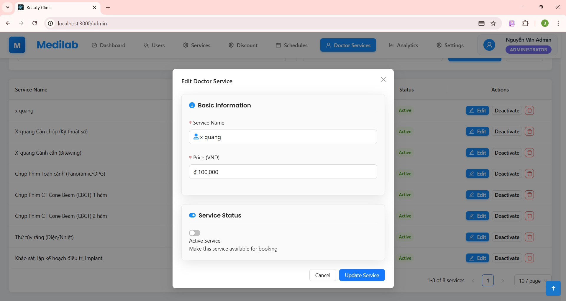

***Figure 57. Step 2 in Edit doctor services***

#### Deactivate doctor services

* + - 1. From the Doctor services screen, tap on the **"Deactivate"** icon
      2. If the admin wants to deactivate, choose yes and the status will change to “Inactive” else choose no.

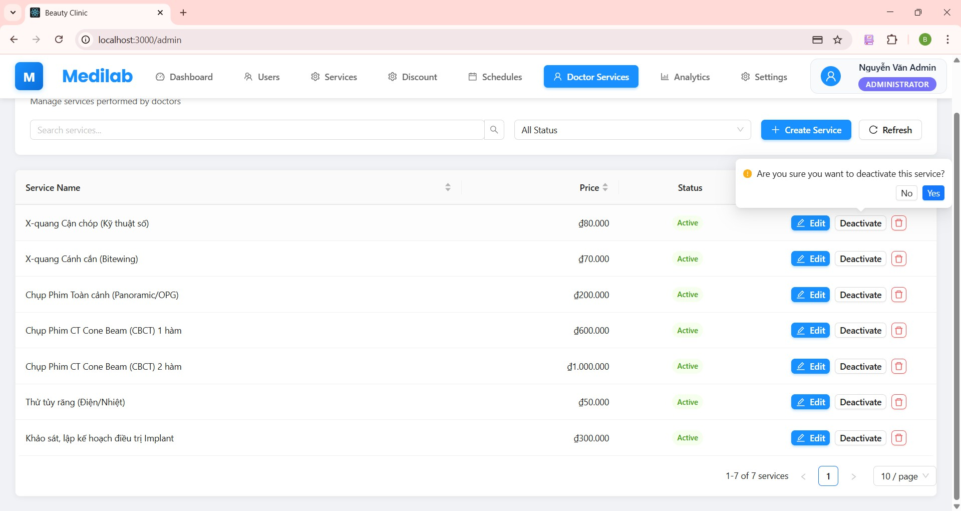

***Figure 58. Step 2 in Deactivate doctor services***

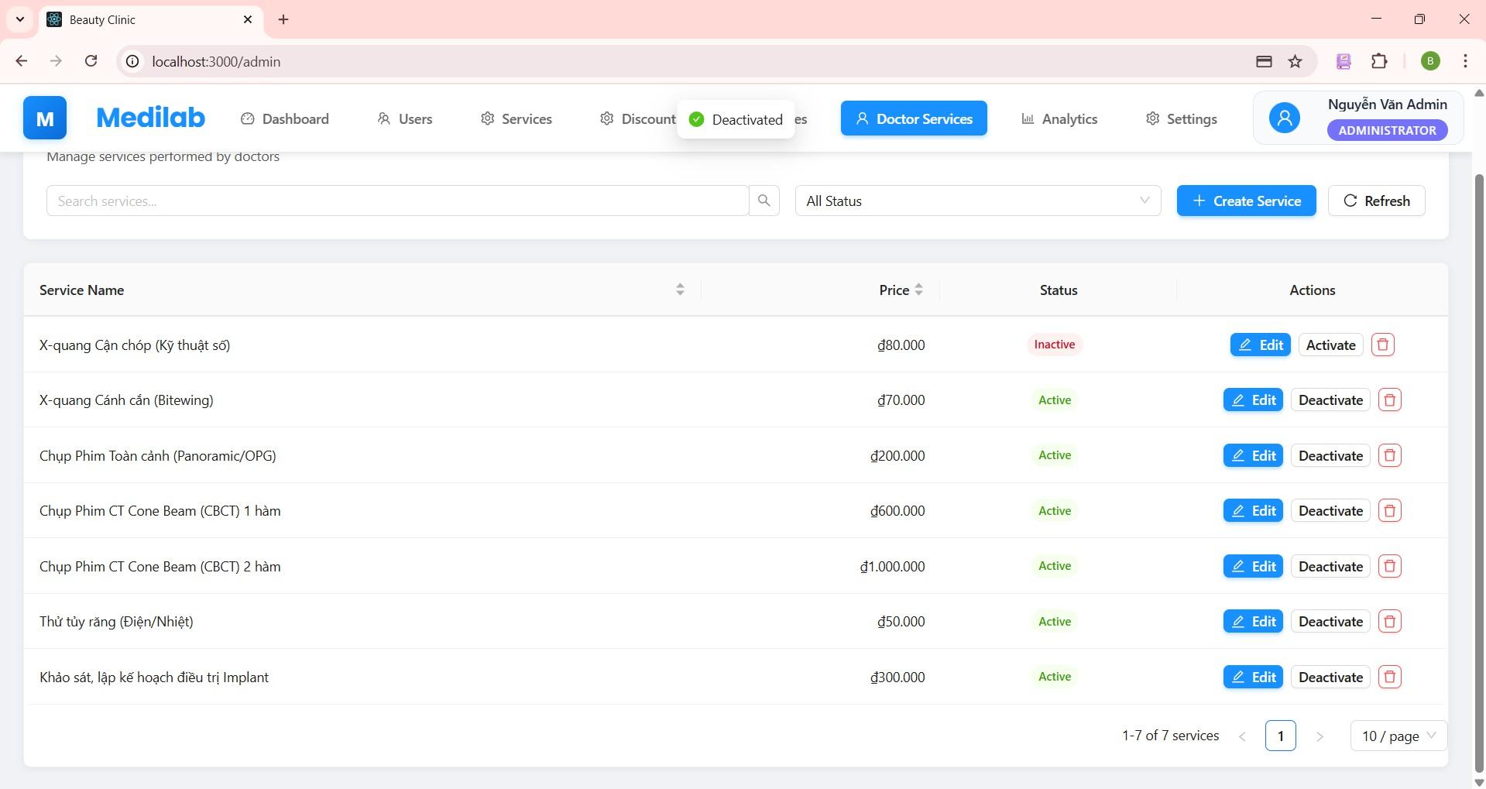

***Figure 59. Step 2 in Deactivate doctor services***

#### Delete doctor services

* + - 1. From the Doctor services screen, tap on the **"Delete"** icon
      2. If the admin wants to delete, choose yes else choose no.

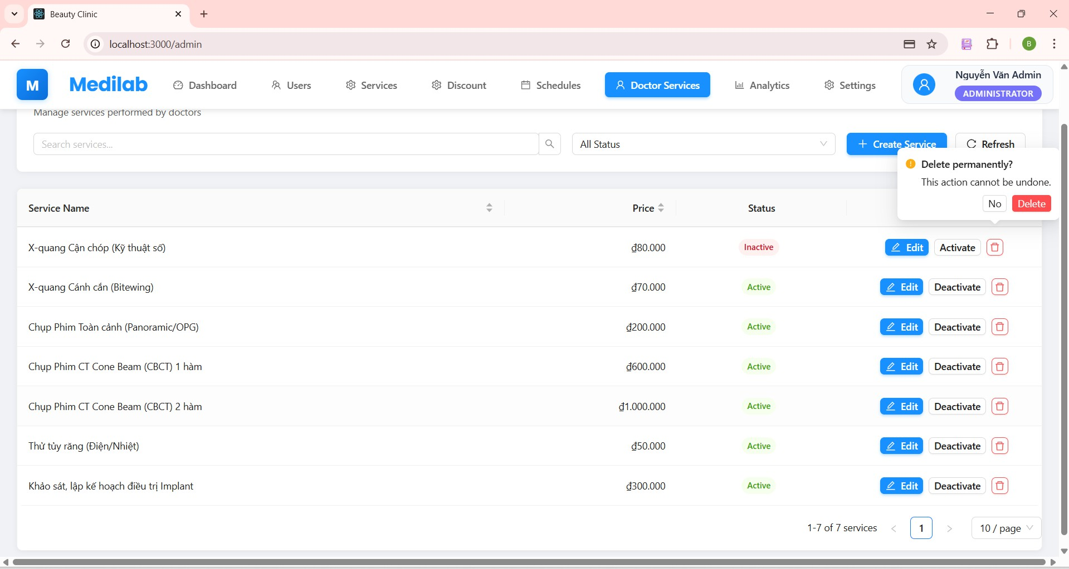

***Figure 60. Step 2 in Deactivate doctor services***

#### View employees information

* + - 1. Login with role Manager
      2. View employees' information is the main screen. The manager gets all the information from the employees.

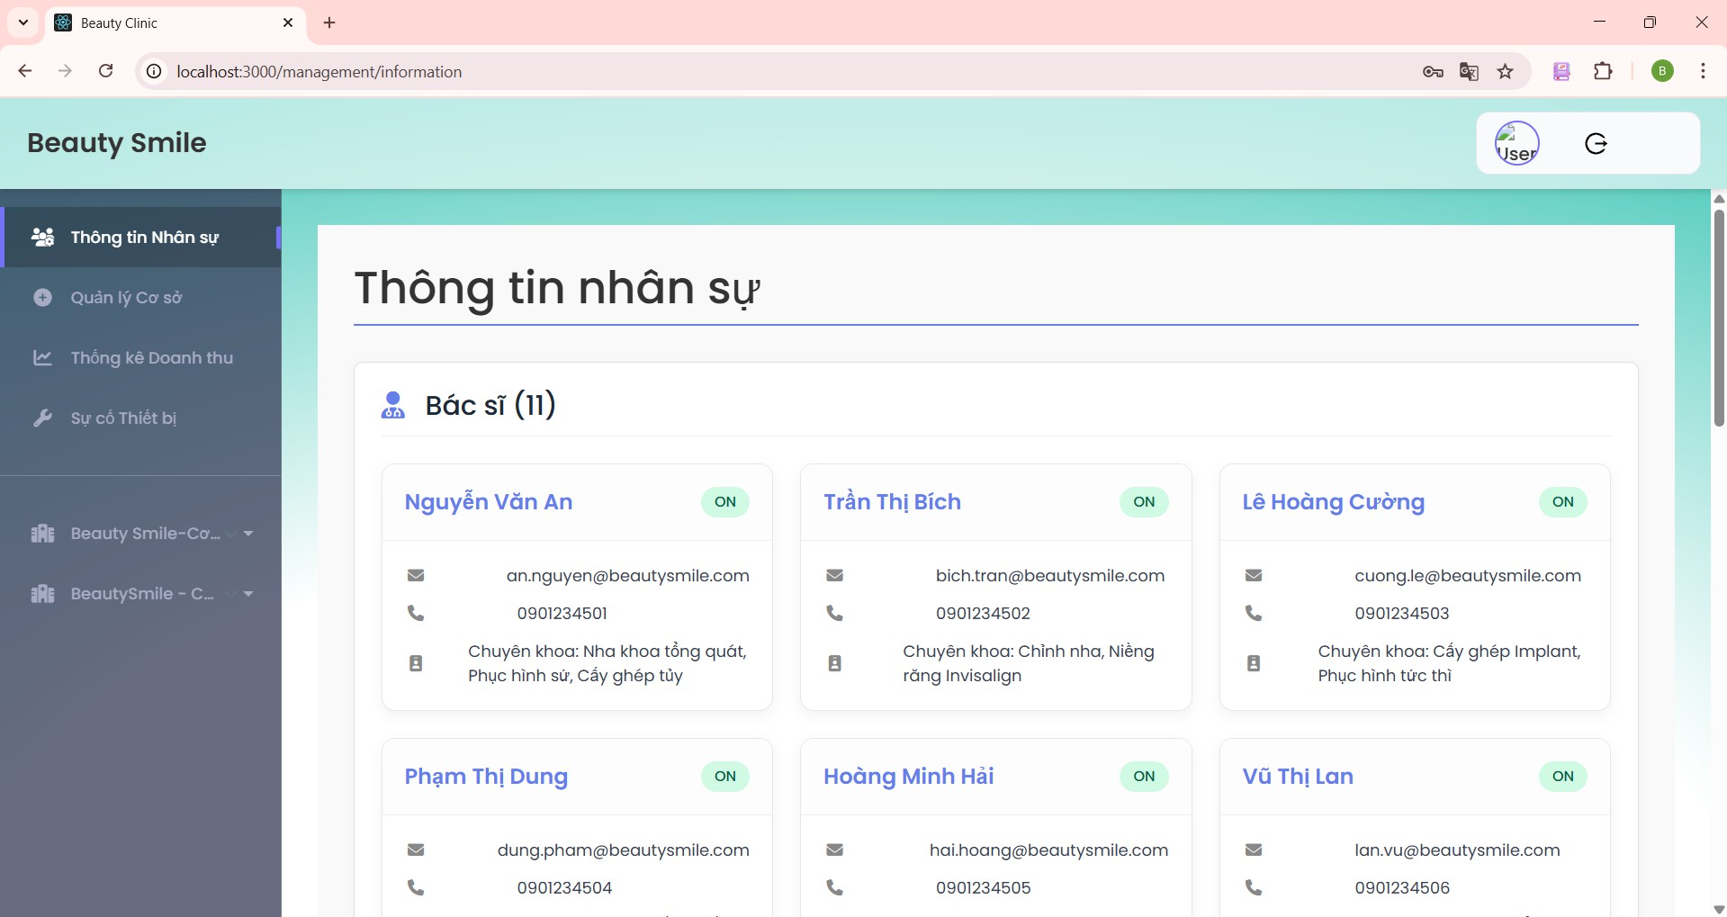

***Figure 61. Step 2 in View employees information***

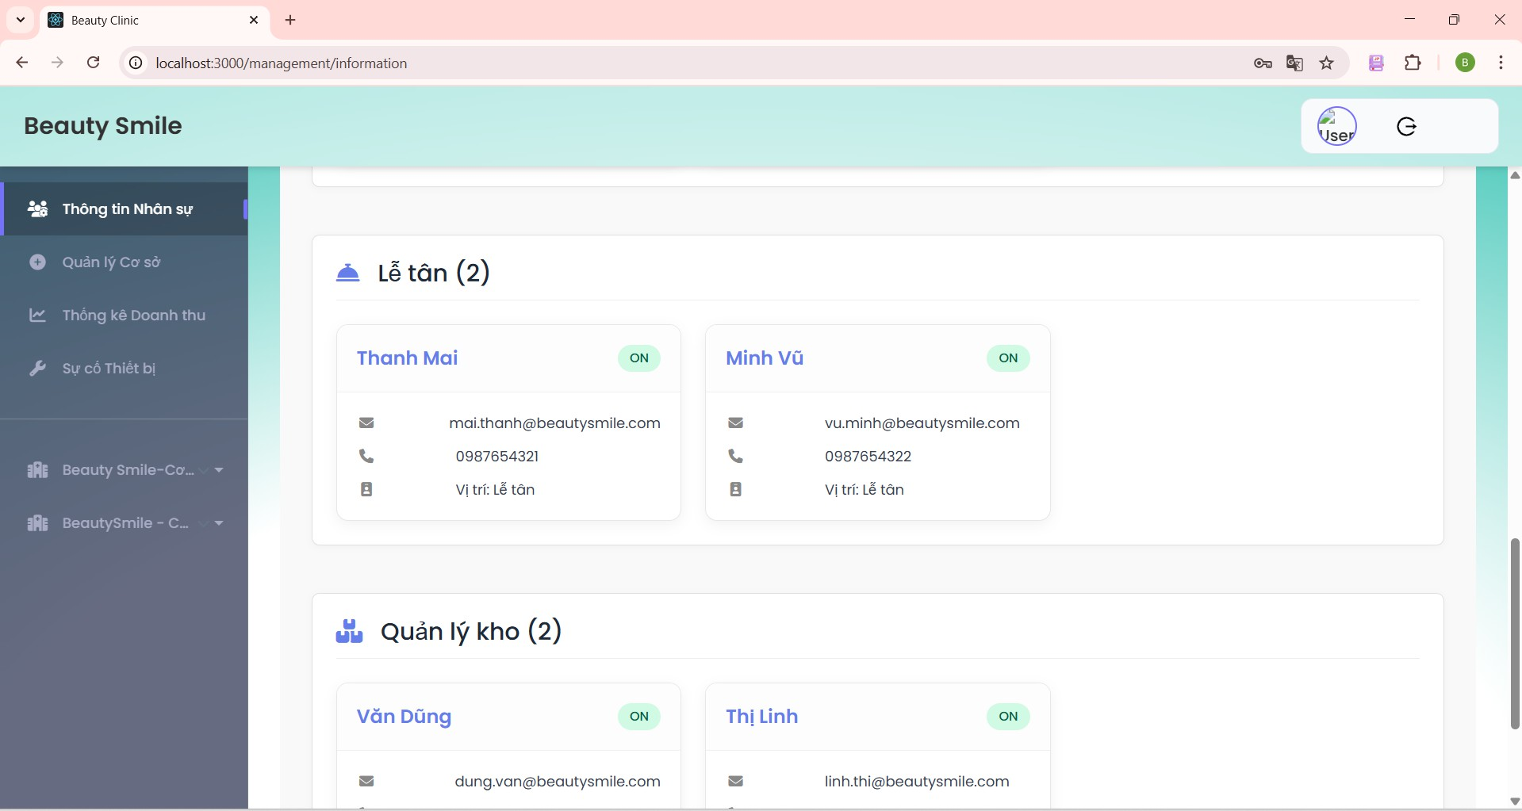

***Figure 62. Step 2 in View employees information***

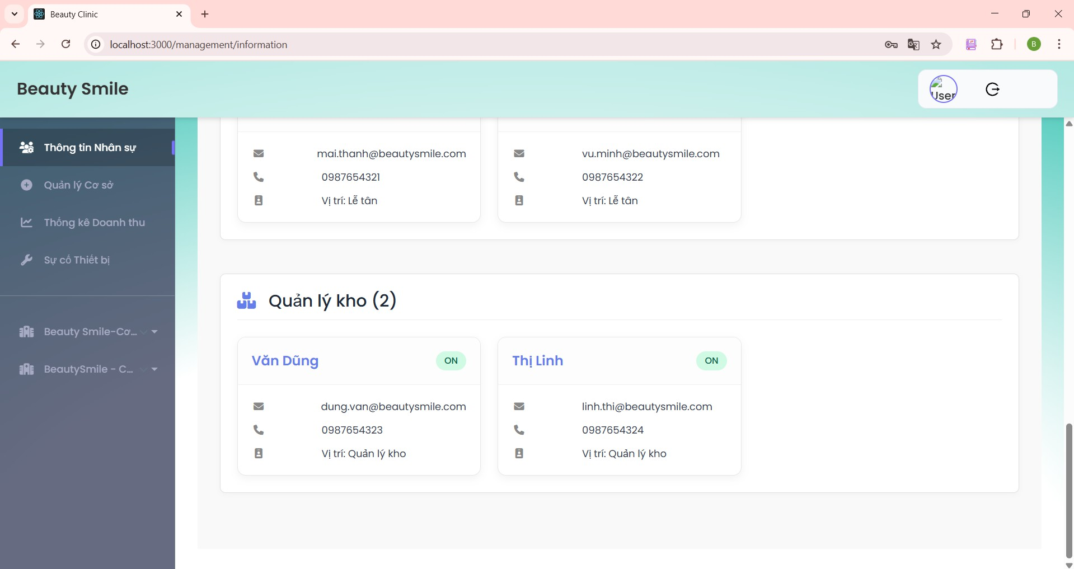

***Figure 63. Step 2 in View employees information***

#### View location information

* + - 1. From the employees information, click the management location on the side bar. The manager gets all the information from the locations.

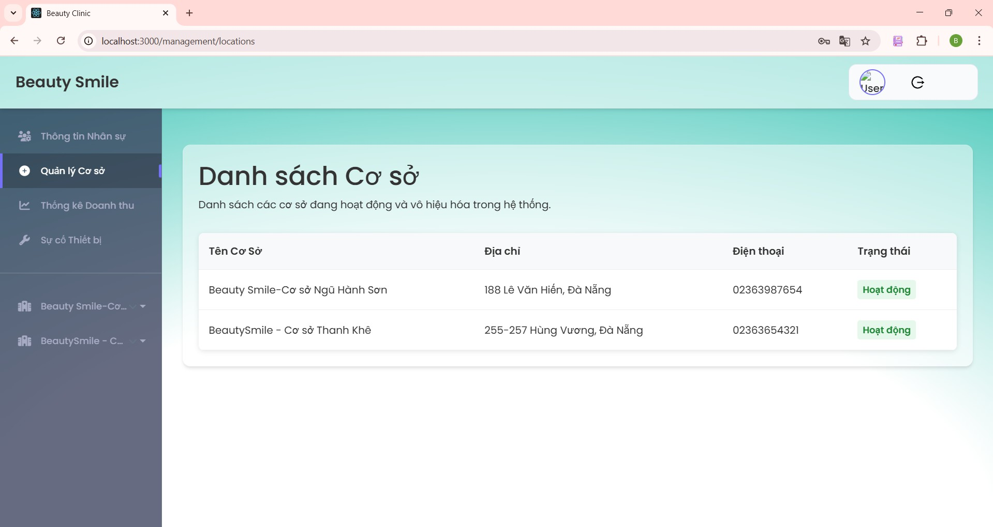

***Figure 64. Step 1 in View location information***

#### View Statistic revenue

* + - 1. Click “Statistic revenue” on the side bar to get revenue by day, week, month, year.

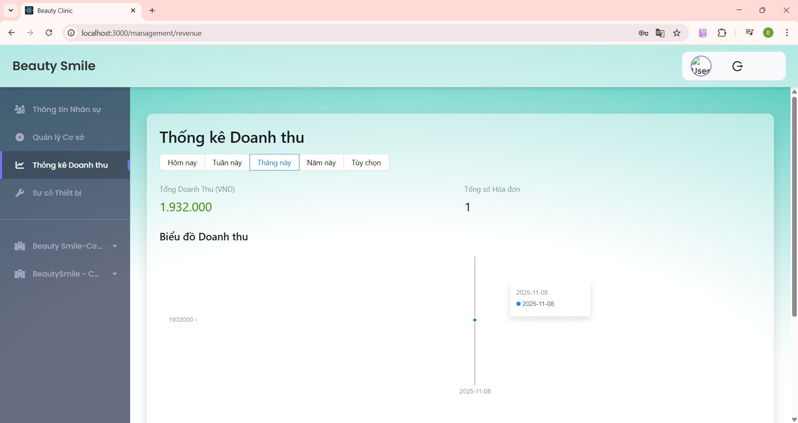

***Figure 65. Step 1 View statistic revenue***

#### View schedule doctor

* + - 1. From the side bar, click the location which manager wants to get a schedule.
      2. Click the “Doctor Schedule” dropdown.
      3. Select a “Part time” or “full time” button to get a schedule.

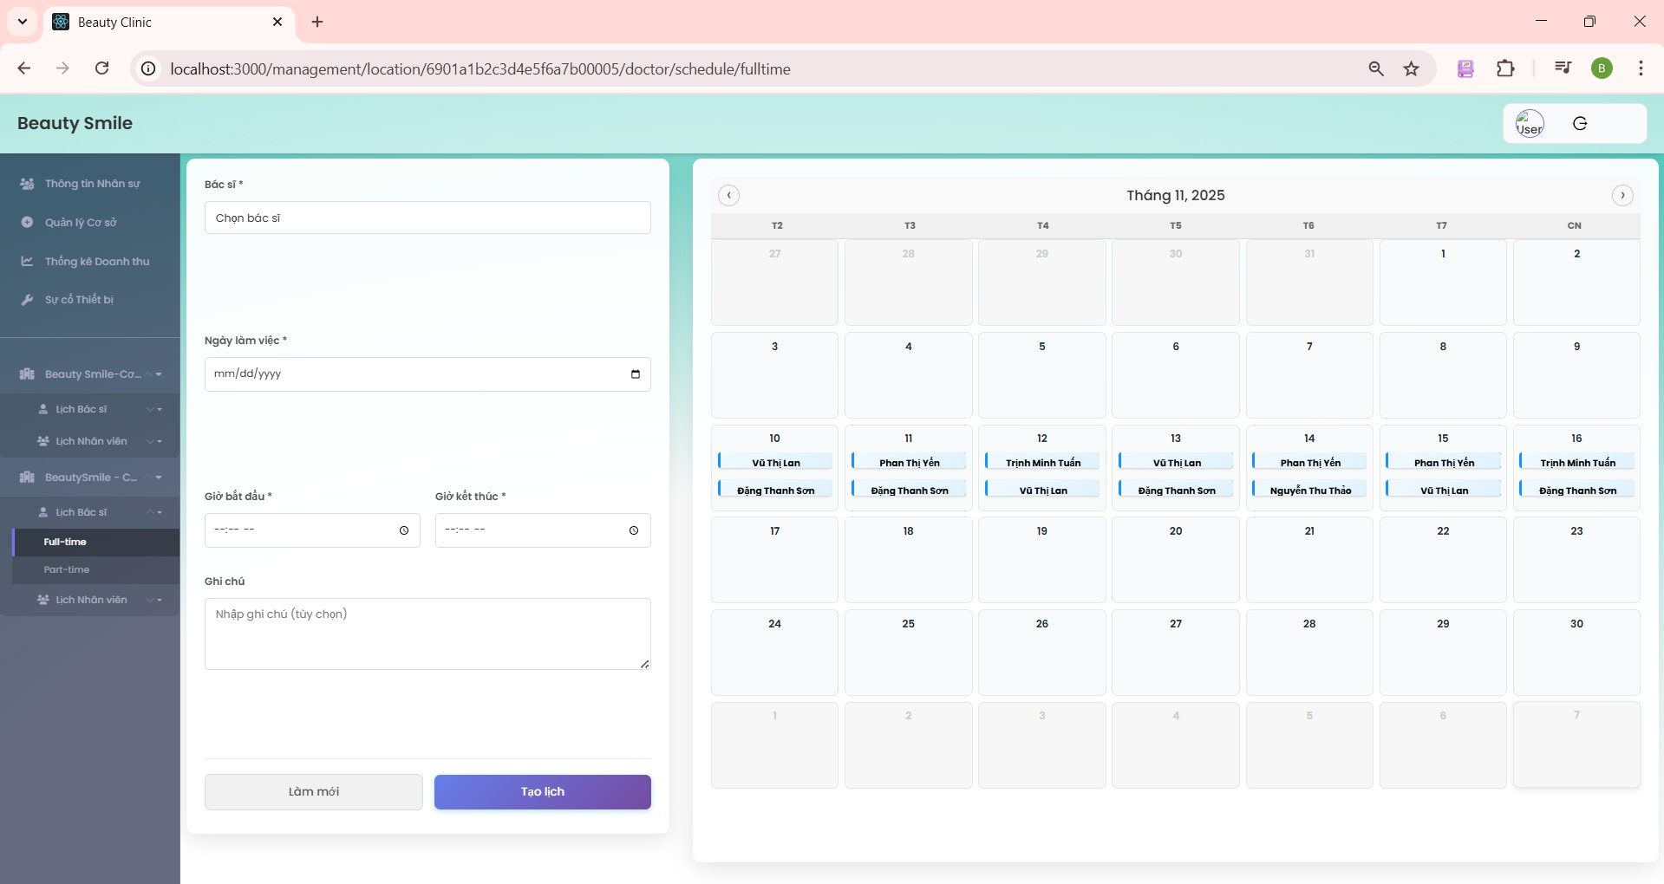

***Figure 66. Step 3 View Doctor schedule***

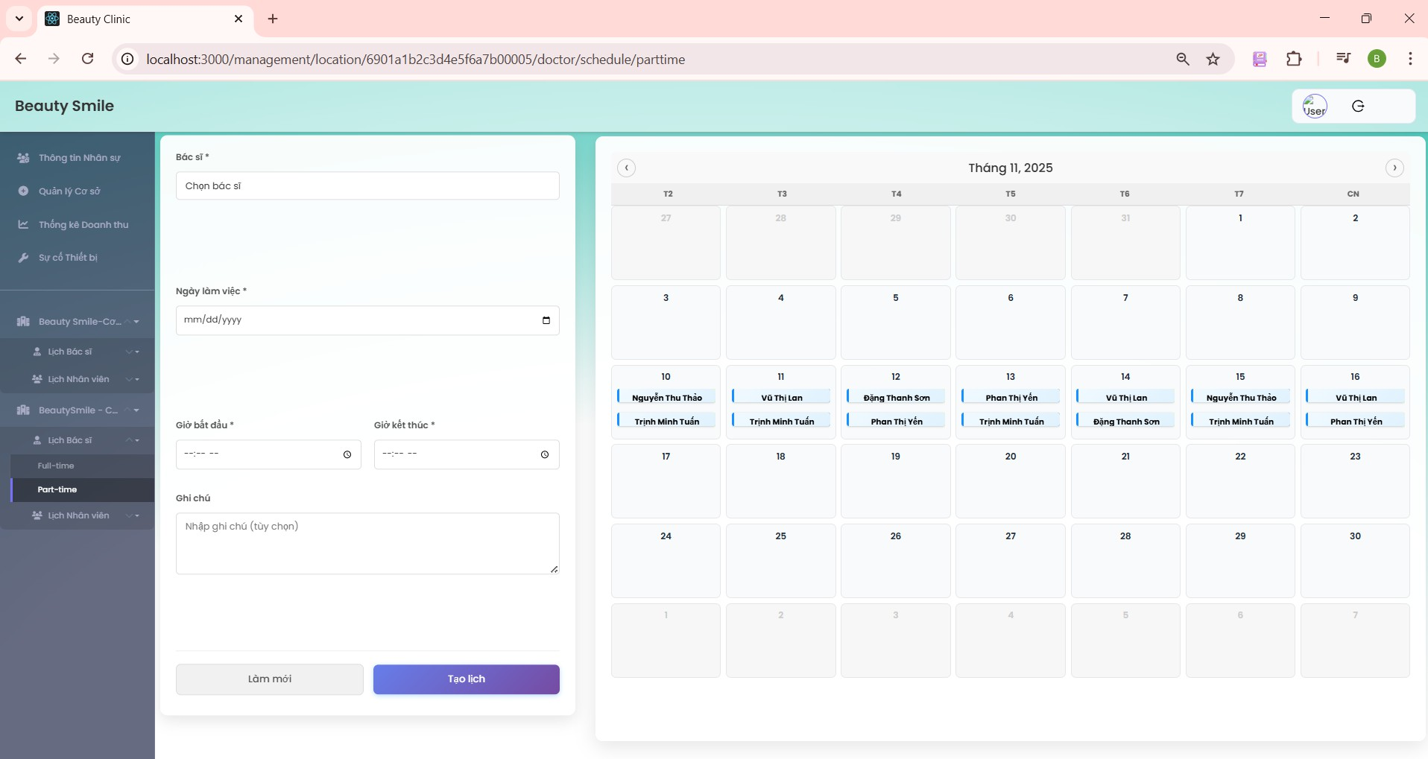

***Figure 67. Step 3 View Doctor schedule***

#### Create doctor schedule

* + - 1. From the location schedule on the side bar, click “Doctor schedule”
      2. Select the doctor that the manager wants to create a schedule.
      3. Select date that the manager wants to create a schedule.
      4. Select start time and end time that the manager wants to create a schedule.
      5. Click the blue “Create” button to succeed.

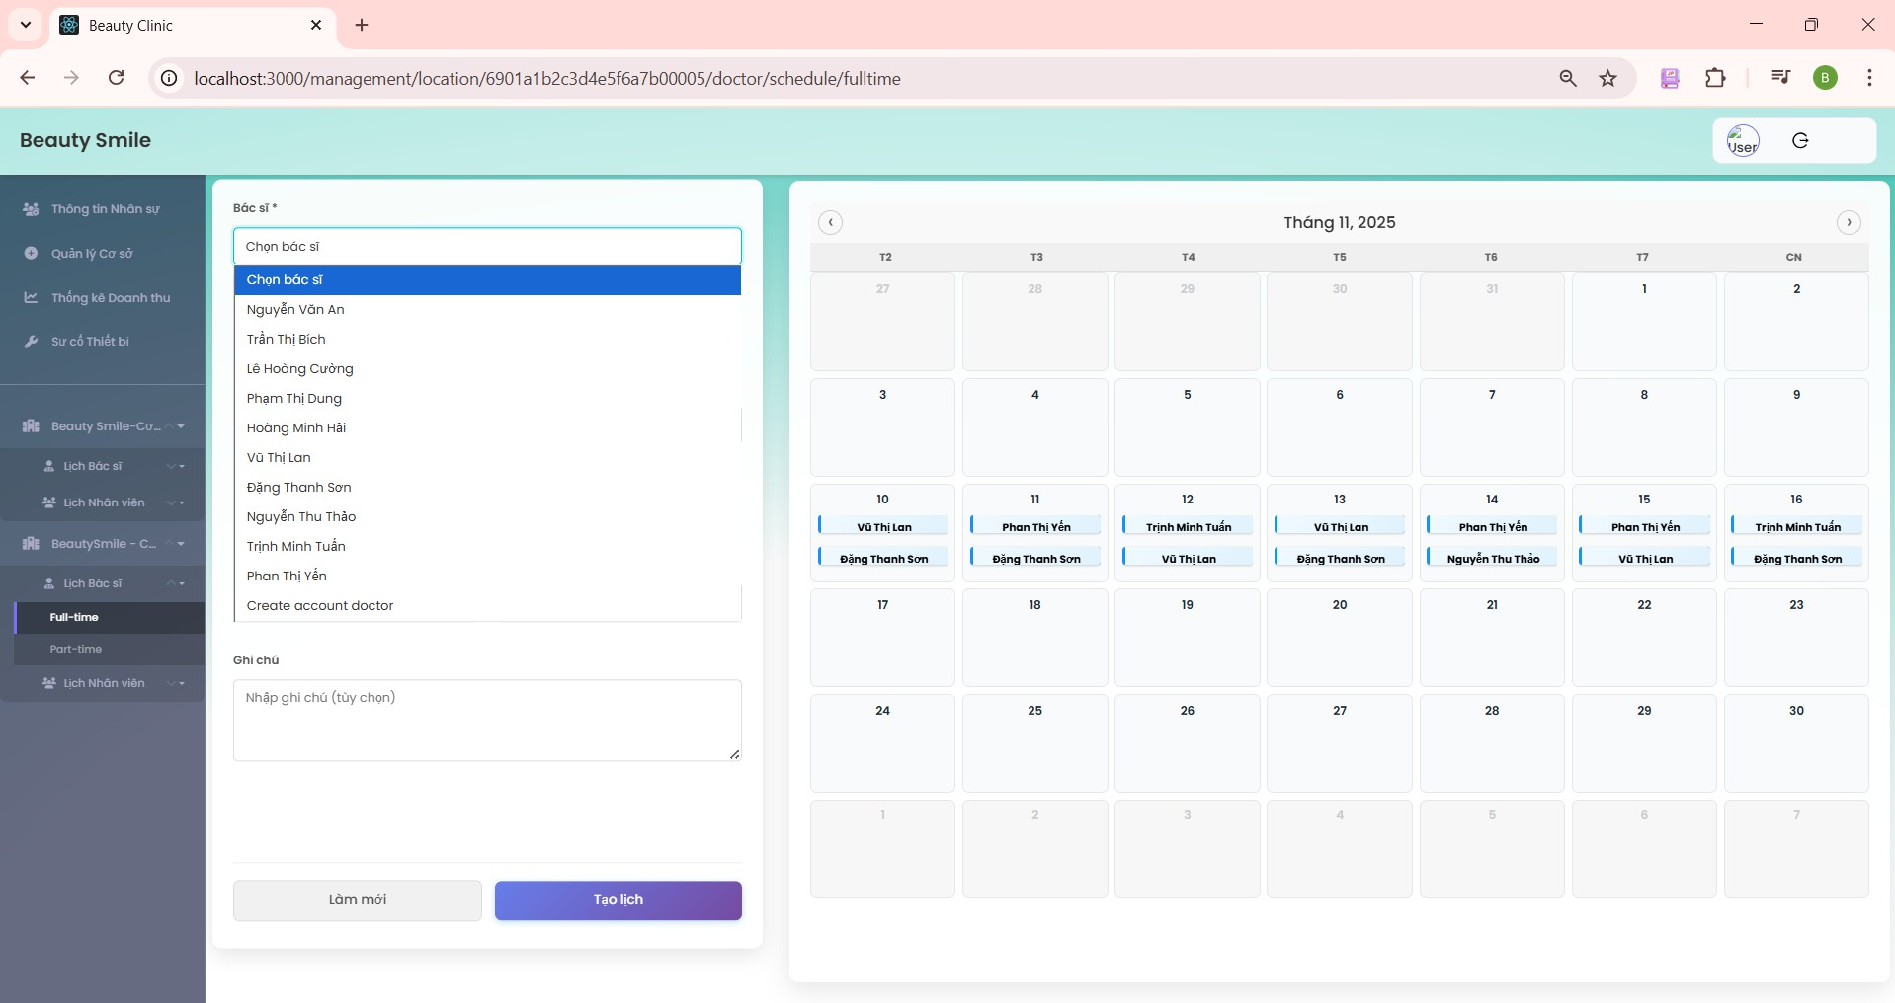

***Figure 68. Step 2 in Create doctor schedule***

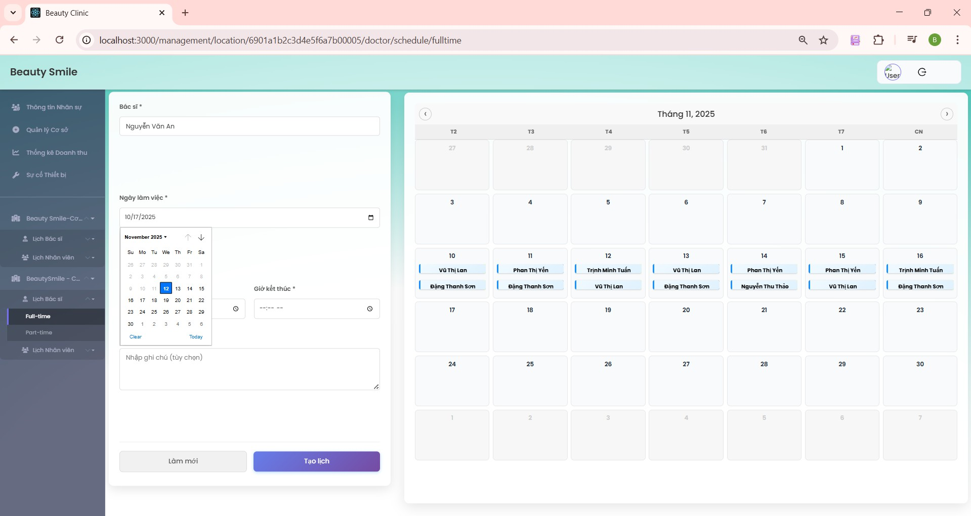

***Figure 68. Step 3 in Create doctor schedule***

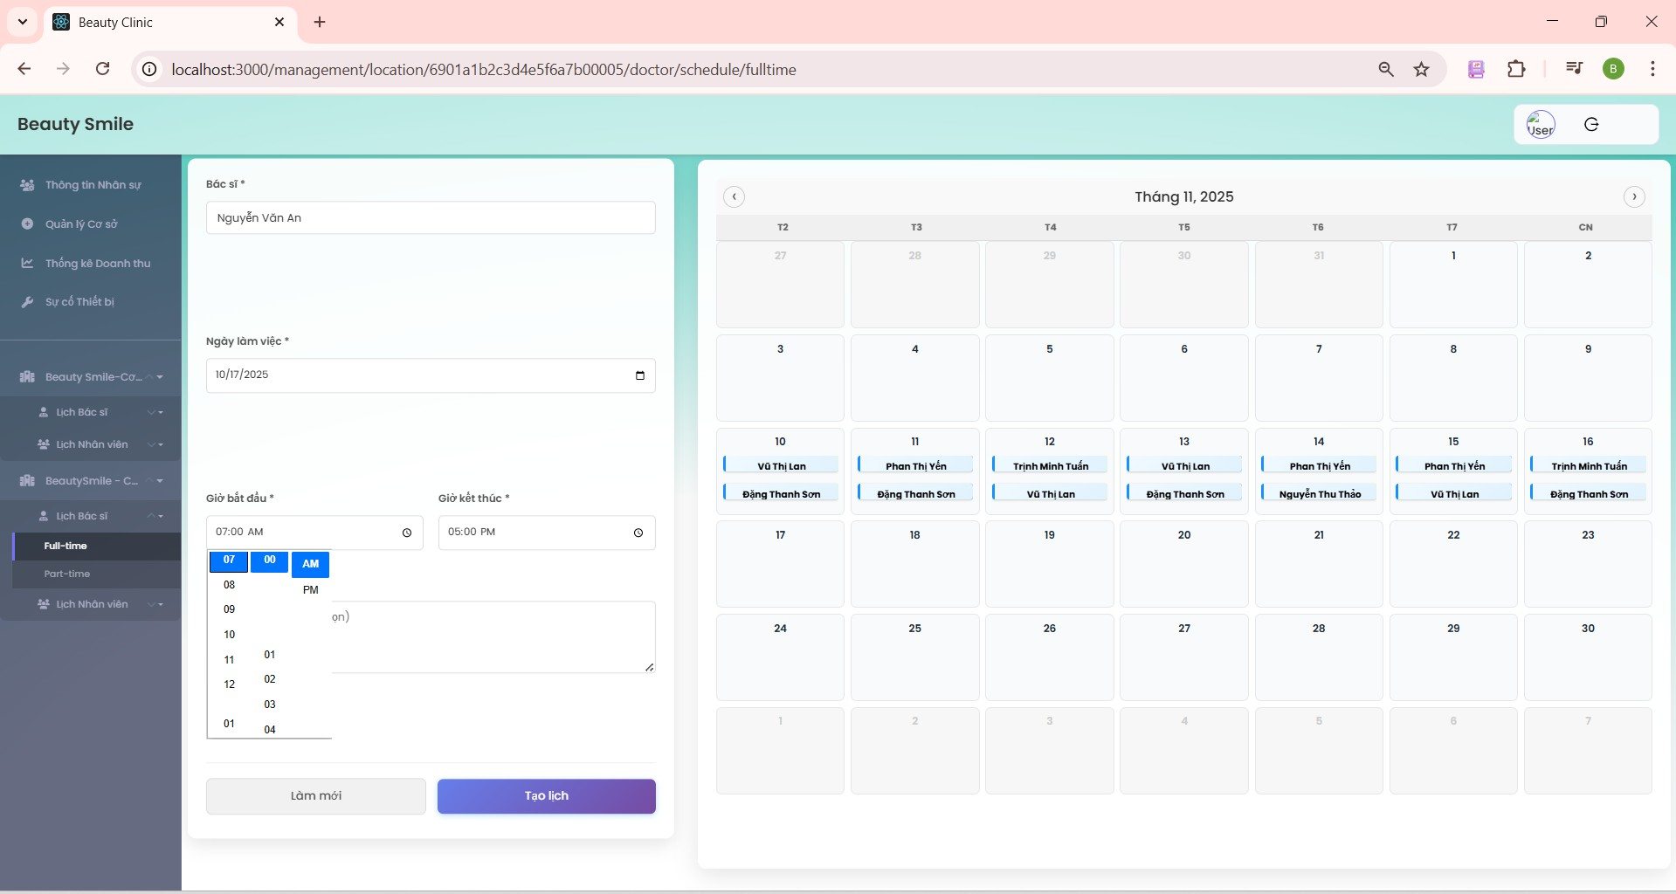

***Figure 69. Step 4 in Create doctor schedule***

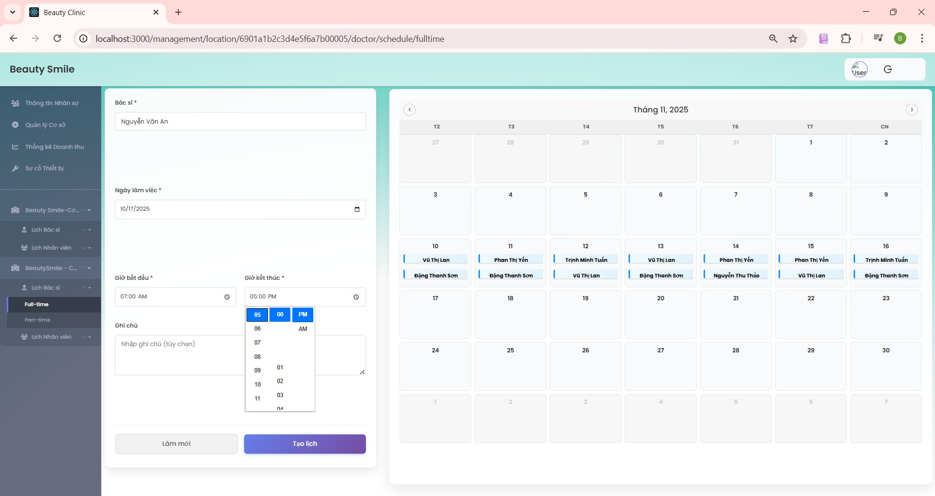

***Figure 70. Step 4 in Create doctor schedule***

#### View Staff schedule

* + - 1. From the side bar, click the location which manager wants to get a schedule.
      2. Click the “Staff schedule” dropdown.
      3. Select a “part time” or “full time” button to get a schedule.

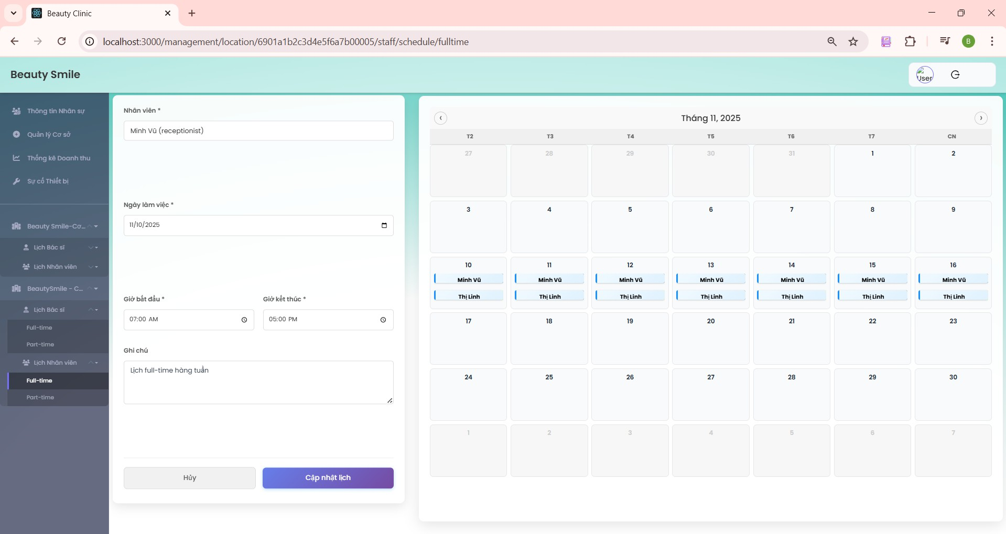

***Figure 71. Step 3 in View staff schedule full-time***

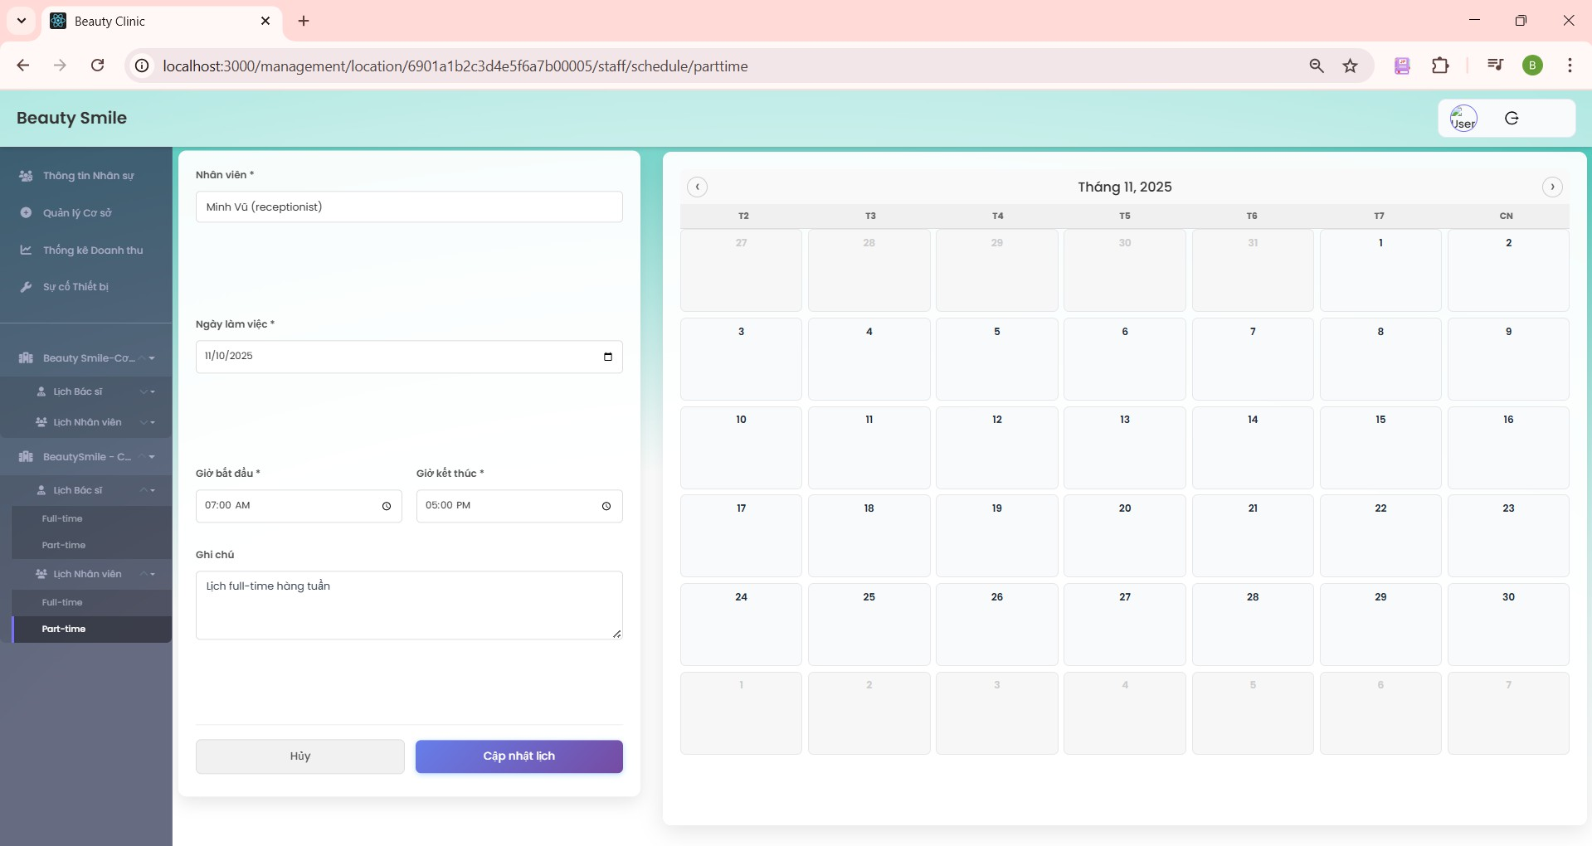

***Figure 72. Steps 3 in View staff schedule part-time***

#### CRUD staff schedule

* + - 1. From the location schedule on the side bar, click “Staff schedule” Select the staff that the manager wants to create a schedule.
      2. Select the date that the manager wants to create a schedule.
      3. Select start time and end time that the manager wants to create a schedule.
      4. Click the blue “Create” button to succeed.

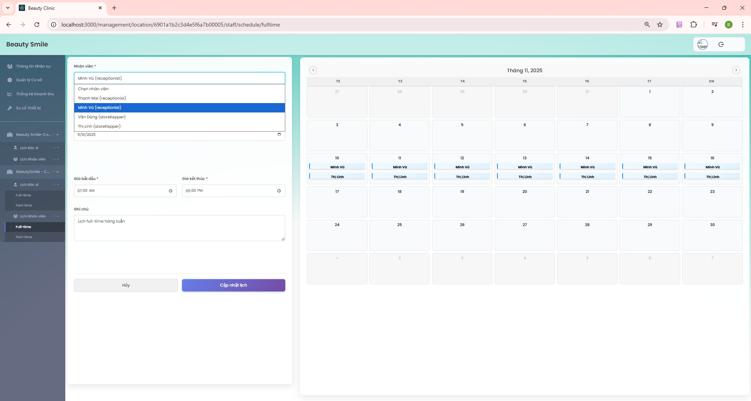

***Figure 73. Steps 1 in CRUD staff schedule***

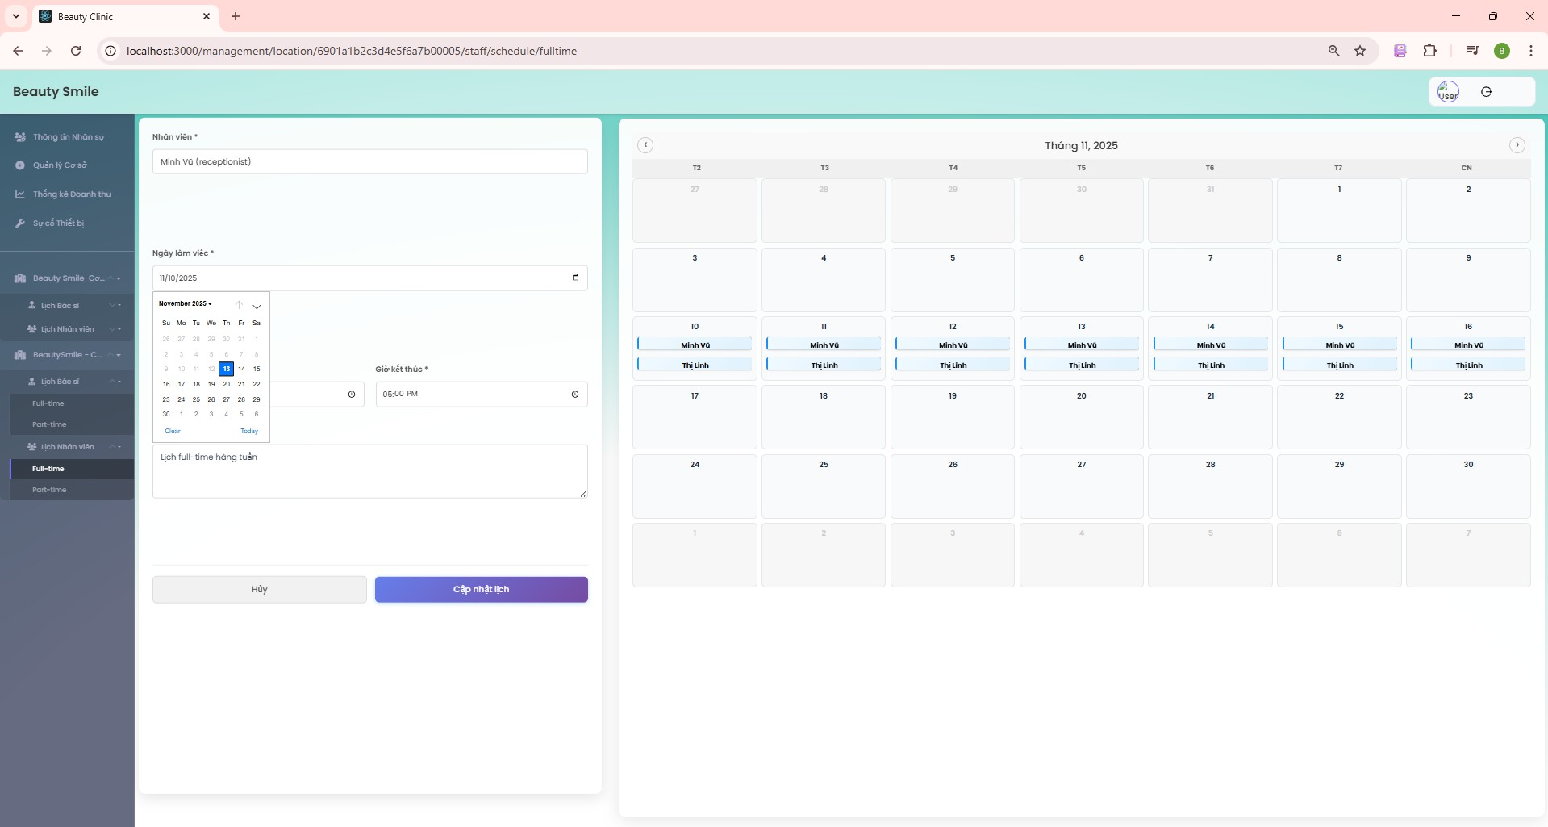

***Figure 74. Steps 2 in CRUD staff schedule***

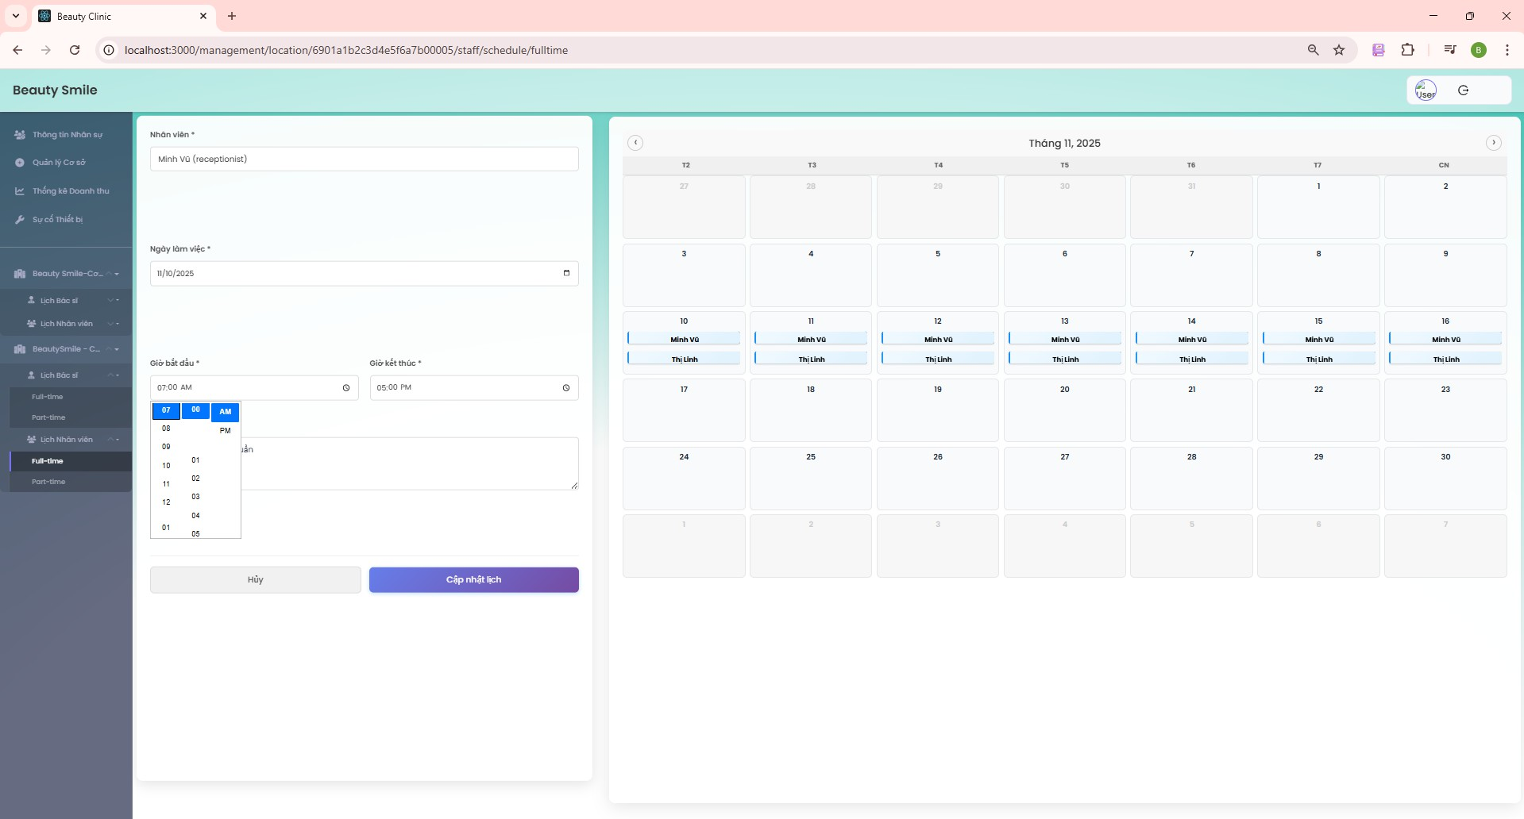

***Figure 75. Steps 3 in CRUD staff schedule***

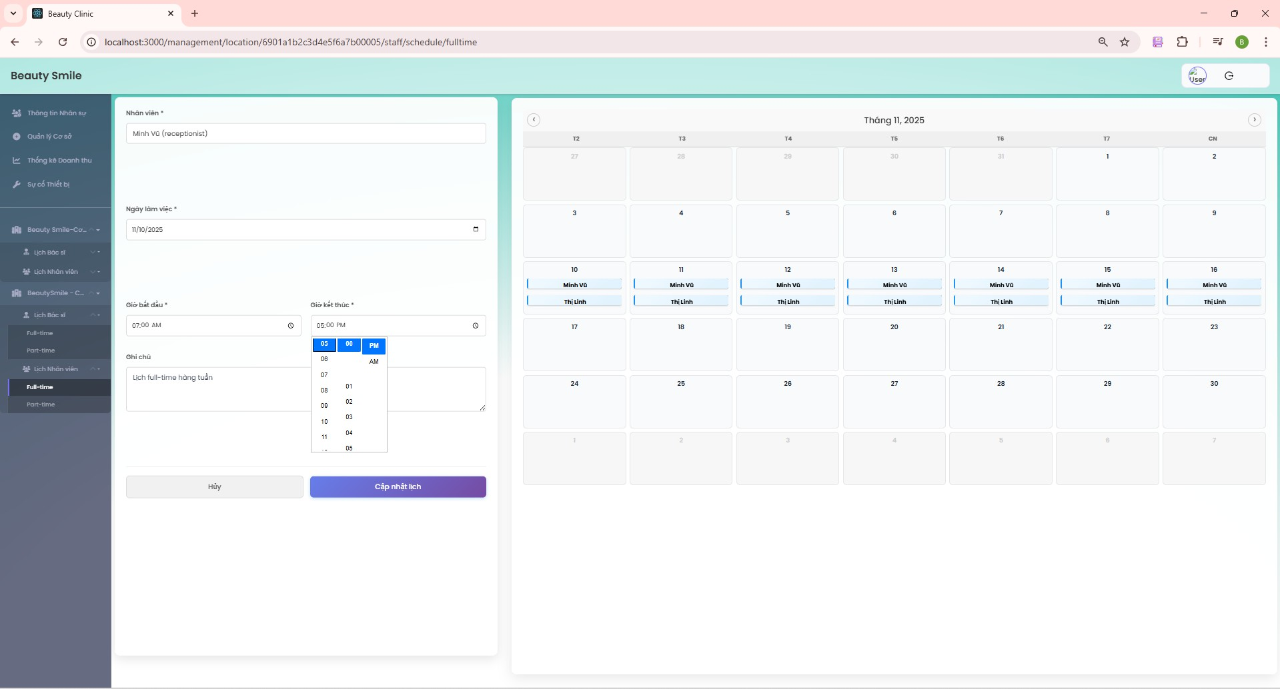

***Figure 76. Steps 3 in CRUD staff schedule***

* + - 1. To edit the staff schedule, click the “Edit” icon on the schedule.
      2. Update information in the left box like create staff schedule.
      3. Click the blue “Cập nhật lịch” button to succeed.

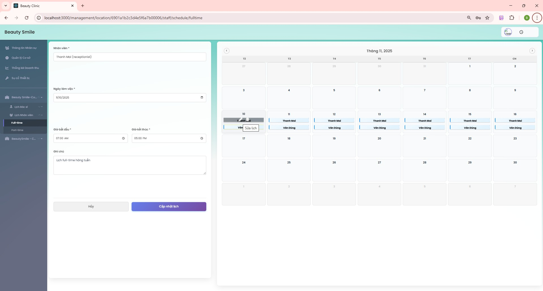

***Figure 77. Steps 5 & 6 & 7 in CRUD staff schedule***

* + - 1. To delete the staff schedule, click the “delete” icon on the schedule.
      2. A notification will be sent to the screen. Click “Ok” to succeed.

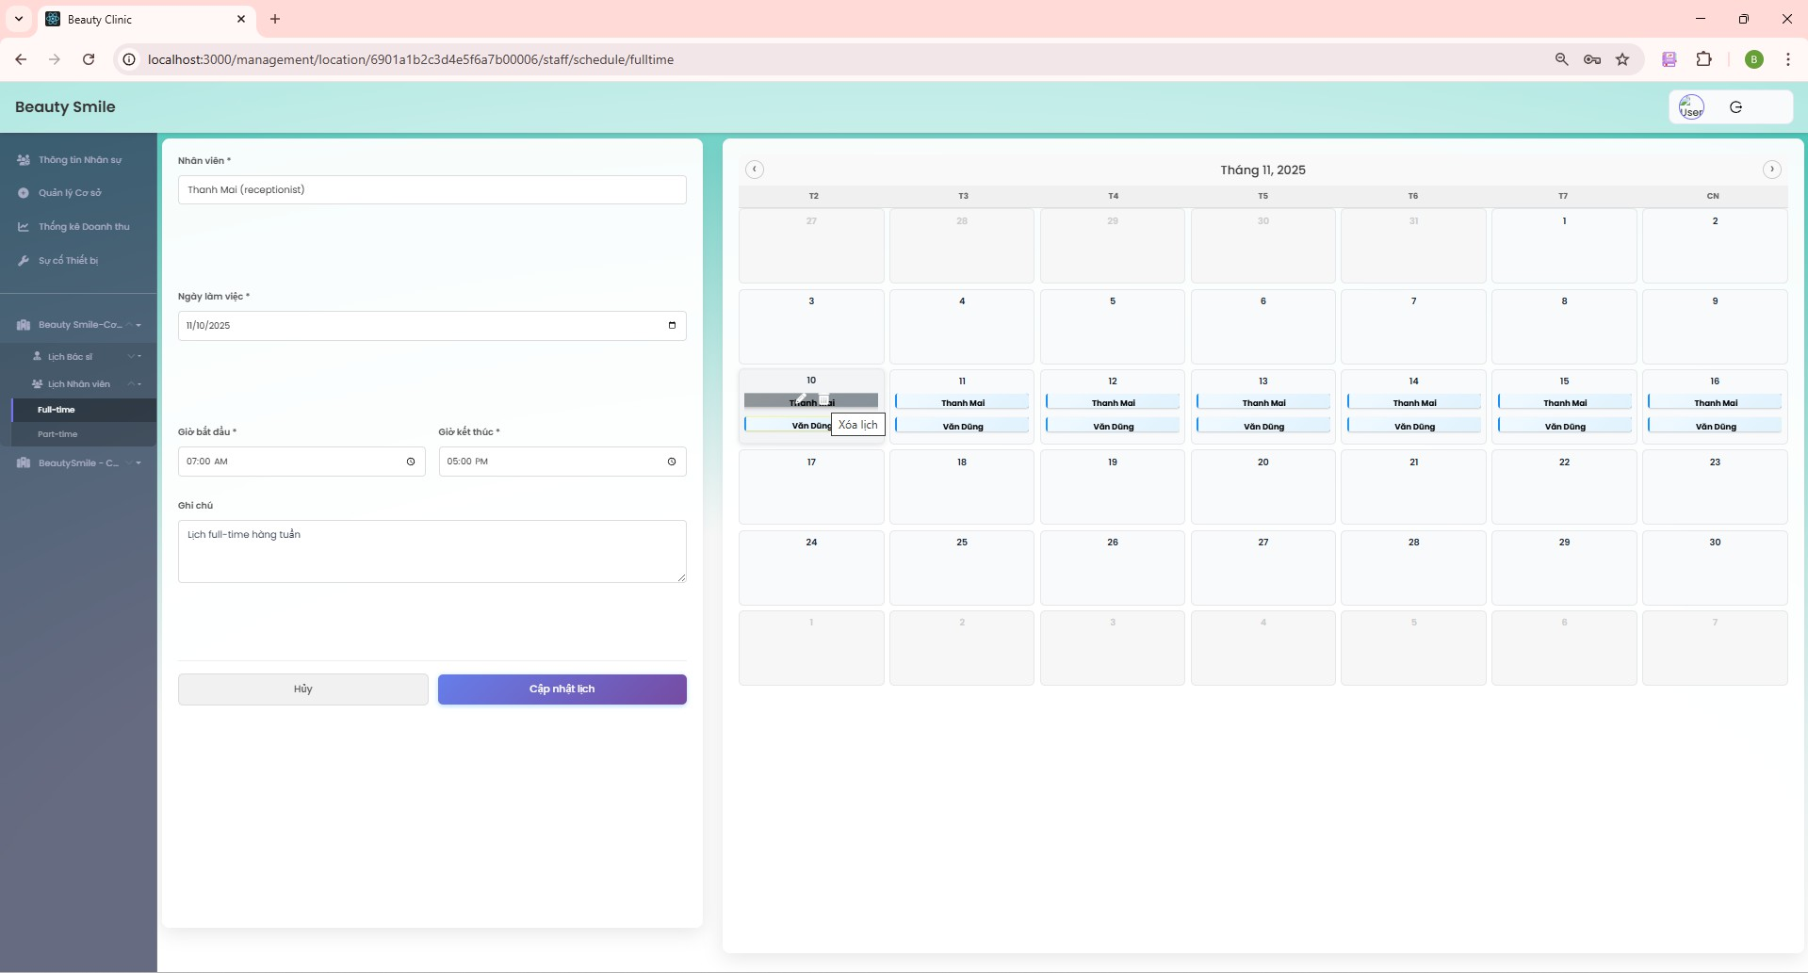

***Figure 78. Steps 8 in CRUD staff schedule***

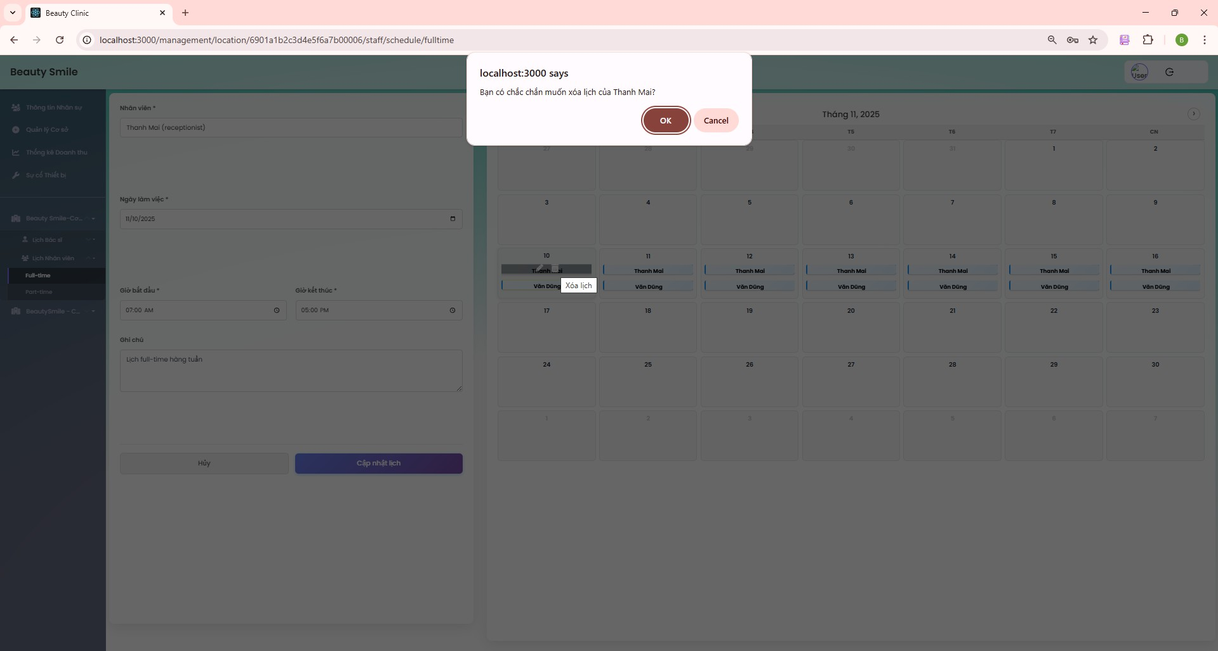

***Figure 78. Steps 9 in CRUD staff schedule***

#### View Schedule for staff (For staff)

* + - 1. Login with email with role staff.
      2. In the Home screen, click “Lịch làm việc” on the side bar to get all the schedules.

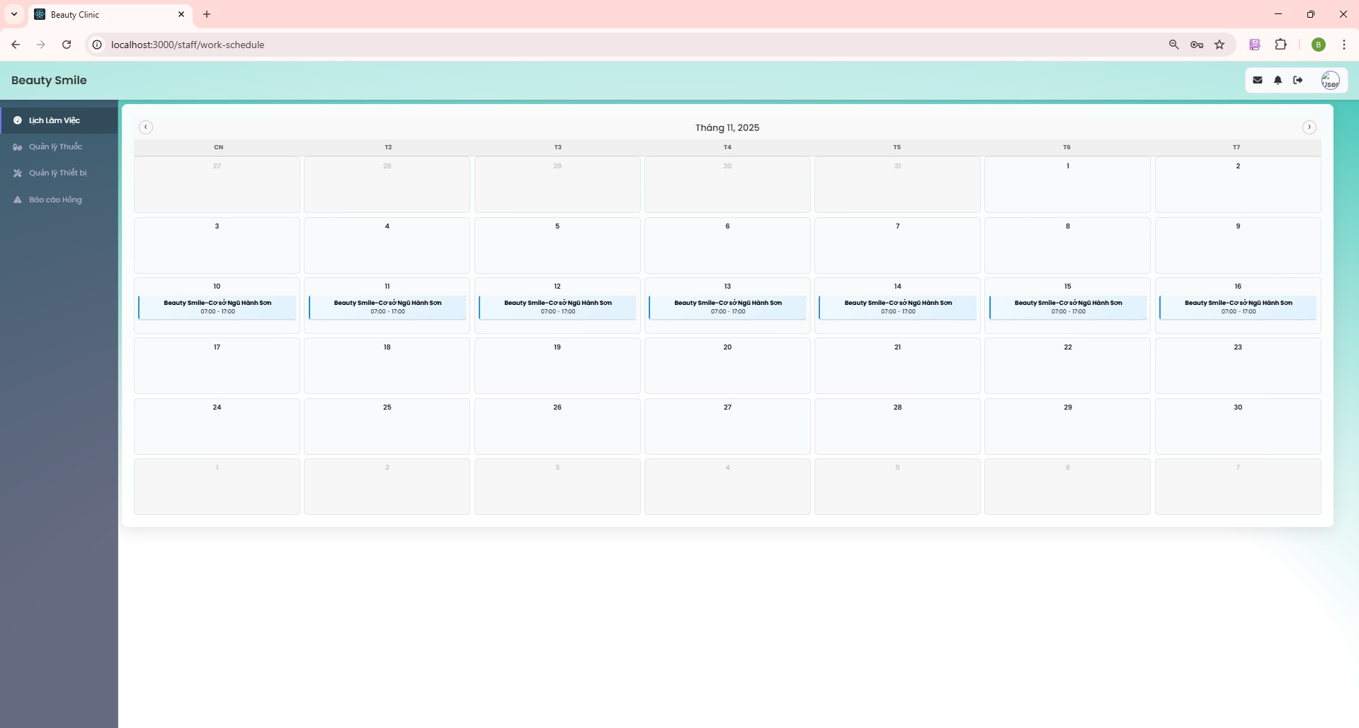

***Figure 79. Steps 2 in view staff schedule***

#### Create appointment offline (For staff)

* + - 1. From the Home screen, click the “Appointment” on the side bar.

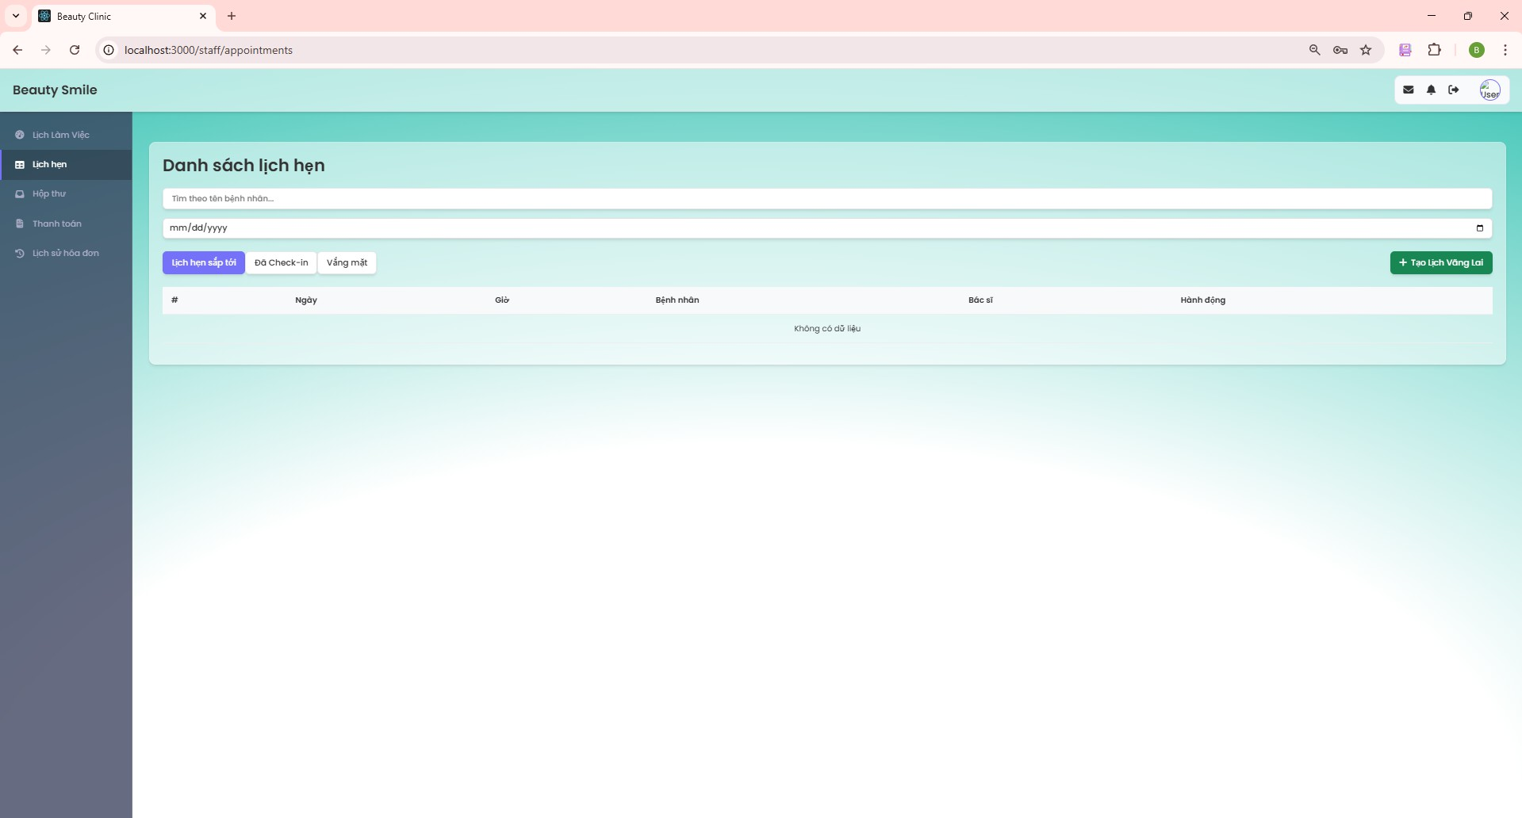

***Figure 80. Steps 1 in create appointment offline***

* + - 1. Click the green “Create appointment offline” to create an appointment.
      2. If the patient has an ID number in the system before, skip the input information to choose location. If this is the first time that patient comes to , staff have to input the patient's information.

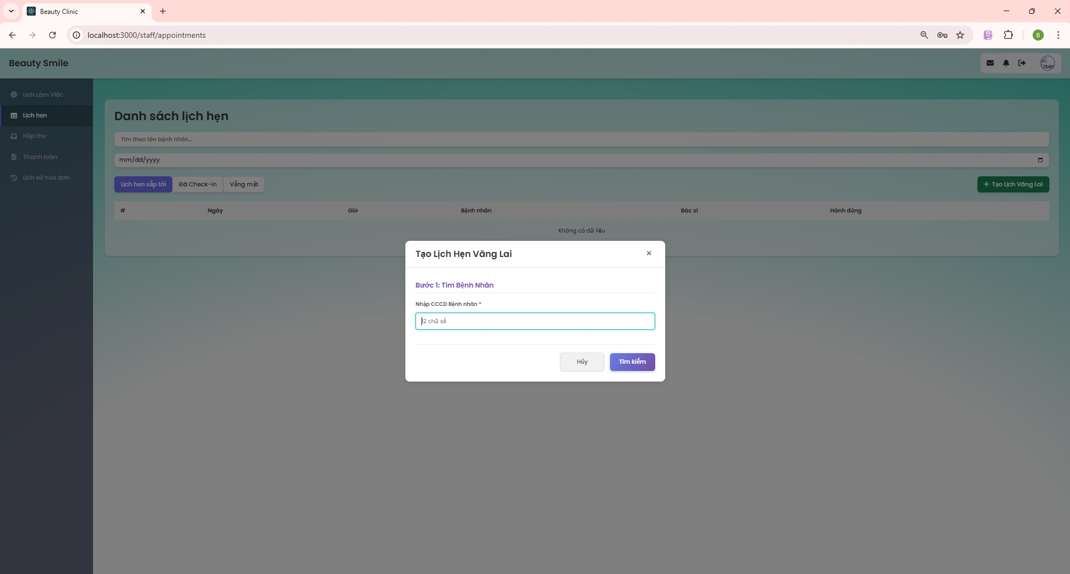

***Figure 81. Steps 3 in create appointment offline***

* + - 1. Input personal information in all text boxes and dropdowns.

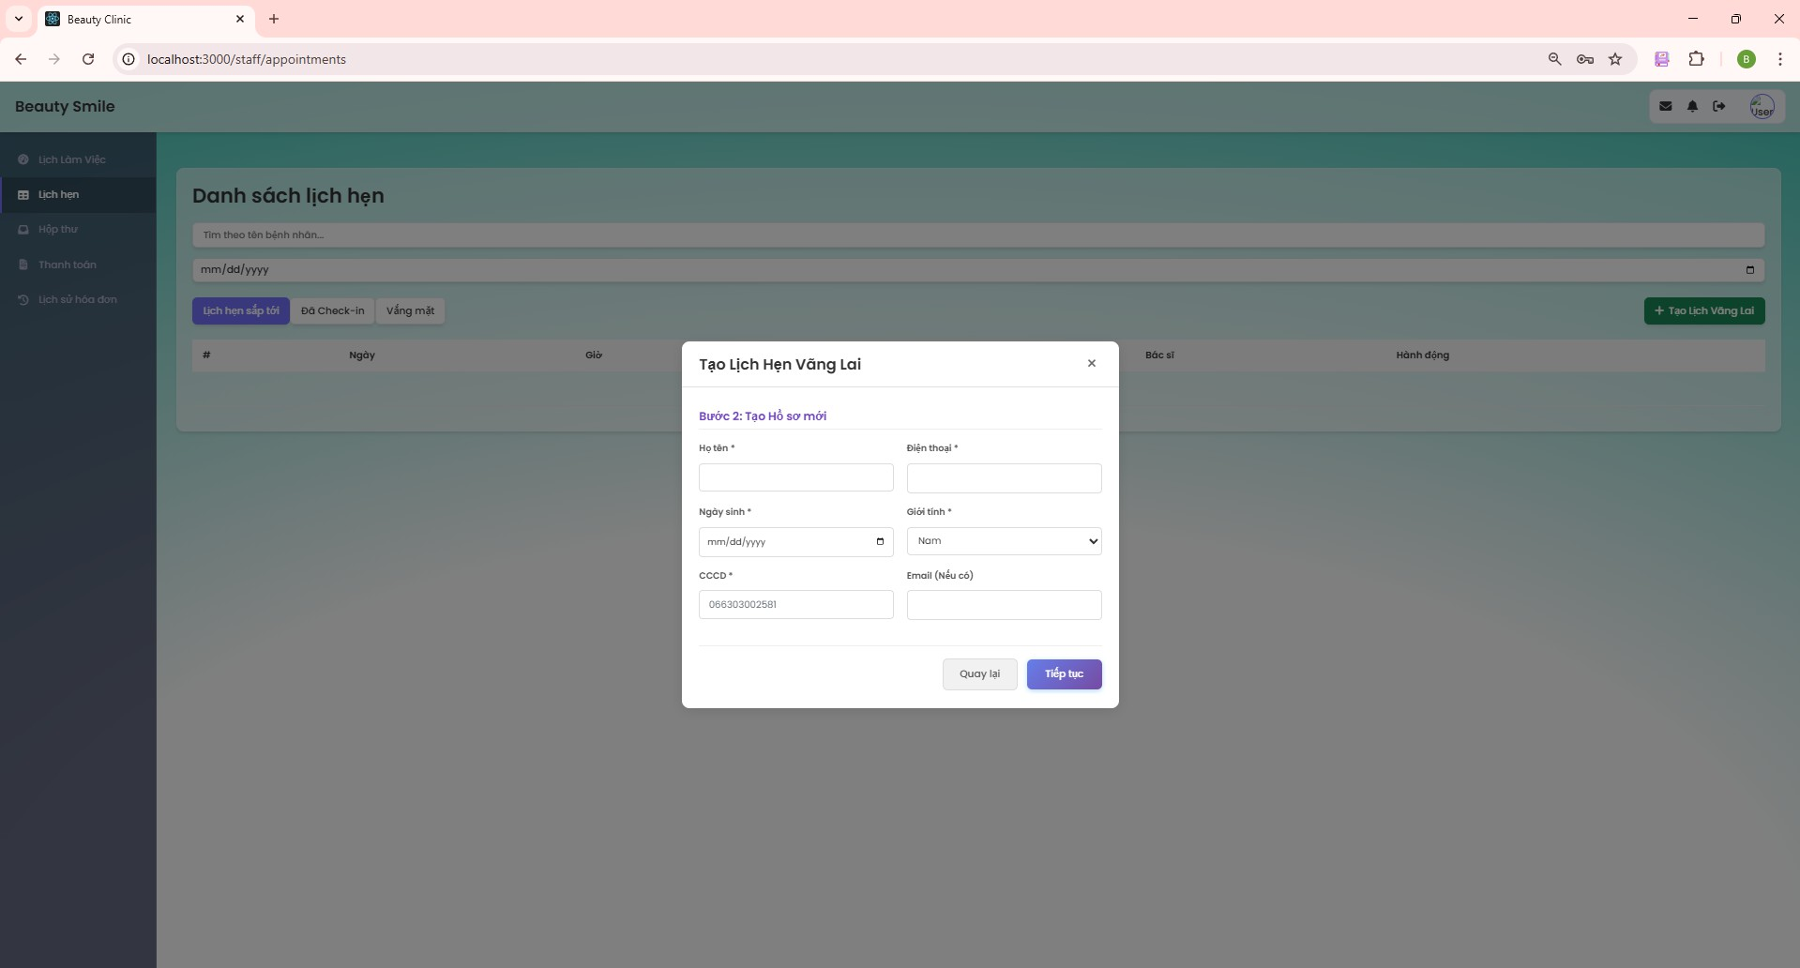

***Figure 82. Steps 4 in create appointment offline***

* + - 1. Choose the location that the patient comes to. Click “Create” to succeed.

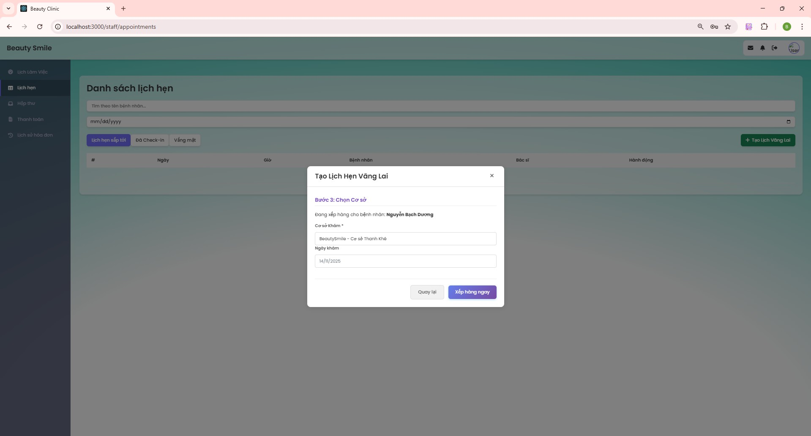

***Figure 83. Steps 5 in create appointment offline***

#### View revenue (for staff)

* + - 1. On the Home screen, click “revenue” on the side bar to get all the information.

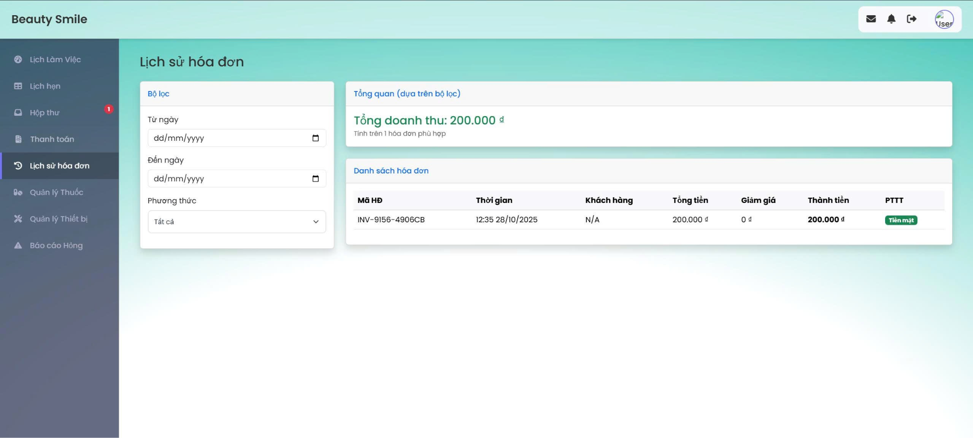

##### *Figure 84. Step 1 in View revenue.*

#### CRUD payment

* + - 1. On the Home screen, click the “Payment” button on the side bar.

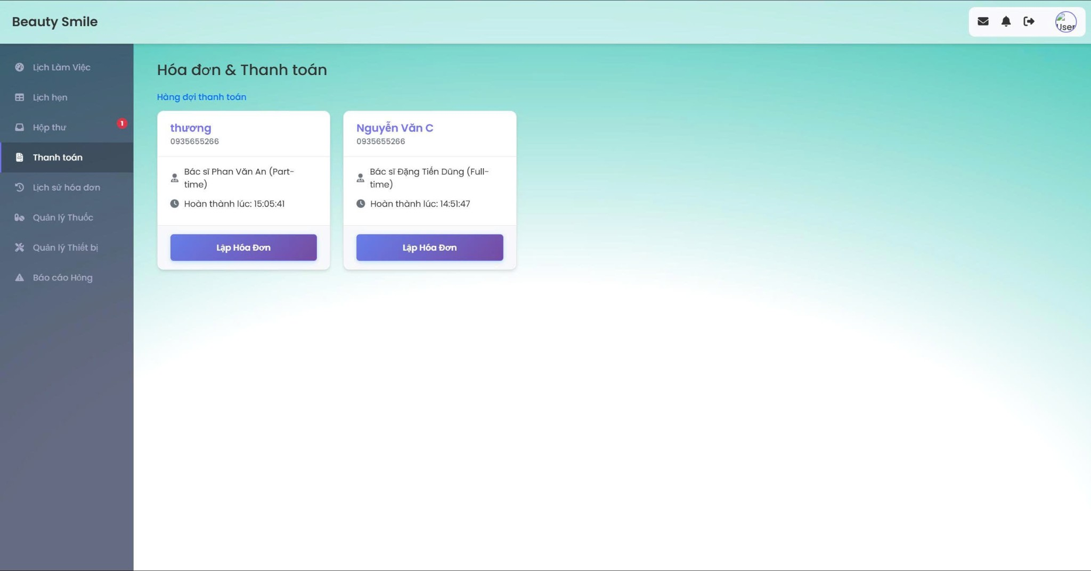

##### *Figure 85. Step 1 in CRUD payment.*

* + - 1. Staff click the blue “Create inventory” to show the screen to create inventory.
      2. Click “Payment” to succeed.

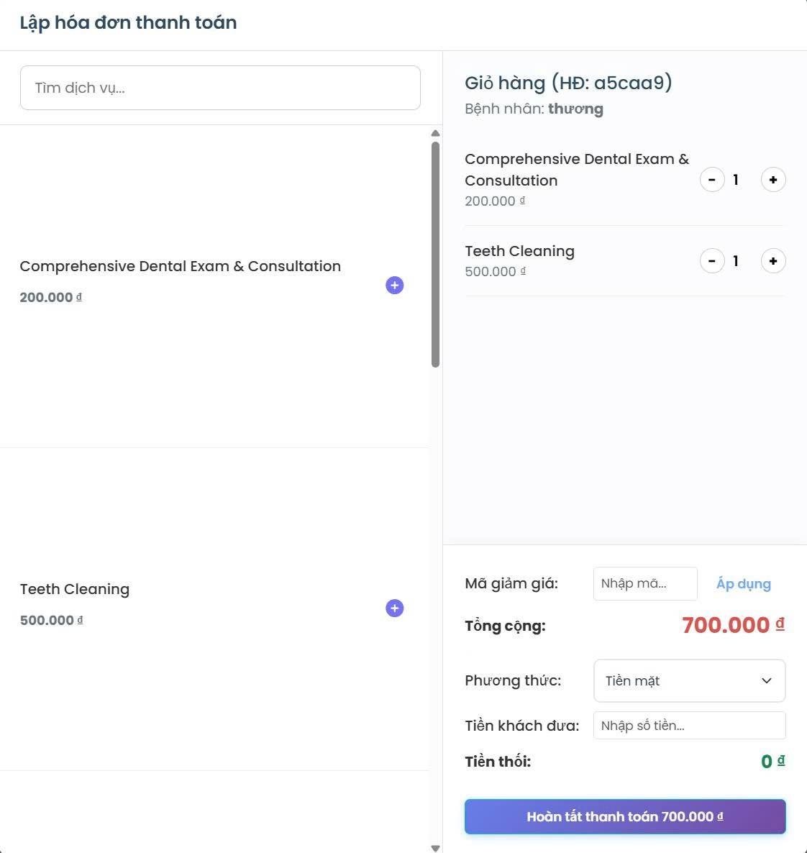

##### *Figure 86. Step 2, 3 in CRUD payment.*

#### View appointment (For doctor)

* + - 1. Login with a role doctor.
      2. On the Home screen, click “Appointment” on the side bar to get all appointments.

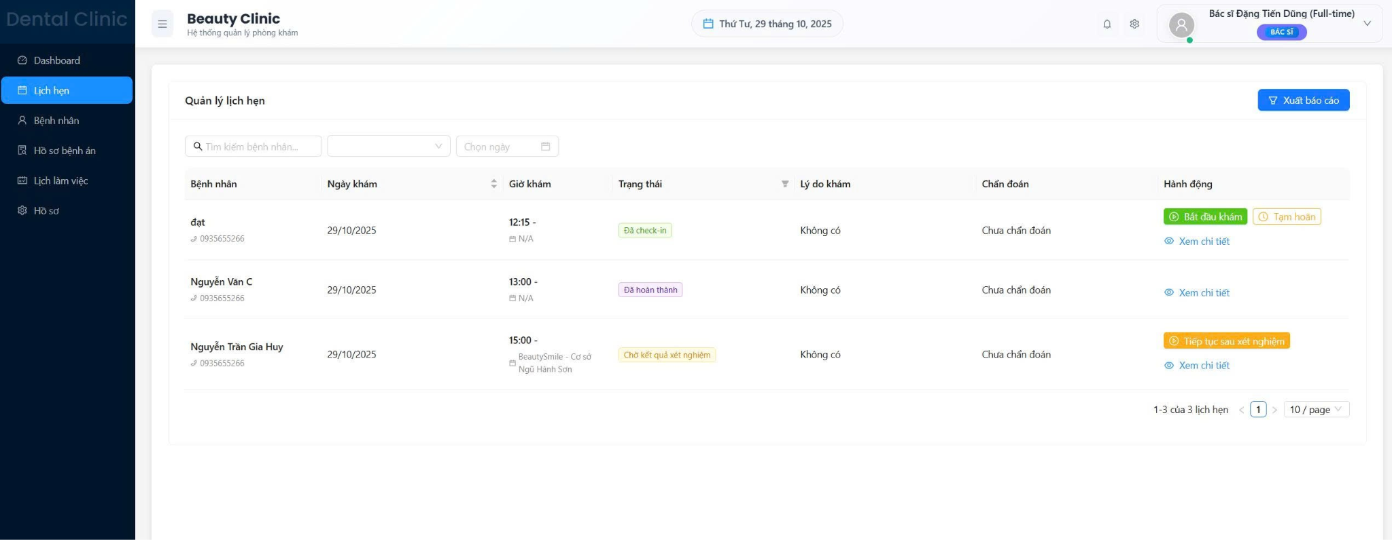

##### *Figure 87. Step 1 in View appointment.*

#### CRUD medical record

* + - 1. On the Appointment screen, click the green “start” button to start to create a medical record.
      2. There are 5 steps to finish a medical record, the first one is Physical Examination. Doctor input information in all the text boxes. Click “Save” to go to the next step.

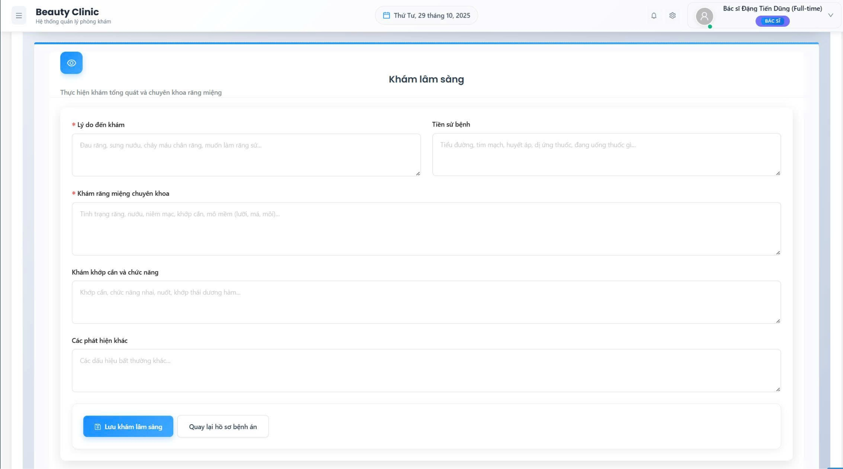

##### *Figure 88. Step 2 in CRUD medical record.*

* + - 1. The second is Laboratory Tests. Doctor input information in all the text boxes.

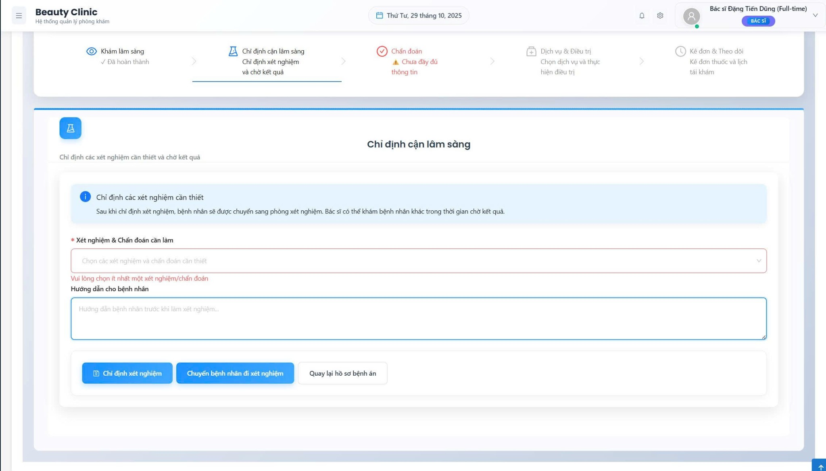

##### *Figure 89. Step 3 in CRUD medical record.*

* + - 1. After the patient finishes step two, the doctor will establish a diagnosis. Click “save” to go to the next step.

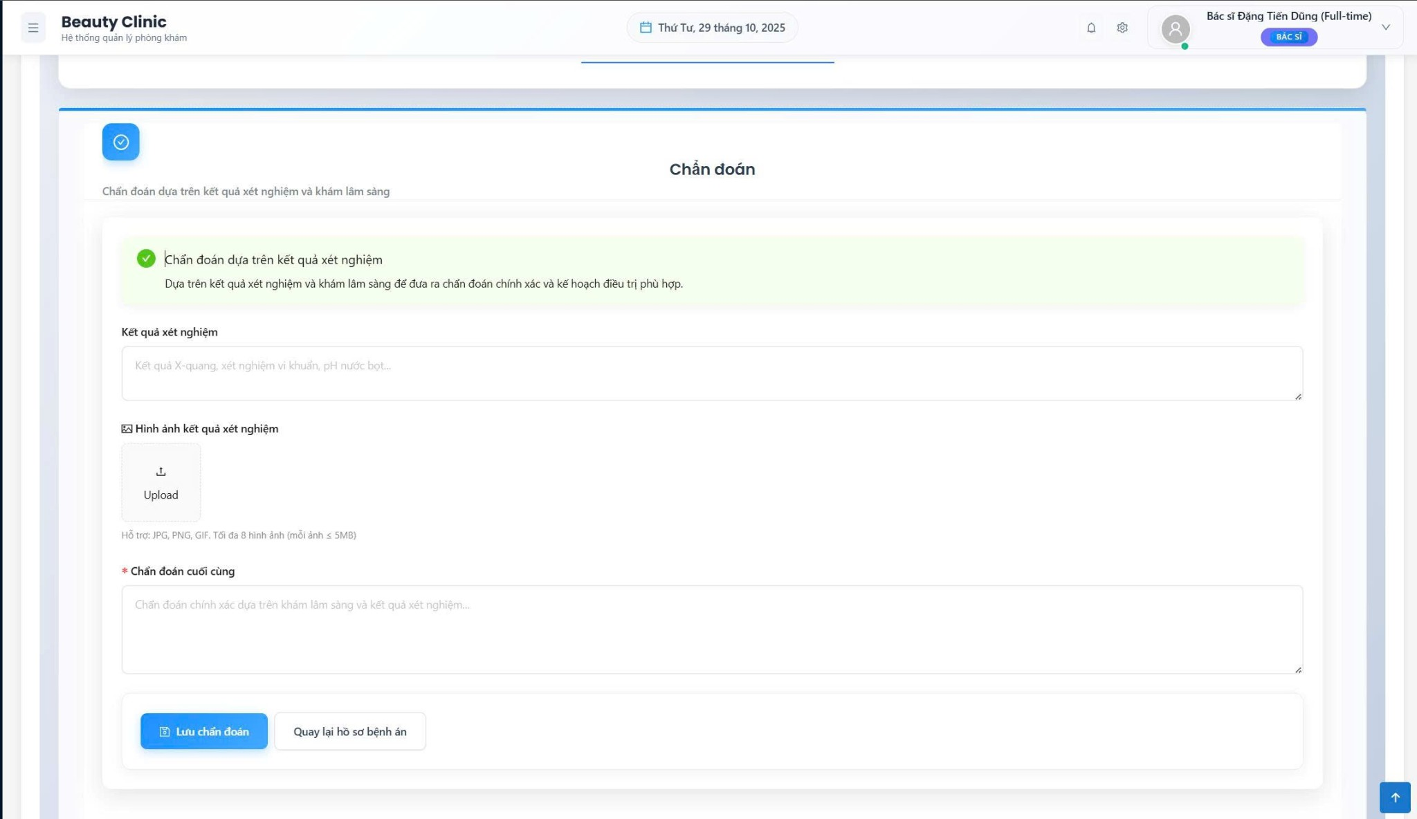

##### *Figure 90. Step 4 in CRUD medical record.*

* + - 1. The next is to choose service to Surgical Treatment and the final is Medical Treatment. Click “save” to succeed.

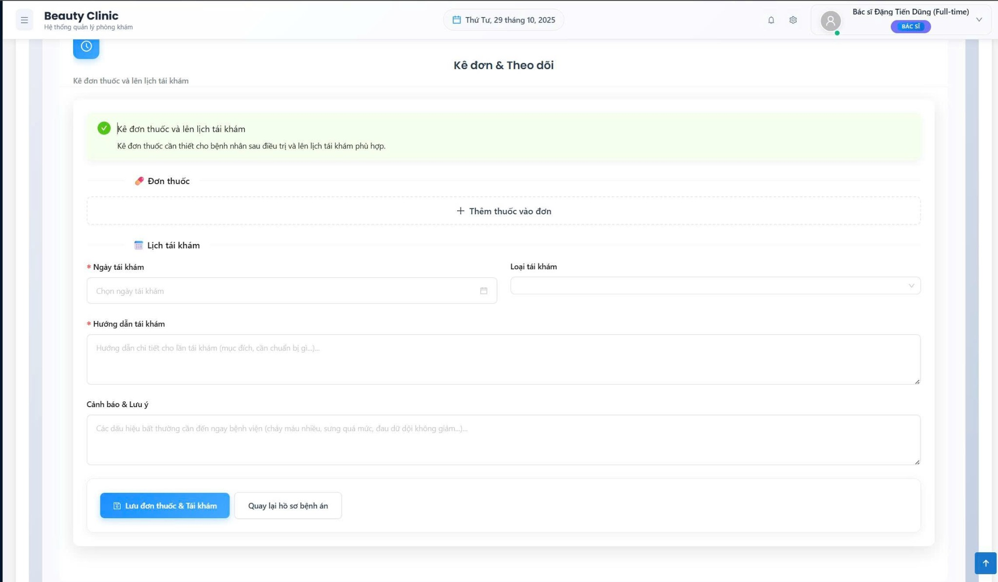

##### *Figure 91. Step 5 in CRUD medical record.*

#### View History medical record

* + - 1. On the Home screen, click “History medical record” on the side bar. The doctor gets all the medical record information.

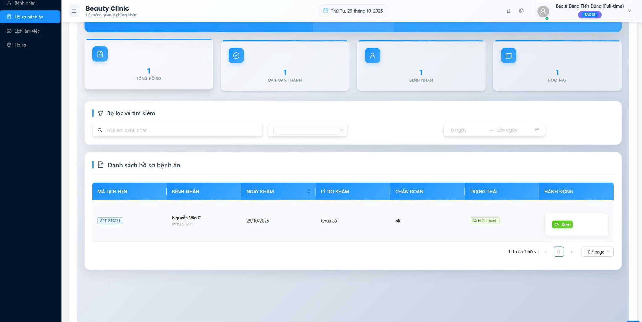

##### *Figure 91. Step 1 in View History medical record.*

#### View doctor schedule (for doctor)

* + - 1. On the Home screen, click “Schedule” to view all doctor’s schedules in all locations.

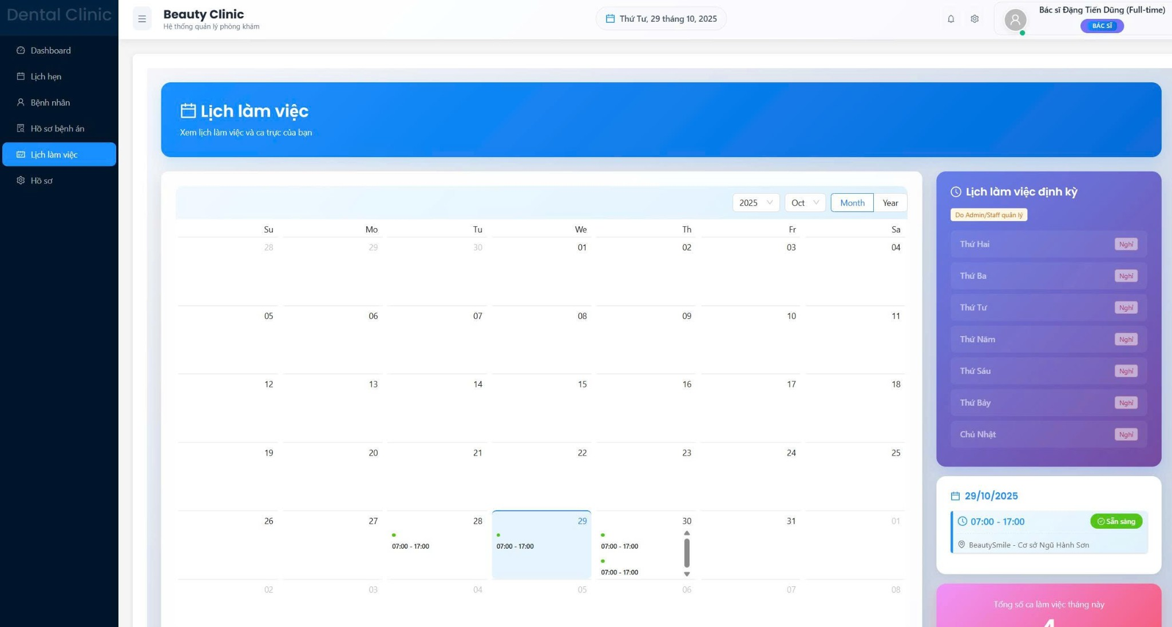

##### *Figure 92. Step 1 in View doctor schedule.*

#### View and update profile (for doctor)

* + - 1. On the Home screen, click “profile” to get a personal profile.
      2. To update phone number, double click on phone number text box, update information, click the blue “Update” to succeed.

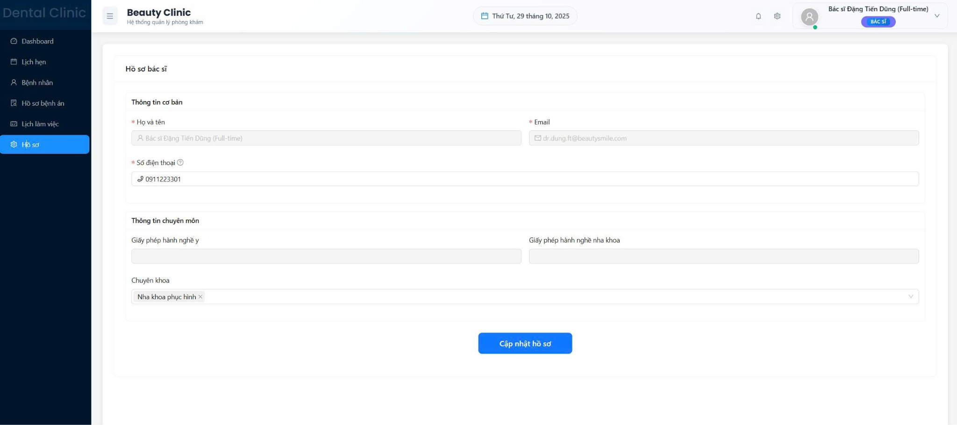

##### *Figure 93. Step 2 in View and update profile.*